**ISUE ORANGE: ISABELA STATE UNIVERSITY ECHAGUE ONLINE**

**RESOURCES APP FOR A NEW GUILD OF EDUCATION**

A

Capstone Project

Presented to the Faculty of

College of Computing Studies, Information and Communication Technology

Isabela State University-Main Campus

Echague, Isabela

In Partial Fulfillment of the

Academic Requirements for the Degree

Bachelor of Science in Information Technology

By:

MARK JOSHUA ELIMAR R. MANDIGMA

WILSON T. MAGAOAY

DWIGHT JEFFERSON M. SALARZON

FEBRUARY 2022

# APPROVAL SHEET

The capstone project attached herein, entitled **“ISUE ORANGE: Isabela State University Echague Online Resources App for a New Guild of Education”**, prepared and presented by MARK JOSHUA ELIMAR R. MANDIGMA, WILSON T. MAGAOAY and DWIGHT JEFFERSON M. SALARZON in partial fulfillment of the requirements for the degree of Bachelor of Science in Information Technology (BSIT) is hereby endorsed.

**ADVISORY COMMITTEE**

**RICARDO Q. CAMUNGAO, DIT**

Capstone Project adviser

**PANEL COMMITTEE**

**BENCHIE L. MARIBAO, DIT** **JOE G. LAGARTEJA, DIT**

Content Panel Member Technical Panel Member

**CHRISTINE CHARMAINE G. SAN JOSE, DIT**

Panel Chair

Approved and accepted as a partial fulfillment of the requirements for the degree of Bachelor of Science in Information Technology (BSIT).

**RENALYN G. TECSON, MSIT**  ___________________________

Program Chair, BSIT Date

**RICARDO Q. CAMUNGAO, DIT**  ___________________________

College Dean Date

**AMBROCIA A. GAFFUD, Ph.D.** ___________________________

University Registrar Date

# ACKNOWLEDGEMENT

This capstone project is a concrete outcome of the researchers' minds and abilities, as well as the participation of everyone who helped and pushed them in some manner during the completion of these capstone requirements.

The researchers would like to extend their profound appreciation and gratitude to the following individuals who have selflessly offered their priceless time and support;

To Mr. Ricardo Q. Camungao, their capstone adviser; Mr. Joe G. Lagarteja, their technical adviser; and Mrs. Benchie L. Maribao, their content adviser, for their outstanding support, suggestions, pieces of advice, and observations in completing this capstone project;

To Mrs. Christine Charmaine G. San Jose, Dean, and the entire faculty and staff of the College of Computing Studies in Information and Communication Technology (CCSICT), for their invaluable support, unforgetable pieces of advice, and care for the students;

They are eternally grateful to their parents, Mr. and Mrs. Elmer M. Mandigma, Mr.

and Mrs. Warlito T. Magaway, and Mr. and Mrs. Rocky B. Salarzon, as well as their brothers and sisters, for the love, moral assistance, financial, and spiritual support, and for teaching them never to give up in the face of adversity.

-The Researchers-

# DEDICATION

This capstone project is the result of countless and arduous sacrifices. This work is cheerfully and proudly dedicated to the individuals who serve as inspiration, for their efforts to the researchers; from the parents and guardians to the classmates and circle of friends who offered assistance in the midst of difficulties while doing this project.

Above all, to the Almighty God, who has showered them with blessings in their daily lives, and especially for the strength, courage, patience, wisdom, time, and guidance in carrying out their mission.

-The Researchers-

# TABLE OF CONTENTS

APPROVAL SHEET I

ACKNOWLEDGEMENT II

DEDICATION III

TABLE OF CONTENTS IV

CHAPTER I. INTRODUCTION 1

1.1 Rationale of the Project 1

1.2 Project Highlights 2

1.3 Objectives of the Project 3

1.4 Scope and Delimitations 4

CHAPTER II. REVIEW OF RELATED LITERATURE 6

2.1 Review and Related Literature 6

2.2 Technical Background 13

CHAPTER III. METHODOLOGY 17

3.1 Requirement Analysis 17

3.2 Technical Background (Project Framework) 37

3.3 Data, Software, and Hardware Specification 39

3.4 Functional Decomposition Diagram 54

3.5 Data Flow Diagram (Zero Diagram) 55

3.6 Entity Relationship Diagram 58

3.7 Systems Design 60

3.8 Development and Testing 61

3.9 Software Testing 64

3.10 Implementation Plan 68

CHAPTER IV. RESULTS AND DISCUSSIONS 70

4.1 Test the System Performance 73

4.2 Implementation Plan 82

4.3 Evaluation Result 86

CHAPTER V. SUMMARY, CONCLUSIONS AND RECOMMENDATIONS 95

5.1 Summary 95

5.2 Conclusion 97

5.3 Recommendations 99

REFERENCES 100

APPENDICIES 103

A. Relevant Source Code 103

B. User’s Manual 130

C. Gallery 182

D. Certificate Of Implementation 185

E. Grammarian’s Certificate 187

F. Curriculum Vitae 189

# CHAPTER I INTRODUCTION

### 1.1 Rationale of the Project

All establishments, enterprises, countries' economies, and businesses have experienced serious consequences as a result of the COVID 19 epidemic since its inception.

The Interagency Task Force for the Management of Emerging Infectious Diseases Resolutions (IATF) and the Commission on Higher Education (CHED) mandated a law that all people are prohibited from going outside, schools and universities are instructed to do work from home, and all classes are done using various online learning platforms. The Task Force for Interagency Cooperation on this learning platform has made major contributions to student learning, but it has also had negative implications for students as a result of their faculty members use of various learning platforms. A lot of students are struggling with their studies, which is forcing them to miss out on some of their extracurricular activities. Switching between several learning systems is also confusing and time demanding for them. In the part of the faculty, monitoring of student phase learning is not evident and the assurance of inculcating the adequate knowledge and skills of the course is not manifested. Likewise, the top management relies only on accomplishment reports submitted and no means of verifying the authenticity of the conducted activities.

The Isabela State University, specifically the College of Computing Studies Information and Communication Technology (CCSICT), is one of the academic

institutions experiencing these issues. While the majority of their students are enrolled in online learning, not all of their faculty members are using the same learning platform, with some using Google Classroom, Edmodo, and other platforms. The need of having a unified learning management platform that has functionalities in facilitating, supervising and monitoring the conduct of asynchronous and synchronous classes is essential to centralize the learning management process provided to the clientele.

It is in this light that the design and development of the ISUE ORANGE which stands for Isabela State University Online Resources App for a New Guild of Education is timely and relevant in the present learning environment. The system primarily aims to provide a platform for the management of learning activities of both students and faculty members of the College of Computing Studies, Information and Communication Technology (CCSICT) main campus. The ISUE ORANGE is a web-based system with a mobile-first strategy that would serve as a tool for students and faculty member to plan, execute, and evaluate their individual learning gains. Having this kind of learning management tool, the proponents believe that the system will help students achieve improved learning efficiency, realizing that faculty members and the university can still delivered a quality of education in the midst of a pandemic.

### 1.2 Project Highlights

The study's highlights include the creation of the Isabela State University Echague

Online Resources App for a New Guild of Education (ISUE ORANGE) for Isabela State University's College of Computing Studies Information and Communication Technology (CCSICT) (Main Campus). The following features will be present in a mobile-first webbased system;

* Allows faculty members to create content such as Announcements, Creating and Publishing Quizzes and Exams, Disseminating Learning Materials, and

Allocating Grade Percentage;

* Management of class records and evaluation tools;
* Provide basic item analysis for enhancement of evaluation tools;
* Monitor students' learning phase through the student progress functionality;
* Provide a mechanism to lessen if not prevent the occurrence of cheating during taking exams.

### 1.3 Objectives of the Project

The study primarily aimed to design and develop a unified learning management system coined as “Isabela State University Echague Online Resources App for a New Guild of Education (ISUE ORANGE)” for the College of Computing Studies Information and Communication Technology (CCSICT) of Isabela State University – Echague Campus to improve the traditional method of online learning used to evaluate and track students' academic performance. Specifically, it sought to;

1. Test the system functionalities using Apache JMeter as testing tools for
   1. Load testing based on the following criteria:
      1. CPU Usage;
      2. Disk Input and Output speed;
      3. Bandwidth;
      4. Error Rate.
   2. Stress testing based on the following criteria:
      1. CPU Usage;
      2. Disk Input and Output speed;
      3. Bandwidth;
      4. Error Rate.
2. Prepare an implementation plan for the project.
3. Evaluate the user’s acceptance on the system functionalities using the Technology Acceptance Model (TAM) based on the following criteria.
   1. Design and layout
   2. Content management
   3. File administration and content
   4. Communication
   5. Management Gradebook and grading criteria
   6. Management of testing and assessment tool
   7. Mobility
   8. Security

### 1.4 Scope and Delimitations

The study covered the design and development of ISUE ORANGE which provided student and faculty members of the College of Computing Studies Information and Communication Technology (CCSICT) a unified learning management system to conduct asynchronous and synchronous classes. The system is accessible in an online environment with the following modules announcement, classes, modules, classwork, gradebook, student progress, student, grading criteria, about, and settings. The system functionalities include the following features:

* Creating and uploading of lessons;
* Constructing of assignments and projects with enabling setting

configuration;

* Administering and managing of evaluation tools;
* Downloading of learning materials;
* Facilitating Personal virtual dashboard for announcements, activities, and collaboration with students and faculty members;
* Content Management System. It includes the university calendar, student and university information, helpful and related course links and downloads. ● A thread and chat features are available for comments and consultation.

The system has four (4) users having different level of privileges in using the system namely student, faculty, program chair and campus academic and related affairs director subscription to avail cloud storage was considered to centralized data storage and made available anytime anywhere provided that wireless fidelity (Wi-Fi) is available.

The system can be viewed in smart phones and browsers with a minimum

requirement based on hardware and equipment’s specification but the system is also limited in sending notifications via text messaging.

# CHAPTER II REVIEW OF RELATED LITERATURE

This chapter discussed a review of related literature to analyze and discuss the concepts in system development related to the proposed system. It had also presented a theoretical and conceptual framework that further supported the proposed system.

### 2.1 Review and Related Literature

A review, in January 2017, reported that in the Philippines alone, there were an estimated 40 million social network users this year, (Statista, 2017). More Filipinos spent their time on social media than anyone else in the world with an average of 4.17 hours daily in the Philippines as one of the users of SNS (social networking sites). Almost 93 percent of public schools across the country already had equipment used in the online learning mode for the school year 2020-2021. (Montemayor, 2020).

The increased use of ICT in higher education in recent years resulted in a number of projects attempting to integrate LMS within the learning environment. A large number of colleges and universities across the country embraced e-learning because it provided more training to students while being fast, convenient, and consistent. Proven to be far more effective than traditional classroom-based models. The JRU College Division Computer Science Department always delivered traditional lectures using technology, such as software demonstrations and PowerPoint presentations. (Ryan A. Ebardo and Arlene Mae C. Valderama, 2010).

This led to examining the factors of the Filipino college students’ behavioral intention to use LMS as part of their education journey from the constructs of integrated multimedia instruction, perceived quality work of life, system interactivity, and internet connectivity experience, perceived ease of use, perceived usefulness, and social media influence. The aim of this study was to discover the factors that influence college students' acceptance of e-learning technology, specifically LMS, as a reinforcement of the teaching and learning process in the Philippines. As a result, the study discovered that internet communication experience had a positive relationship with perceived ease of use and behavioral intention; it also discovered that system interactivity had a positive relationship with perceived usefulness, but contrary to system interactivity, there was no clear evidence that it also affected the perceived quality of work life. The interaction within the system (learner–interface, learner tool, learner-task, learner-content, learner faculty members, and learner-student) undoubtedly resolved one of the established weaknesses of eLearning which was the absence of face-to-face interaction. Results also meant to serve as one of the pioneers that offer information on e-learning acceptance in the Philippines. (Garcia, 2017)

One of the new tools available was released by Google. Pangasinan State University was currently subscribed to GSuite for Education, and recently Google introduced Classroom as an eLearning platform for an educational institution. This research aims to evaluate the new product, its functionalities for the purpose of adapting and deployment.

The main objective of this paper was to identify the usability and evaluation of the Learning Management System (LMS) Google Classroom, its functionalities, features, and satisfaction level of the students. As a result, Google Classroom plays a great role in making learning easier. Based on the usability evaluation of the platform, Google Classroom is extremely useful in understandability, attractiveness, and operability.

Although the platform was useful for non-academic activities, it was especially useful for assignments and collaborative learning. It was suggested to test this in a fully online environment. As the study collected more data, it was also recommended to assess other problems based on the data, such as the relationship between the profile and the platform's level of usability. This study also recommended to continue collecting data for future studies. (Ventayen, Estira, De Guzman, Cabaluna, & Espinosa, 2017).

Since March 2020, after the Covid-19 virus turned into a worldwide pandemic (WHO, 2020), many public and private institutes including schools and universities were closed across the countries. In June 2020, the Ministry of Higher education (MoHE) came up with a countrywide learning management system project called HELMS (Higher Education Learning Management System). It was a web-based service used as a tool to assists universities in different functions like managing, delivering, planning, and tracking the learning and teaching process. This was introduced as a primary medium for education during the pandemic, after a large-scale and meticulous analysis through interviews. The result proved that e-learning adoption had not been considered as a priority for Ministry of Higher Education (MoHE) and they had not anticipated the situation such as countrywide quarantine under which online learning should be replaced with onsite education, also found that the absence of an inclusive policy and guideline for management and use of the system had also affected the quality aspects of the HELMS. The findings of this research were consistent with the results from previous studies (Almaiah et al., 2020; Atan et al., 2011; Beebe, 2010; Dhawan, 2020).

According to (Dellosa et. al, 2012), the term Modular Object-Oriented Dynamic Learning Environment (MOODLE) or just Moodle was a developing framework in the data innovation schooling field. It was a learning management system framework that utilizes the web. It was additionally now a verb that portrays the way toward doing an online course. Any individual who utilizes Moodle was a Moodle. This study was started to decide the capability of using an institutional learning management system to fill in as the standard device for use in the virtual classroom. The learning management system contains features on enrolment, roles, course management, course report, and modules on assignment, chat, forum, glossary, lesson, quiz, survey, and workshop. The LMS was evaluated by the student respondents in four areas: the system, the technical support, functions and capabilities, and the tools and were found to be generally good and acceptable.

This was carried out to assist preschool classroom management by developing an LMS called Electronic Pupil Learning System (EPILS) tailored to meet the level of understanding of a kindergarten; a convenient way for faculty members to assign and evaluate activities; for the principal to post announcements, news, and events; and for parents to keep track of their children's classroom activities. To use the system, users must have a computer or a phone. The problem systems that prompted the researcher to develop EPILS as a solution were it follows: in the traditional classroom setting, faculty members must spend time preparing and creating a template for their pupils' activities; there was a lack of a classroom interactivity tool to support learner-centered education for kindergarten students; and parents are unable to fully track their children's performance.

According to (Resuello, 2017), portability enables a teacher to bring his or her mobile phone wherever he or she goes, including into the classroom which would help him/her manage a class more effectively. Today, mobile phones were used to improve student organization, accelerate collaboration, and maximize technology portability. In this study, an attempt had been made to create an Android-based Class Record System, with the goal of achieving mobility in managing and monitoring student class records. Its primary goal was to create a consolidated and secure archive of student information, assessment results, and attendances stored in Android-based mobile phones. With the use of mobile phones, recording, searching, viewing and updating of a student’s pertinent academic information would be faster, handy, and just a click away.

According to (Iteit Spamast-Malita, Southern Philippines Agribusiness and Marine and Aquatic School of Technology, 2018) the study was conducted in order to provide an effective system for viewing grades for students to avoid going to school just to check their grades at the end of each semester. Where Southern Philippines Agri-Business and Marine and Aquatic School of Technology installed and used the application (SPAMAST) this application was simple and does not necessitate extensive training for the student, only brief instructions on how to use the application. It was directly applied to the users' current problems. Aside from an Android phone/Smart phone, there is no need to bring any additional tools to help with the operation, anyone can also save time by using the application, exchange of information is not necessary. It did not affect the goals of the institution. It was determined that the application had a positive impact on the students' side, as they can effectively view their grades using their smartphones as long as they are connected to the internet. As a result, students can use the system.

According to (Brioso, 2017), people are living in the technological era. When compared to ancient times, time had changed rapidly. Various techniques in the field of educational learning were discovered in order to save time while producing good results. The proposed system was effective as perceived by the respondents and to the implementation. The e-classroom management system with performance feedback mechanism system as a tool that would help with the issues, deficiencies, and problems as categorically stated as class organization/management, class participation and class monitoring in blending to the existing system would create a mix-mode strategy in teaching-learning approach in the context of pedagogy was perceived as effective and acceptable by the respondents. As a result, the developed system was fully confirmed and rated as "Very Satisfactory" from the given measures such as system's functionality, usability, reliability, portability, and security.

According to, (Javier & Dirain, 2019)., the aim of this study was to see if there was a connection between certain variables and the use of Edmodo by the participants. The positive evaluation of skills, behaviors, and activities associated with online learning with or use of Edmodo had a significant impact on students' academic success. Blended learning with Edmodo had indeed taken instruction into a greater leap opening clear pathways to its prospective use in other similar courses at CSU and other educational institution in the Philippines and it was strongly recommended that the University may fully integrate blended learning approach towards its vision of educating for the best as well as other higher education institutions advancing instruction to a greater leap.

According to (Sanchez, Sebastiá, Molina, & Saiz, 2018), the Schoology tool was evolving into a free educational platform for the work of ICTs, also known as LMS (Learning Management System). This more user-friendly and practical, and that attempts to reinvent the technology used in learning so far. It enables faculty members to provide instructional materials as well as organize and evaluate the learning process; provide the possibility to identify students' individual needs, the teaching-learning process becomes more tailored to the needs of the students; created some resemblance to social networks in terms of notices, participation, discussion forums, and continuous feedback; Through the statistics section, it is possible to monitor and control the students' activities. As a result, Schoology conducted the study to support k-12 schools and higher education institutions by allowing users to create, manage, and share academic content. The conclusion was that the students' adaptation to the use of Schoology was quick and efficient, which can fit all without incurring an increase in activities in comparison to control groups, which came to support the studies.

### 2.2 Technical Background

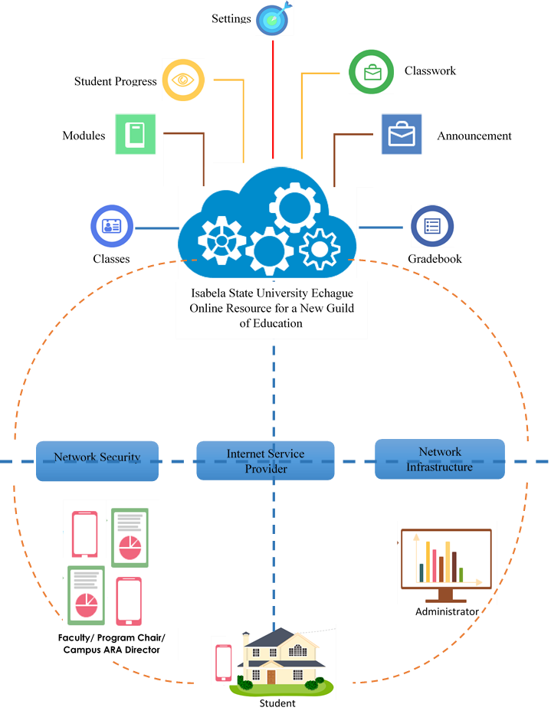

***Figure 1*.** *ISUE ORANGE System Architecture.*

Figure 1 shows the system architecture of Isabela State University's Echague Online Resource for a New Guild of Education. The ISUE ORANGE can be accessed by students, faculty, program chairs, and campus ARA Directors via various devices such as mobile phones, laptops, or desktops with the help of a browser and an internet connection. These roles can use the features of the system by creating and joining classes, view gradebook, and students' progress, and interacting through the use of announcements and classwork. The internet is a necessary resource needed to be able to access the website and to be able to use the different functions that the system provides, as shown in the figure.

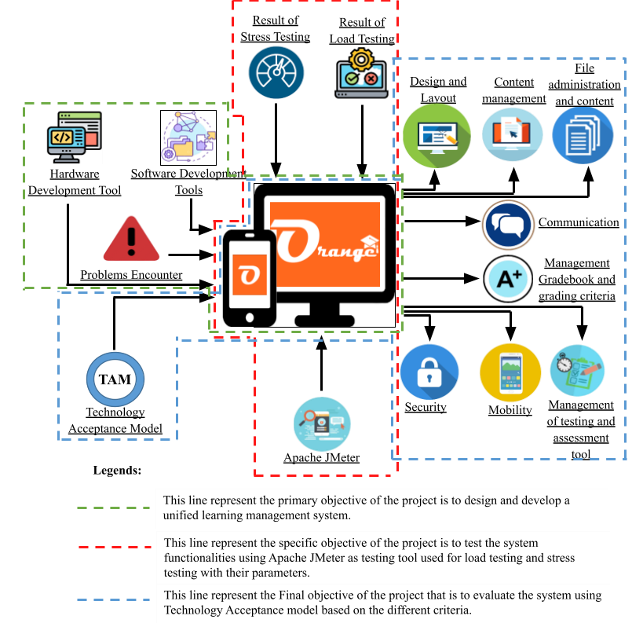

***Figure***

***2***

**.**

*Conceptual Framework*

The above figure shows the Input-Process-Output (IPO) of the system. In this study, the researchers provided all the necessary features and data that students and faculty members needed in order to use the project. The system provided a reliable and efficient way of tracking academic performance and monitoring the users, likewise, the system approach using input, process, and output (IPO).

**INPUT**

The input should be the system requirements to operate and create the system properly. For software development purposes, Visual Studio code was used for programming purposes, and it was connected to the database, which was MySQL. While Vue.js was the framework used in creating the whole interface of the system, from logging in to different interfaces inside the system, and with the web application framework Laravel as the back end of the system, it supported the front-end authentication, routing, and sessions of the system. A postman was also used in the system. This tool was utilized for API testing to check if the output/returned value or data was well-structured, reliable, and had the correct response. Github was also used in the system. This was used for collaboration with the proponents, tracking changes to the codes. For the hardware development tools, the minimum memory of the computer was 4 GB (Random Access Memory) RAM or higher to perform the system at a satisfactory speed. The processor or central processing unit (CPU) was be at least 3.00 GHz or higher to calculate large arithmetic calculations in a short period of time. And 1 TB of internal storage. For mobiles and smartphones, the minimum version of Kitkat and higher, and 4GB of RAM and 32GB of ROM and higher, Apache Jmeter was used to test the system performance and capability of the project, and the Technology Acceptance Model (TAM) was utilized to evaluate the system functionalities based on the different criteria.

**PROCESS**

The development of the project consisted of the processes of the system construction based on the inputs in developing the system, the problems that users encounter, the system testing phases, and the evaluation phase of the system. Development of the project consisted of conceptualization of the project and construction of the program code for the project to be able to test the system capability and manageability for its users' data while the implementation plan was held. The testing phase was conducted, and the documentation was included with the start of the conceptualizing of the project. The evaluation of the system was conducted as part of the users' training, which was conducted to evaluate the system's functionalities and gather the users’ evaluation of every respondent.

**OUTPUT**

The process part of the conceptual framework showed the system construction itself, from the concept of the research up to the implementation. Finally, the output showed the developed system named Isabela State University Echague Online Resource for a New Guild of Education (ISUE ORANGE). The outcome of the testing phase, used Apache JMeter as a tool to test the system's performance (stress testing and load testing), as well as the outcome of the evaluation phase, used the technology acceptance model (TAM) to evaluate the system's functionalities based on various criteria.

# CHAPTER III METHODOLOGY

### 3.1 Requirement Analysis

This chapter covers the methodology used by the researchers. In order to develop the project, the researchers applied the System Development Life Cycle (SDLC) by using the Rapid Application Development (RAD) model as shown in Figure 3 below. RAD is a software development methodology that uses minimal planning in favor of rapid prototyping. A prototype is a working model that is functionally equivalent to a module of a system.

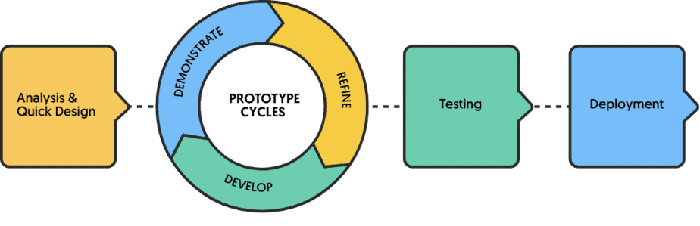

***Figure* 3.** *Rapid Application Development*

**3.1.1 Fishbone diagram**

Ishikawa Diagram is a visualization tool that helps to track down the causes of a problem, variations, defects, or failures in order to identify its root cause.

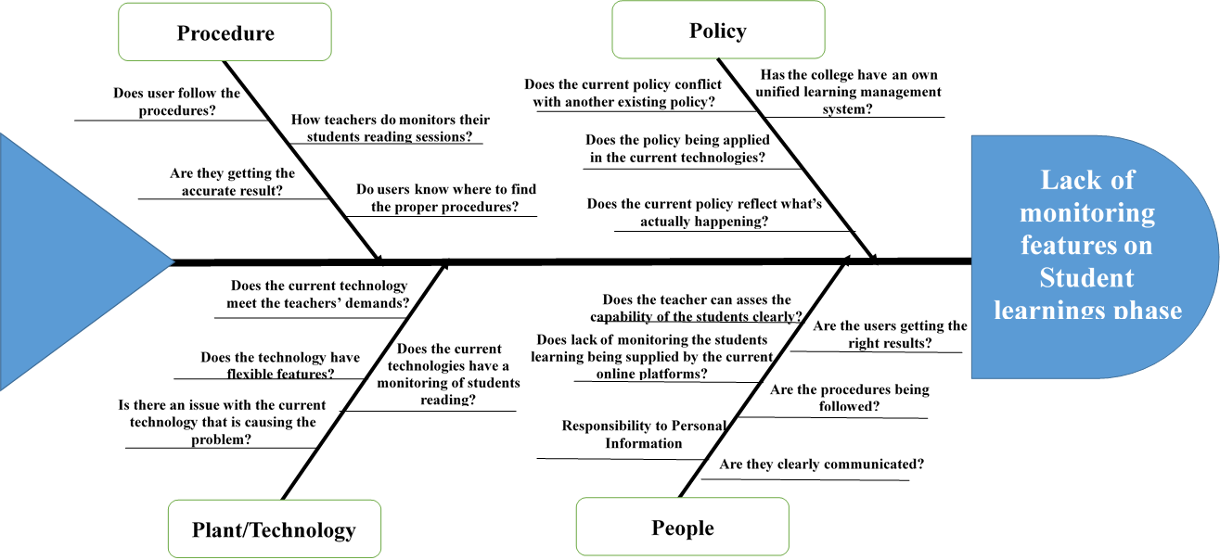

***Figure* 4.** *ISUE* ORANGE *Fishbone Diagram*

Figure 4 displays the different categories of the diagram the researchers use 4P’s named Procedure, policy, Plant/Technologies, and People. This category was used to determine and pinpoint the main effect or problem resulting in a problem of “Lack of monitoring features on students' learning phase”.

**3.1.2 Gantt chart**

A Gantt chart is a handy graphical tool that displays activities or tasks as they are completed against time. It is also referred to as a visual presentation of a project in which the actions are broken down and placed on a chart to make it easier to grasp and analyze.

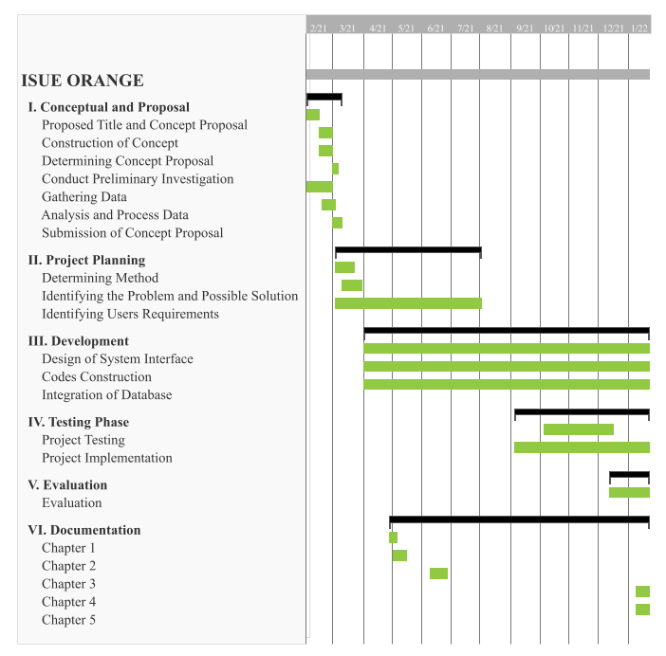

###### **Figure 5**. Gantt chart

Figure 5 displays the date and time planning and development of the project. This chart shows the duration of every step the proponents took from conceptualizing the proposal, project planning, development of the project that took up to this date, implementing the proposed system, evaluating the system, and maintaining the project.

These are the processes involved in creating and maintaining the project.

**3.1.3 Wireframe**

A wireframe is a two-dimensional skeletal outline of a web page or app. Wireframes provide a clear overview of the page structure, layout, information architecture, user flow, functionality, and intended behaviors. As a wireframe usually represents the initial product concept, styling, color, and graphics are kept to a minimum. Wireframes can be drawn by hand or created digitally, depending on how much detail is required.

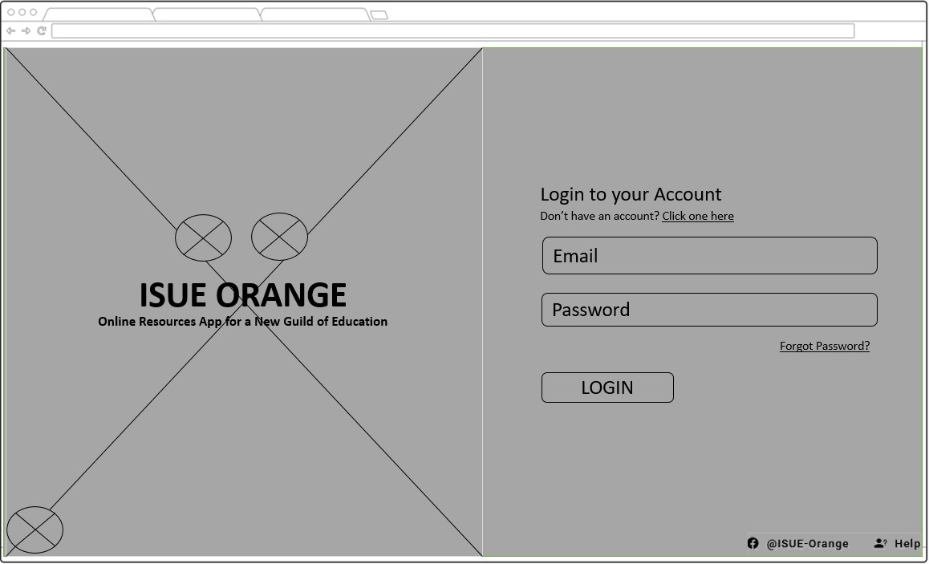

***Figure* 6.** *Login Page*

This figure shows the login page of the system. In order for the user to access and use the ISU ORANGE, they need to enter their valid username and password to proceed.

This was developed to authenticate all the users and for security purposes of the system.

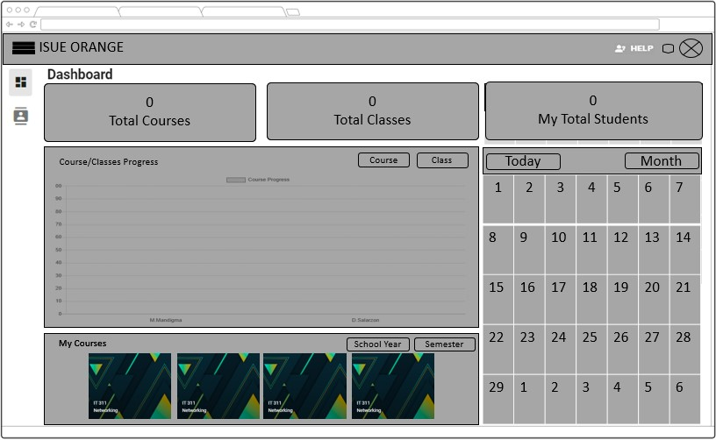

***Figure* 7.** *Faculty Dashboard*

Figure 7 shows the dashboard page and it displays the total number of courses, classes and students and it also contains the calendar with the events of the classwork they created and its due date. The faculty members can also see the course/class progress.

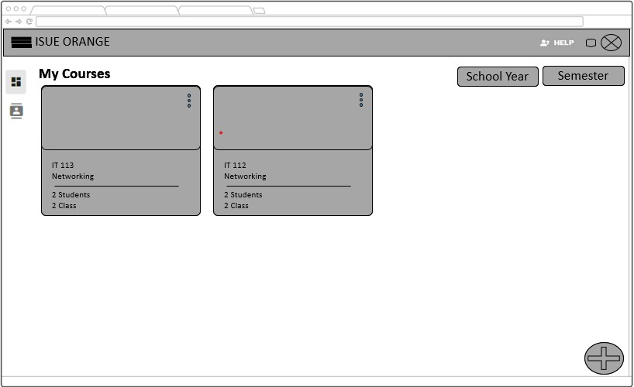

***Figure* 8.** *Faculty Courses*

This figure displays the created courses that the faculty members created. They can sort the courses depending on what school year and semester, they can also create new one by clicking the button on the bottom right side of the website.

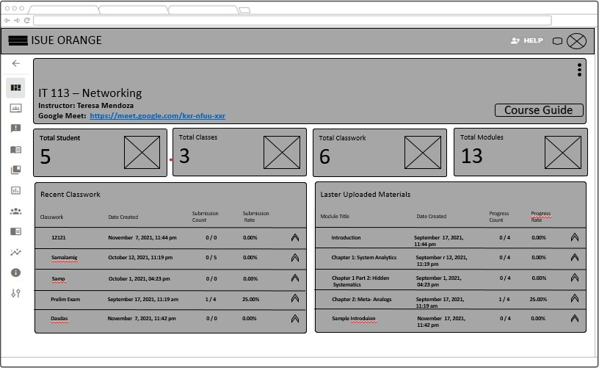

***Figure 9*.** *Faculty Overview*

Figure 9 shows the course overview and it consists of the total number of Students, classes, classwork, and modules they created. The faculty members are also able to view the recent activities they made like the classwork and module where they can see the submission and progress count of the Learners and also the date, they created the activity.

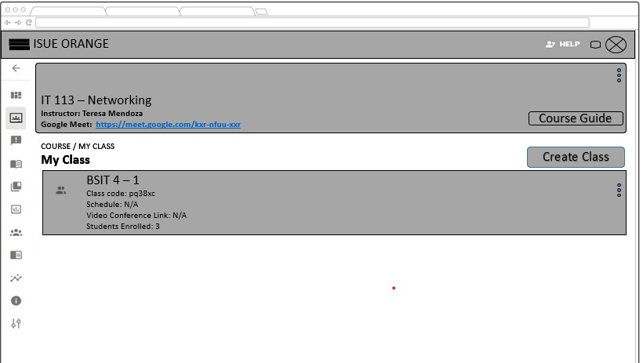

***Figure***

***10***

***.***

*Faculty*

*Class*

In this figure the faculty members are able to view all the list of classes and create a class inside the course they created and it will show the section and class code of the class and the students in the class.

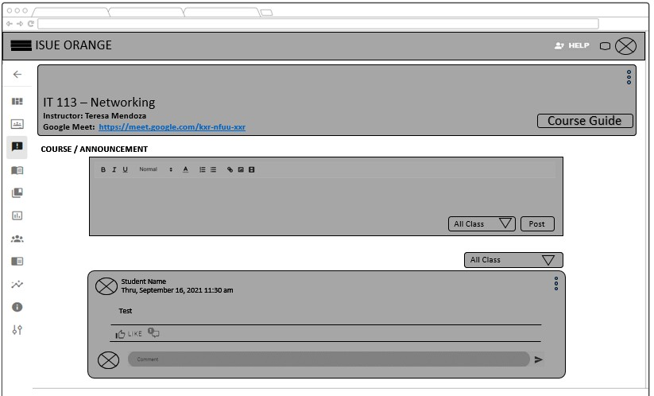

***Figure 11.*** *Announcement*

Figure 11 shows the announcement page where users are able to create an announcement to their classes, it can be to all classes within that course or to a specific class only. The faculty members and students can interact with the post by commenting and giving like to the post.

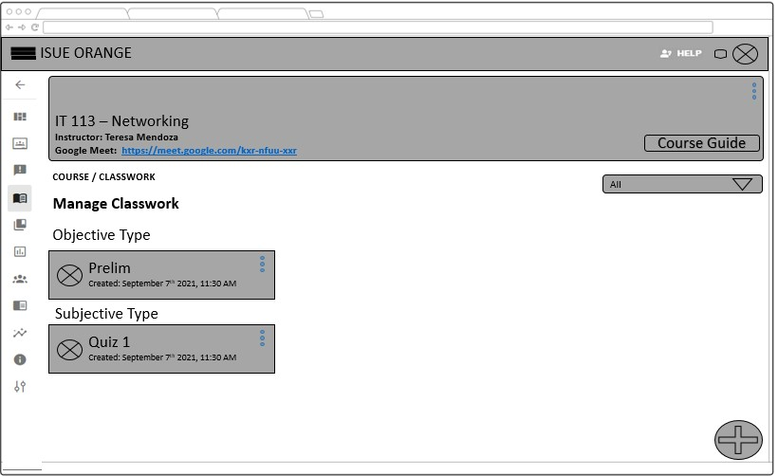

***Figure 12.*** *Classwork*

Figure 12 displays all the classwork’s created and divided into 2 types, subjective type and objective type of classwork. The faculty members are able to create and edit the created classwork and select classwork categories whether the classwork is objective or subjective.

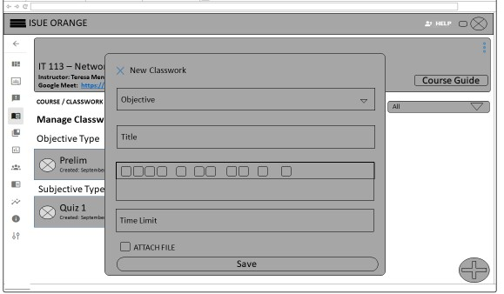

***Figure 13.*** *Classwork Objective Type*

In this figure it shows the “New Classwork'' modal when the button when plus icon is clicked on the bottom right of the page. The faculty members can choose what type of classwork they will use either objective type or subjective type, and for the objective type the faculty members needs to input the title of the classwork, instruction, and the time limit and they can save the classwork to proceed on the creation of questions.

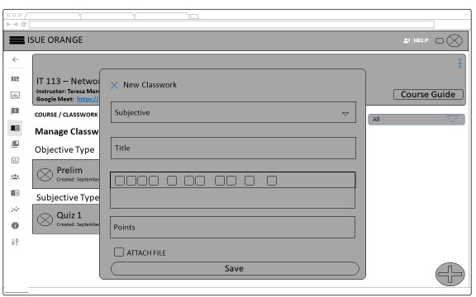

###### **Figure 14.** Classwork Subjective Type

Figure 14 shows the “New Classwork'' modal for the subjective type of classwork when the button when plus icon is clicked on the bottom right of the page, same with the figure 13. For the Subjective type the faculty members needs to input the title of the classwork, the instruction points, and they can also attach a file and save the classwork to proceed on the publishing page.

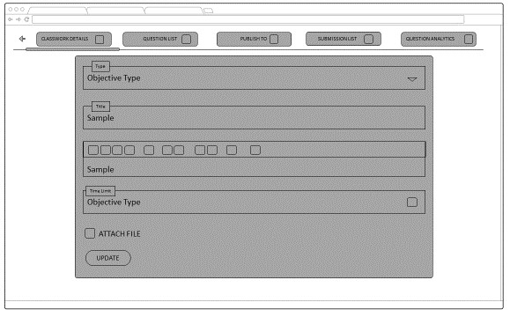

***Figure 15.*** *Classwork Details*

Figure 15 displays the classwork details where the faculty members are able to view and update the details of the classwork such as the title, description, time limit, and the attach file and click update to save the changes.

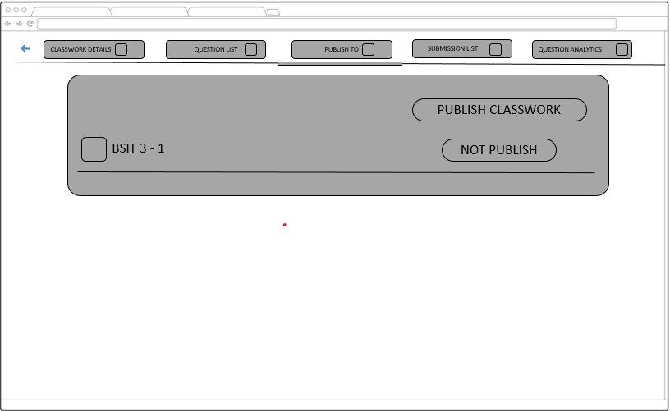

###### **Figure 16.** Objective Type of Classwork Question’s Tab

Figure 16 shows the questions tab on the objective type of classwork where it displays all the lists of questions that are created and this also where the faculty can create questions from different types of questions whether multiple-choice, true or false, identification, and matching type the faculty members can input points per question.

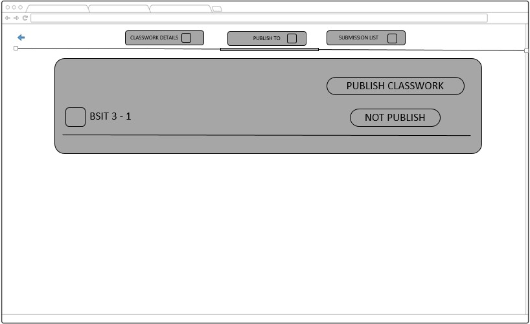

***Figure 17.*** *Classwork’s Publish Tab*

Figure 17 illustrates the publish tab where the faculty members can publish the classwork to all or selective classes that are present in the course. The faculty members can set the date when the classwork will be open and close. The faculty members can set up the setting for the publishing of the classwork.

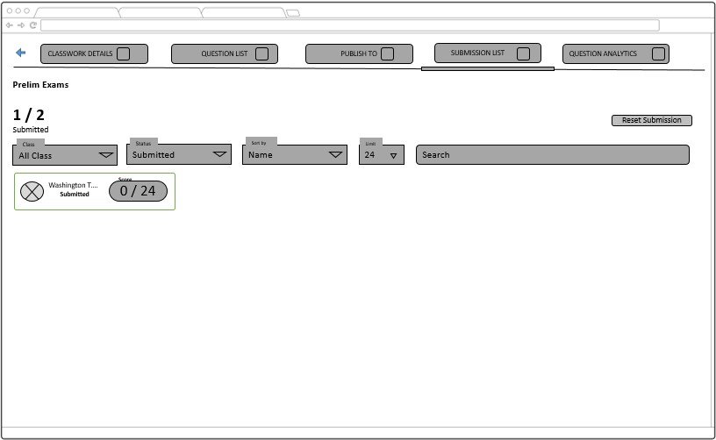

###### **Figure 18.** Objective Classwork Submission List

Figure 18 illustrates the submission list tabs where the faculty members are able to see all the lists of students including their names, status of submissions, and scores. The faculty members can search, filter the submission list by classes, the status of a submission, sort by (name, highest score, and lowest score) and limit the number of students to be shown.

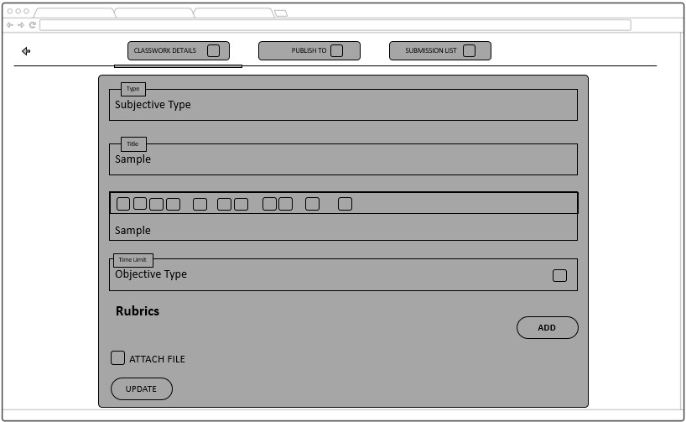

***Figure 19.*** *Subjective Classwork Details Tab*

Figure 19 shows the classwork details on the subjective can be edited and the faculty members can add rubrics to provide more information for students to follow. The faculty members can edit the title, description, time limit of the classwork.



###### **Figure 20.** Subjective Classwork Publish

In this figure the faculty members can publish the classwork within the course and the faculty members can set the date of the classwork when to start and when does the classwork end.

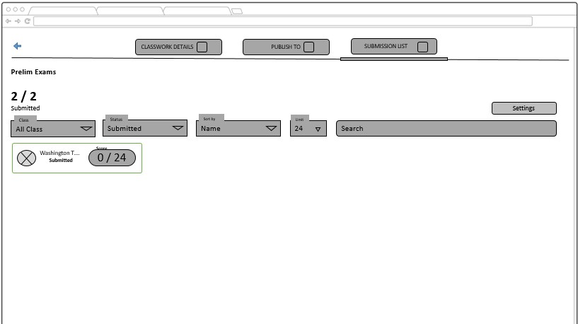

***Figure 21.*** *Subjective Classwork Submission List*

In this figure the faculty members can view who and how many learners have taken the classwork they publish; they can sort the viewing by class, Status, Sort by, and limit.

They can also search for the name of the person they want to check.

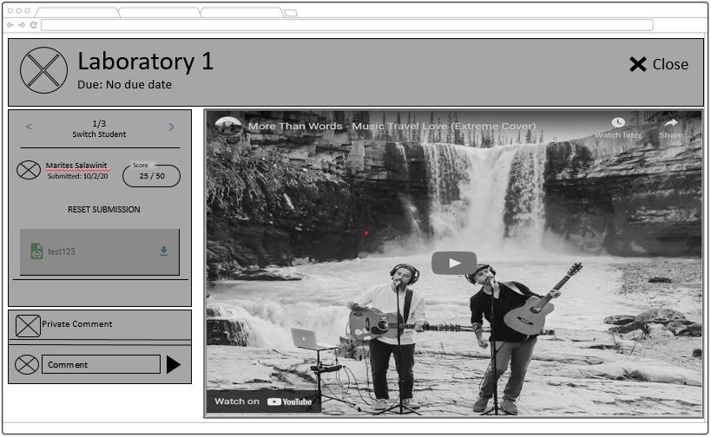

***Figure 22****. Subjective Submission Checking*

This figure shows the student’s submission on the subjective type of classwork. The faculty members are able to view the student’s submitted attachments and add the student’s scores. It also shows the date and time of submission and comments which faculty members are also able to insert a comment on the submission of the students. The faculty members can also reset the students' submissions on this page.

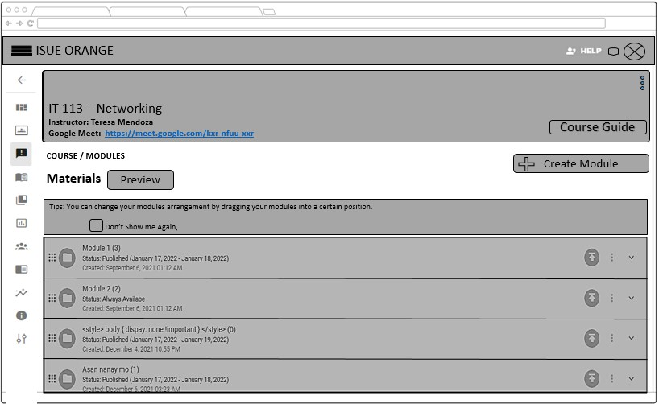

***Figure 23.*** *Modules*

Figure 23 shows the modules page for the faculty members where they are able to view all the modules and their contents. The faculty members can create a module/folder and add items inside the module/folder. Faculty members are also able to publish or unpublished their classwork and they can set a date when it will be available.

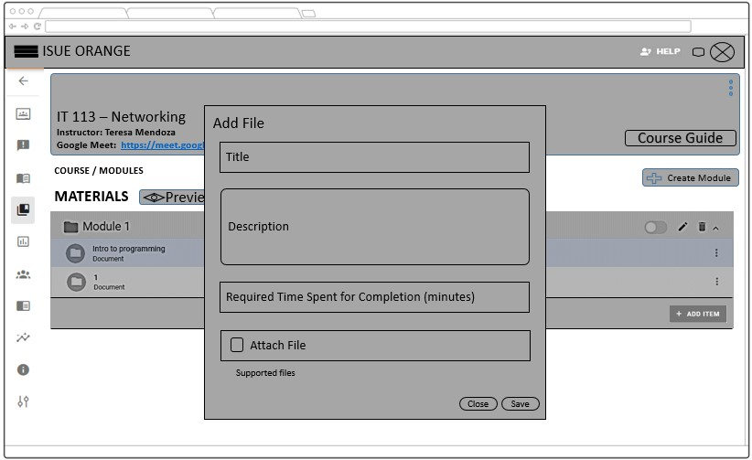

***Figure 24****. Add Learning Materials*

To add learning materials the faculty members needs to click the add item below the folder and a modal will pop up and add the file the faculty members needs to add title, description, the required time to spend reading the learning materials and to attach the learning materials they need. And click save.

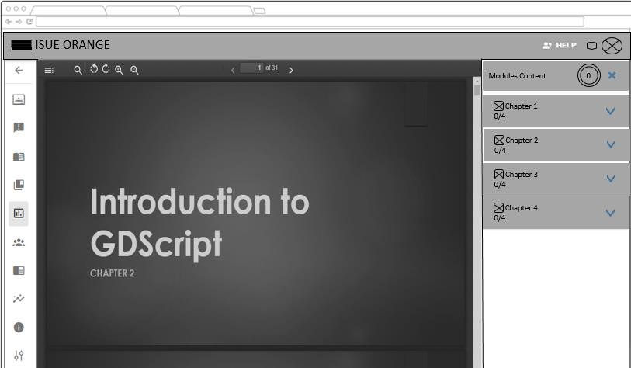

***Figure 25.*** *Module Preview*

In this figure the faculty member’s can preview the learning materials they upload and the format style. On this page, the faculty members can also see the percentage of the overall learning materials and peer learning materials. It will show the required time spent that the faculty members inputted.

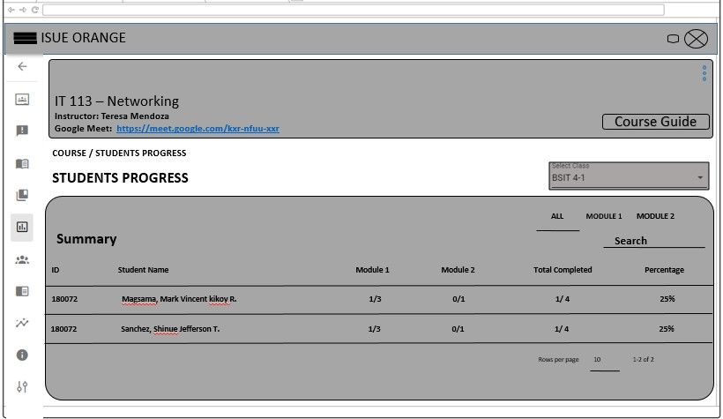

###### **Figure 26.** Student Progress Overall

In this figure the faculty members can view the progress of the learners upon reading the learning materials that the faculty members published, it will show what the learning materials that the student accomplished are or finished already, the faculty members can also view the overall completed and percentage of the learners.

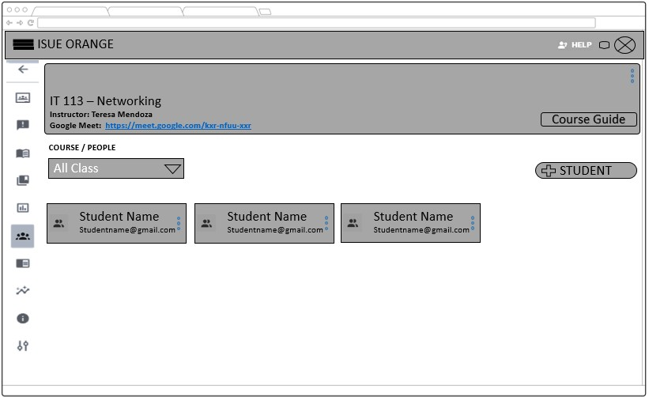

***Figure 27.*** *Students’ Progress Module*

Figure 27 displays that the faculty members can view the reading progress of their student. If the indicator below the specific learning material it means the learner finished the required spent time on reading that learning material and if red it means the reader hasn't met the certain condition or the required spent time on reading the learning materials.

And the faculty members can view the total computed time of learners spent.

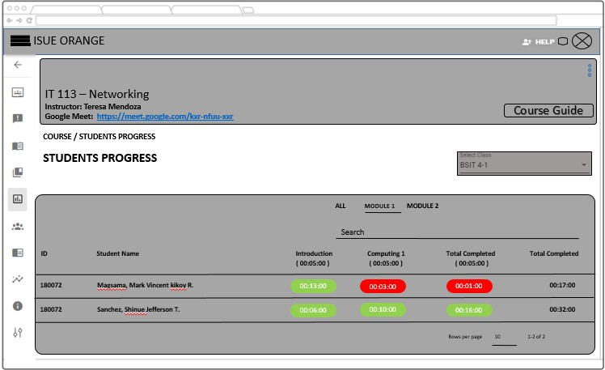

***Figure 28.*** *People*

In this figure shown the faculty members can view the class list in their respective classes the faculty members can also sort the arrangement and then remove certain learners that don’t belong in the Master list.

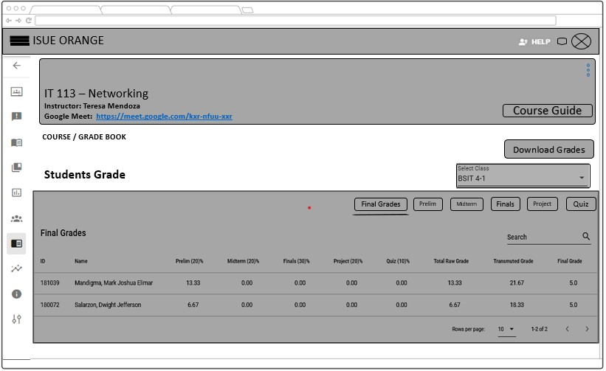

***Figure 29.*** *Faculty Grading Records*

In this figure the faculty member can view all the grades of the learners from what the faculty members inputted in the grading criteria. The faculty members can also view the grades per class and view it per category such as prelim, midterm, etc. the faculty members can also download the grading sheet and export it to excel.

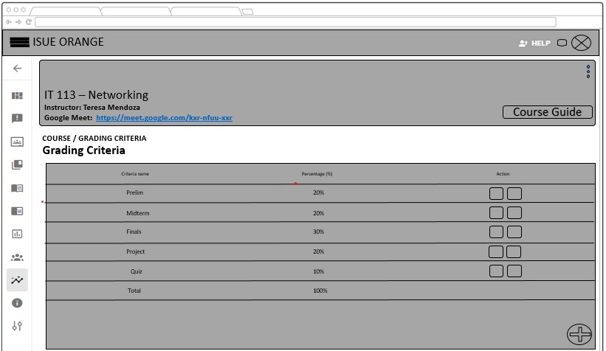

***Figure 30.*** *Grading Criteria*

In this figure the faculty members can edit and delete a certain category to their choice. The faculty members can add another criterion as long the total percentage doesn’t

meet/ the total percentage is 100%.

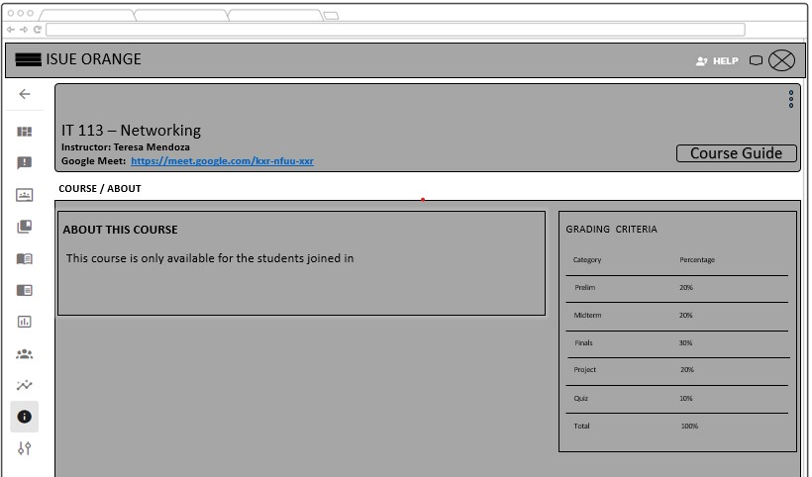

***Figure 31.*** *About Course*

In this figure the faculty members can edit their about Course and input the course guide or course description, the faculty members can also view the grading criteria they created.

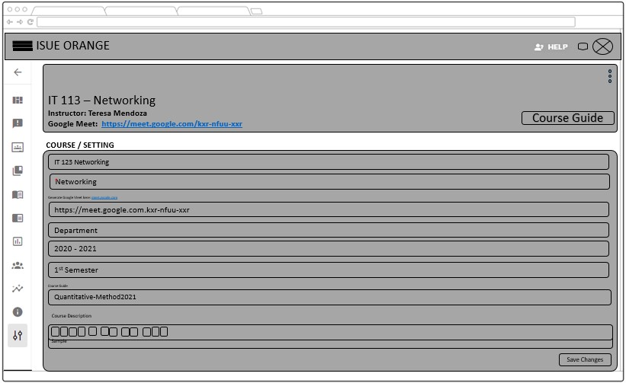

***Figure 32****. Settings*

In this figure the faculty members can view, edit and update their Course Setting, the faculty members can input the Course code, Course name, and Google meet link,

Department, Year, semester, the course guide, and the course description.

### 3.2 Technical Background (Project Framework)

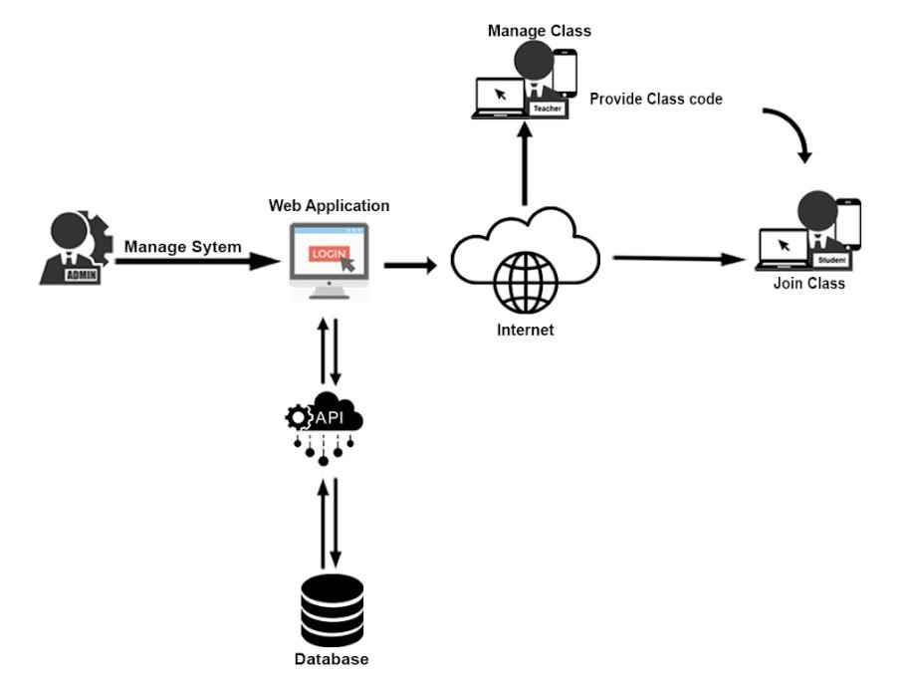

###### **Figure 33.** Project Framework of the Project

Figure 33 depicts the various components of the framework in which the technology is employed. Within the framework, each component performs a distinct function. The following components are listed below with their specific functions.

1. **Administrator**: The Administrator oversees managing both faculty

members and students as well as creating and deleting accounts. They are the ones in charge of the database and other system resources.

1. **Faculty member/s**: They are the ones in charge of creating classes and sharing the class code within the class list, as well as posting announcements, classwork, modules, and reviewing their students’ progress. They can also see the question analytics for more information.
2. **Student/s:** They are in charge of joining the class, viewing class information, taking quizzes and exams, and viewing their progress in both classes and reading learning materials. They also track scores and grades.
3. **Mobile and Computer Devices:** This is the system's interface with the users (learners and faculty members). The user uses a web browser such as Google Chrome, Firefox, or Internet Explorer to view and access the system's webpage**.**
4. **Internet:** The system is a web-based system with a mobile-first approach. It can be accessed through the web and mobile devices of its users with the aid of the internet. Users cannot access and view the system's web page unless they have an internet connection and a valid account. Users can send and receive information via the internet.
5. **Server:** The server handles the users' requests and responses. It is in charge of matching the provided data into the database. If the request matches a record in the database, it will be processed again by the server and send the match data to the user. If the request does not match the database, it will send a notification to the server, which will then send the result to the user via the notification. The user then views the server's response from the database via the user's devices.

### 3.3 Data, Software, and Hardware Specification

The following was a detailed discussion of the different technologies used by the proponents for the development of the "Isabela State University Echague Online Resources App for a New Guild of Education (ISUE ORANGE)".

3.3.1 Software

3.3.1.1 Front-end

**Vue.js -** Vue.js is a progressive framework for JavaScript used to build web interfaces and single-page applications. This framework was used by the researchers in different perspectives, like the overall interface of the system, such as the Login, Landing Webpage, Grading System, Admin, and etc. The proponents chose this kind of framework for a clean and better interface for the proposed system.

3.3.1.2 Back-end

**Laravel** - Laravel is a web application framework with expressive and elegant syntax. Accessible yet powerful, providing powerful tools needed for large, robust applications. The proponents used this for superb inversion of control containers, expressive migration systems, and tightly integrated unit testing support, giving the proponents the tools, they needed to build the proposal with which they were tasked.

**MySQL** - MySQL is an open-source relational database management system. As with other relational databases, MySQL stores data in tables made up of rows and columns. Users can define, manipulate, control, and query data using Structured Query Language, more commonly known as SQL. The researchers used MySQL as the database

management system to store data (assignments, class works, etc.).

3.3.1.3 Development Tools

**Github** - GitHub is a code-hosting platform for version control and collaboration. The researchers used this software/tool to let us work together on projects from anywhere, with real-time collaboration, tracking changes to the codes, and maintaining a useful list with the latest version, 2.19.12.

**Visual Studio Code** - Visual Studio Code is a source-code editor made by Microsoft for Windows, Linux, and macOS. It is used to develop computer programs, as well as websites, web apps, web services, and mobile apps. The researchers used Visual Studio Code version 1.63. This software/tool was used for creating the proposed system and supporting it with debugging, syntax highlighting, intelligent code completion, snippets, code refactoring, and embedded Git.

**Postman** - Postman is an API platform for building and using APIs. The researchers used Postman version 9.0. This tool was used for API testing of the proposed system and used to check if the output was well structured, reliable, and returned the correct responses.

**3.3.2 Hardware.**

###### **Table 1.** Hardware Specifications

|  |  |
| --- | --- |
| **Devices and Equipment** | **Specification** |
| Laptops/Desktop-Set | * Intel Core i3 3.70 GHz Processor -   Higher   * RAM: 4GB, - Higher * Storage: Internal Storage: 1TB – higher |
| Mobile/Smart Phones | * (Android) Kit-Kat version and   Higher  4GB 32GB RAM and Higher     * IO/S 10.0.1, version and Higher   3GB 32GB RAM and Higher |
| Internet Connections | ● 3 Megabits per second (Mbps) and  Higher |
| Browser | * Google Chrome (Version   96.0.4664.110).   * Opera (Version 82.0.4227.43) * Firefox (Version 95.0.2) * Microsoft Edge (Version   96.0.1054.62) |

Table 1 shows the devices and equipment in the list. These are the minimum requirements and specifications to make full use of the system upon using the system on different devices.

###### **Table 2.** Infrastructure Specification

|  |  |  |
| --- | --- | --- |
| **Cloud Infrastructure** | **Specification** | **Cost** |
| Cloud Server  (Subscription to  Digital Ocean) | * CPU: Intel(R) Xeon(R)   Gold 6140 CPU @  2.30GHz   * RAM: 8GB, * Storage: 50 GB | 63,000.00/Year |
| Cloud Storage  (Subscription) | ● 250 GB | 4,000.00/Year |
| Domain  (Subscription) | ● GoDaddy | 2,000.00/Year |
| Secured Socket Layer | SHA-2 Encryption | 0 |
| **Total Cost** | | **69,000.00/Year** |

Table 2 shows the present server infrastructure specification. These descriptions are the core processors and storage of the cloud server that has been purchased and used on 1st semester of the College of Computing Studies in Information Communication Technology.

**Digital** **Ocean -** the proponents used this cloud computing because it was easy to use, low cost, and was recommended to us by our technical adviser. And this provides scalability, reliability, adaptability, and centralizes collaboration.

**3.3.3 Data**

The following discusses the technology used in storing the data for the system. In this study, the technology that researchers used in storing data on the system was MySQL. This technology assisted the researchers in storing various types of data that end-users store upon using the system.

The name of the database is “**capstonesdb”**, with a table that consists of different fields, rows and columns, or so-called tuples named tbl_choices, tbl_class_announcements, tbl_class_classworks, tbl_classes, tbl_classposts, tbl_classworks, tbl_comments, tbl_departments, tbl_join_requests, tbl_likes, tbl_main_grade_categories, tbl_main_modules, tbl_notifications, tbl_question_analytics, tbl_questions, tbl_schoolyears, tbl_semesters, tbl_student_course_subject_grades, tbl_student_exam_activity_logs, tbl_sub_modules, tbl_student_main_grades, tbl_sub_questions, tbl_subject_courses, tbl_subjective_rubrics, tbl_submissions, tbl_submitted_answers, tbl_teacher_courses, tbl_user_departments, tbl_user_details, tbl_userclasses, user_notifications, users, websockets_statistics_entries, activity_log, failed_jobs, jobs, migrations, password_resets, personal_access_tokens, sessions.

**Data Dictionary**

***Table 3.*** *users*

|  |  |  |  |  |
| --- | --- | --- | --- | --- |
| **KEY** | **Field Name** | **Description** | **Field Type** | **Length** |
| PK | id | Auto increment user id | BIGINT |  |
|  | email | Email of the user | VARCHAR | 255 |
|  | password | Password of the user | VARCHAR | 255 |
|  | role | Role of the user | VARCHAR | 255 |
|  | device_key | user device key | VARCHAR | 255 |

###### **Table 4.** tbl_user_details

|  |  |  |  |  |
| --- | --- | --- | --- | --- |
| **Key** | **Field Name** | **Description** | **Field Type** | **Length** |
| PK | id | Auto increment user additional details id | BIGINT |  |
| FF | user_id | User id of the user | BIGINT |  |
|  | firstName | First Name of the user | VARCHAR | 255 |
|  | middleName | Middle Name of the user | VARCHAR | 255 |
|  | lastName | Last Name of the user | VARCHAR | 255 |
|  | student_id | Student Id Number | INT |  |
|  | address | Address of the user | VARCHAR | 255 |
|  | cp_no | Cellphone Number of user | INT |  |
|  | profile_pic | Profile Picture of user | VARCHAR | 255 |

###### **Table 5**. tbl_userclasses

|  |  |  |  |  |
| --- | --- | --- | --- | --- |
| **Key** | **Field Name** | **Description** | **Field Type** | **Length** |
| PK | id | Auto increment user class id | BIGINT |  |
| FK | class_id | Class id of class | BIGINT |  |
| FK | user_id | User id of the user | BIGINT |  |
| FK | course_id | Course id of the course | BIGINT |  |
|  | progress | Class progress | INT |  |

###### **Table 6.** tbl_teacher_courses

|  |  |  |  |  |
| --- | --- | --- | --- | --- |
| **Key** | **Field Name** | **Description** | **Field Type** | **Length** |
| PK | id | Auto increment teacher courses id | BIGINT |  |
| FK | user_id | User of id of user | BIGINT |  |
| FK | course_id | Course id of the course | BIGINT |  |

###### **Table 7.** tbl_subject_courses

|  |  |  |  |  |
| --- | --- | --- | --- | --- |
| **Key** | **Field Name** | **Description** | **Field Type** | **Length** |
| PK | id | Auto increment course id | BIGINT |  |
|  | class_name | Class Name | VARCHAR | 255 |
|  | class_code | Class Code | VARCHAR | 255 |
| FK | course_id | Course Id of course | BIGINT |  |
|  | meeting_link | Class Virtual Meet Link | VARCHAR | 255 |
|  | schedule | Class Schedule | MEDIUMTEXT |  |
|  | is_auto_accept | Class Joining Status | BOOLEAN | 1 |

###### **Table 8.** tbl_classes

|  |  |  |  |  |
| --- | --- | --- | --- | --- |
| **Key** | **Field Name** | **Description** | **Field Type** | **Length** |
| PK | id | Auto increment class id | BIGINT |  |
|  | course_code | Course Code | VARCHAR | 255 |
|  | course_name | Course Name | VARCHAR | 255 |
|  | v_classroom_link | Virtual Meet Link | VARCHAR | 255 |
|  | course_description | Course Description | MEDIUMTEXT |  |
|  | course_picture | Course Picture | MEDIUMTEXT |  |
|  | completed | Course Status | BOOLEAN | 1 |
| FK | semester_id | Semester Id | BIGINT |  |
| FK | school_year_id | School Year Id | BIGINT |  |
|  | course_guide | Course Guide | MEDIUMTEXT |  |

###### **Table 9.** tbl_classposts

|  |  |  |  |  |
| --- | --- | --- | --- | --- |
| **Key** | **Field Name** | **Description** | **Field Type** | **Length** |
| PK | id | Auto increment class post id | BIGINT |  |
| FK | user_id | Id post owner | BIGINT |  |
| FK | course_id | Id of the course where post belongs | BIGINT |  |
| FK | class_id | Id of class where post will be posted | BIGINT |  |
| FK | announcement_id | Id of the announcement details | BIGINT |  |

###### **Table 10.** tbl_announcements

|  |  |  |  |  |
| --- | --- | --- | --- | --- |
| **Key** | **Field Name** | **Description** | **Field Type** | **Length** |
| PK | id | Auto increment announcement id | BIGINT |  |
|  | content | Content of the announcement | MEDIUMTEXT |  |

###### **Table 11.** tbl_comments

|  |  |  |  |  |
| --- | --- | --- | --- | --- |
| **Key** | **Field Name** | **Description** | **Field Type** | **Length** |
| PK | id | Auto increment comments id | BIGINT |  |
| FK | post_id | Id post where the comments belong. | BIGINT |  |
| FK | classwork_id | Id of the classwork that is commented | BIGINT |  |
| FK | user_id | Id of class where post will be posted | BIGINT |  |
|  | to_user | Id of user where the specific comment belongs to. | BIGINT |  |
| FK | course_id | Id of the course where comments post or classwork belongs. | BIGINT |  |
|  | type | Type of comment classwork comment or Post comment | VARCHAR | 15 |
|  | content | Content of the comment. | MEDIUMTEXT |  |

###### **Table 12.** tbl_classworks

|  |  |  |  |  |
| --- | --- | --- | --- | --- |
| **Key** | **Field Name** | **Description** | **Field Type** | **Length** |
| PK | id | Auto increment classwork id | BIGINT |  |
| FK | course_id | Id course where the classwork belongs | BIGINT |  |
| FK | user_id | Id of the user who create the classwork | BIGINT |  |
|  | type | Type of classwork | VARCHAR | 55 |
|  | title | Title of the classwork | VARCHAR |  |
|  | instruction | Instruction of the classwork | MEDIUMTEXT |  |
|  | attachment | Attachment file of the classwork | MEDIUMTEXT |  |
|  | attachment_name | Name of the Attachments | VARCHAR | 255 |
|  | attachment_size | Size of the attachment | VARCHAR | 15 |
|  | duration | Duration of classwork if objective type | INT |  |
|  | points | Points of the classwork | INT |  |

###### **Table 13.** tbl_class_classworks

|  |  |  |  |  |
| --- | --- | --- | --- | --- |
| **Key** | **Field Name** | **Description** | **Field Type** | **Length** |
| PK | id | Auto increment id of posted classwork in each class id | BIGINT |  |
| FK | class_id | Id class where the classwork in publish | BIGINT |  |
| FK | classwork_id | Id of the classwork | BIGINT |  |
|  | availability | Availability of the classwork | BOOLEAN | 1 |
|  | from_date | Starting date of classwork | TIMESTAMP |  |
|  | to_date | End date or Due date of the classwork | TIMESTAMP |  |
|  | reviewAnswer | Review Answer | BOOLEAN | 1 |
|  | ShowAnswerType | Show Type of Answer | BOOLEAN | 1 |
|  | ShowDateFrom | Date where Answer will start to show | TIMESTAMP |  |
|  | ShowDateTo | Date where Answer will end to show | TIMESTAMP |  |
|  | response_late | Check if the user is allowed late to submit. | BOOLEAN | 1 |
| FK | grading_criteria_id | Grading Criteria where classwork belongs to. | BIGINT |  |

###### **Table 14.** tbl_main_modules

|  |  |  |  |  |
| --- | --- | --- | --- | --- |
| **Key** | **Field Name** | **Description** | **Field Type** | **Length** |
| PK | id | Auto increment id of modules | BIGINT |  |
| FK | course_id | Id course where the modules is belonged | BIGINT |  |
|  | isPublished |  | INT |  |
| FK | created_by | User id of the user who created the module | BIGINT |  |
|  | module_name | Name of module | VARCHAR | 255 |
|  | description | Short description about the module | VARCHAR | 255 |
|  | position | Position of module in arrangement of modules | INT |  |
|  | date_from | Date where the module will be available | TIMESTAMP |  |
|  | date_to | Date where module will not be available | TIMESTAMP |  |

***15.*** *tbl_sub_modules*

|  |  |  |  |  |
| --- | --- | --- | --- | --- |
| **Key** | **Field Name** | **Description** | **Field Type** | **Length** |
| PK | id | Auto increment id of sub modules | BIGINT |  |
| FK | main_module_id | Id of main modules where this sub module belongs | BIGINT |  |
|  | sub_module_name | Name of the sub modules | VARCHAR | 255 |
|  | description | Description about this sub module | MEDIUMTEXT |  |
|  | type | Type of this sub module, video, docx, ppt, etc. | VARCHAR | 255 |
|  | required_time | The required for the user to read the module | VARCHAR | 255 |
|  | file_attachment | The file attachment of the sub module | VARCHAR | 255 |
|  | link | Link attachment of the module. | VARCHAR | 255 |

###### **Table 16.** tbl_questions

|  |  |  |  |  |
| --- | --- | --- | --- | --- |
| **Key** | **Field Name** | **Description** | **Field Type** | **Length** |
| PK | id | Auto increment id of questions | BIGINT |  |
| FK | classwork_id | Id of classwork where this question belongs | BIGINT |  |
|  | question | Question details | MEDIUMTEXT |  |
|  | answer | Answer for the question | MEDIUMTEXT |  |
|  | type | Type of the question, multiple choice, identification, true or false or matching type | VARCHAR | 55 |
|  | points | Points of the question | INT |  |
|  | sensitivity | Case sensitivity of the answer to the question | BOOLEAN | 1 |
|  | required | Required for the answer must not be null | BOOLEAN | 1 |

###### **Table 17. tbl**_sub_questions

|  |  |  |  |  |
| --- | --- | --- | --- | --- |
| **Key** | **Field Name** | **Description** | **Field Type** | **Length** |
| PK | id | Auto increment id of sub questions | BIGINT |  |
| FK | mainQuestion_id | Id of the main question where this question belongs | BIGINT |  |
| FK | answer_id | id of answer to this sub question | BIGINT |  |
|  | sub_question | Question details | MEDIUMTEXT |  |

###### **Table 18.** tbl_choices

|  |  |  |  |  |
| --- | --- | --- | --- | --- |
| **Key** | **Field Name** | **Description** | **Field Type** | **Length** |
| PK | id | Auto increment id of sub questions | BIGINT |  |
| FK | question_id | Id of the question where this choice belongs | BIGINT |  |
|  | Choice | Choice details | MEDIUMTEXT |  |
|  | isDestructor | If a choice is belonging to destructor of matching type question. | BOOLEAN | 1 |

###### **Table 19.** tbl_submissions

|  |  |  |  |  |
| --- | --- | --- | --- | --- |
| **Key** | **Field Name** | **Description** | **Field Type** | **Length** |
| PK | id | Auto increment id of submissions | BIGINT |  |
| FK | classwork_id | Id of classwork that this submission is for | BIGINT |  |
|  | class_classwork_id | Id where this classwork where it published | BIGINT |  |
| FK | user_id | Id of the user who make this submission | BIGINT |  |
|  | submitted_answers | The Submitted Answer of the user | MEDIUMTEXT |  |
|  | rubrics_score | The Score on rubrics of submission of student | MEDIUMTEXT |  |
|  | score | The score of the submission of the user | INT |  |
|  | graded | The status if submission already checked | BOOLEAN | 1 |
|  | status | The status if user submitted or not | VARCHAR | 55 |
|  | submission_time | The time the user submitted | TIMESTAMP |  |

###### **Table 20.** tbl_student_exam_activity_logs

|  |  |  |  |  |
| --- | --- | --- | --- | --- |
| **Key** | **Field Name** | **Description** | **Field Type** | **Length** |
| PK | id | auto increment id of exam activity logs | BIGINT |  |
| FK | student_id | Id of student who are taking the classwork | BIGINT |  |
| FK | classwork_id | Id of classwork the student is taking | BIGINT |  |
|  | description | Description of the activity the student does during examination | VARCHAR | 255 |

***21*.** *tbl_subjective_rubrics*

|  |  |  |  |  |
| --- | --- | --- | --- | --- |
| **Key** | **Field Name** | **Description** | **Field Type** | **Length** |
| PK | id | auto increment id of rubrics | BIGINT |  |
| FK | classwork _id | Id of classwork where this rubric criterion belongs | BIGINT |  |
|  | criteria_name | Name of the rubrics criteria | VARCHAR | 255 |
|  | description | Description about these criteria | VARCHAR | 255 |
|  | points | Point for these criteria | INT |  |

###### **Table 22.** tbl_notifications

|  |  |  |  |  |
| --- | --- | --- | --- | --- |
| **Key** | **Field Name** | **Description** | **Field Type** | **Length** |
| PK | id | auto increment id of notification | BIGINT |  |
| FK | course _id | Id of course where this notification come from | BIGINT |  |
| FK | class_id | Id of class where this notification comes from | BIGINT | 255 |
| FK | from_id | Id of user who created this notification | BIGINT | 255 |
|  | user_id_to | Id of user where notification will be seen | BIGINT |  |
|  | message | Message of notification | VARCHAR | 255 |
|  | notification_attachment | Attachment of notification | VARCHAR | 255 |
|  | notification_type | Type of the notification | VARCHAR | 255 |

###### **Table 23**. tbl_ user_notifications

|  |  |  |  |  |
| --- | --- | --- | --- | --- |
| **Key** | **Field Name** | **Description** | **Field Type** | **Length** |
| PK | id | Auto increment id of user notification | BIGINT |  |
| FK | notification_id | Id of the notification | BIGINT |  |
| FK | user_id | User id of the user who mark as read the notification | BIGINT |  |
|  | status | Status of notification id read or not | BOOLEAN | 1 |
|  | hide_notification | Hide notification if see of hidden | BOOLEAN | 1 |

###### **Table 24.** tbl_departments

|  |  |  |  |  |
| --- | --- | --- | --- | --- |
| **Key** | **Field Name** | **Description** | **Field Type** | **Length** |
| PK | id | Auto increment id of department | BIGINT |  |
|  | abbreviation | The Short name of the department | VARCHAR | 55 |
|  | name | The complete name of the department | VARCHAR | 255 |
|  | logo | Logo of the department | VARCHAR | 255 |

###### **Table 25.** tbl_schoolyears

|  |  |  |  |  |
| --- | --- | --- | --- | --- |
| **Key** | **Field Name** | **Description** | **Field Type** | **Length** |
| PK | id | Auto increment id of school year id | BIGINT |  |
|  | shoolyear | School Year | VARCHAR | 255 |

###### **Table 26.** tbl_semesters

|  |  |  |  |  |
| --- | --- | --- | --- | --- |
| **Key** | **Field Name** | **Description** | **Field Type** | **Length** |
| PK | id | Auto increment id of semester id | BIGINT |  |
|  | semester | Semester | VARCHAR | 255 |

###### **Table 27.** tbl_user_departments

|  |  |  |  |  |
| --- | --- | --- | --- | --- |
| **Key** | **Field Name** | **Description** | **Field Type** | **Length** |
| PK | id | Auto increment id of department id | BIGINT |  |
| FK | user_id | Id of the user | BIGINT |  |
| FK | department_id | Id of the department | BIGINT |  |

###### **Table 28**. tbl_join_requests

|  |  |  |  |  |
| --- | --- | --- | --- | --- |
| **Key** | **Field**  **Name** | **Description** | **Field Type** | **Length** |
| PK | id | Auto increment id of department id | BIGINT |  |
| FK | user_id | Id of the user | BIGINT |  |
| FK | course_id | Id of the course where the class belong that the user wants to join. | BIGINT |  |
|  | class_id | Id of the class | BIGINT |  |

*29*. *tbl_likes*

|  |  |  |  |  |
| --- | --- | --- | --- | --- |
| **Key** | **Field**  **Name** | **Description** | **Field Type** | **Length** |
| PK | id | Auto increment id of department id | BIGINT |  |
| FK | course_id | Id of the course where the like post belongs | BIGINT |  |
| FK | post_id | Id of the class post that the user mark like | BIGINT |  |
|  | user_id | Id of the user | BIGINT |  |

###### **Table 30**. tbl_main_grade_categories

|  |  |  |  |  |
| --- | --- | --- | --- | --- |
| **Key** | **Field**  **Name** | **Description** | **Field Type** | **Length** |
| PK | id | Auto increment id of department id | BIGINT |  |
| FK | course_id | Id of the course where this grading criteria belongs | BIGINT |  |
|  | name | Name of this grading criteria | VARCHAR | 255 |
|  | percentage | Percentage of this criteria | DOUBLE |  |

###### **Table 31**. Sessions

|  |  |  |  |  |
| --- | --- | --- | --- | --- |
| **Key** | **Field Name** | **Description** | **Field Type** | **Length** |
| PK | id | Id of the session the user made | VARCHAR | 255 |
| FK | user_id | Id of the user who made the session | BIGINT |  |
|  | ip_address | Ip address where the user logged in | VARCHAR | 45 |
|  | user_agent | The browser of the user | TEXT |  |
|  | payload |  | TEXT |  |
|  | last_activity | Last activity of the user | INT |  |
|  | last_date | Last date the user make session | TIMESTAMP |  |

###### **Table 32**. activity_log

|  |  |  |  |  |
| --- | --- | --- | --- | --- |
| **Key** | **Field Name** | **Description** | **Field Type** | **Length** |
| PK | id | auto increment activity id | BIGINT |  |
|  | log_name | Name of the activity log | VARCHAR | 255 |
|  | description | Description of the log | TEXT |  |
|  | subject_type | Type of the activtity | VARCHAR | 255 |
|  | event |  | VARCHAR | 255 |
|  | subject_id | Id of the subject of the activity | BIGINT |  |
|  | courser_type | Type of the cause of the activity | VARCHAR | 255 |
| FK | courser_id | Id of the user who created the activity log | BIGINT |  |
|  | properties | Proterties of log | JSON |  |
|  | batch_uuid |  | CHAR | 36 |

Every table serves as a storage location for different types of information that users input or store while using the system. The data and information that end-users store in the system will be chopped and categorized by how the program codes run. These fields are linked to one another. such as users is connected to faculty member course, connected to main grade categories, subject course, users details, users classes, connected to the class, users departments, departments, main modules, classwork, connected to question, submissions, class classwork’s submission subjective rubrics, and the other tables that are connected to users are comments, likes, school year, class announcement, semester, class post, notification, users notification, and join request these tables are connected through using primary and foreign keys. This helps the researchers connect 1 column to another column, Or from one to one, one to many, and many to many.

### 3.4 Functional Decomposition Diagram

The proponents used a technique called the Functional Decomposition Diagram to show how a computer works. FDD takes something complicated and simplifies it. A process and its hierarchical relationships to each other were usually displayed, and it isolates the processes and shows the data inputs, outputs, and data stores or sources of information. The objective of the function of the system for which logic was specified.

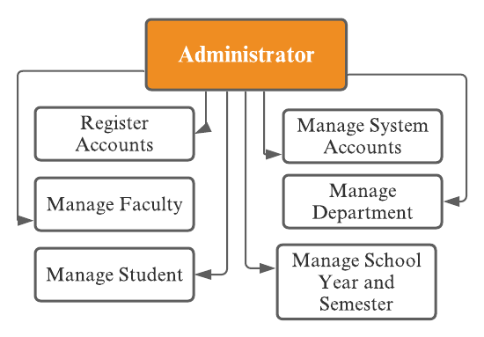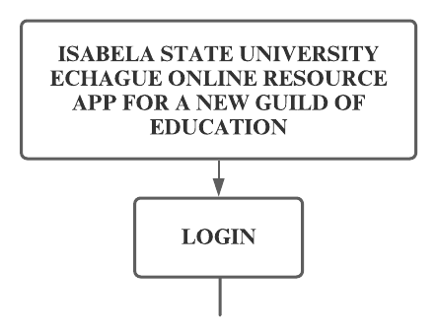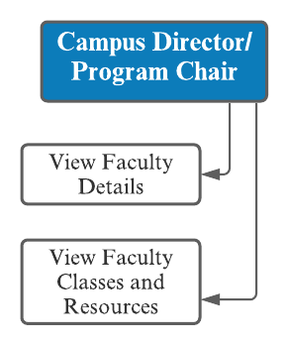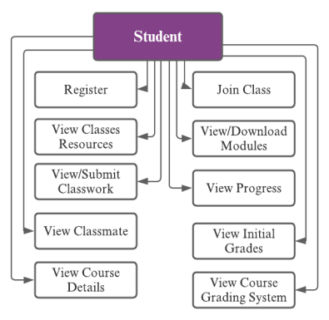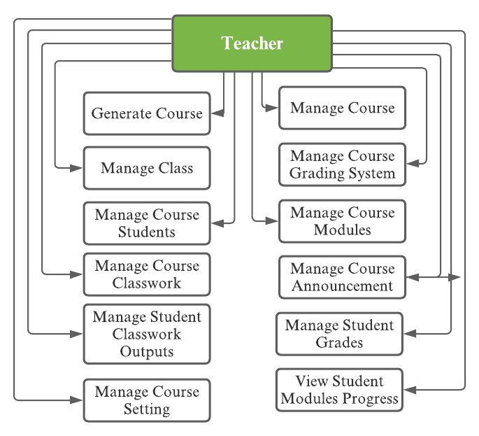

**Ad**

**m**

**in**

**istrator**



**Campus Director /**

**Progra**

**m**

**Chair**



**Student**



**Faculty**

**Member**

***Figure 34****. Functional Decomposition Diagram*

The proponents used the Functional Decomposition Diagram a diagram used in project analysis to show the Administrators, Faculty members, Students, and Campus director/Program Chair functional requirements for every component in the system. In the process, their hierarchical relationship to each other was commonly displayed and isolates the processes, it showed no data inputs, outputs, data stores, or sources of information. The primary objective of FDD was to show the functions of the system for which logic was specified.

### 3.5 Data Flow Diagram (Zero Diagram)

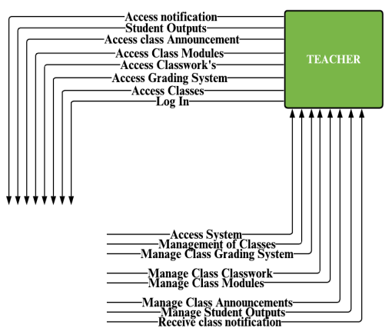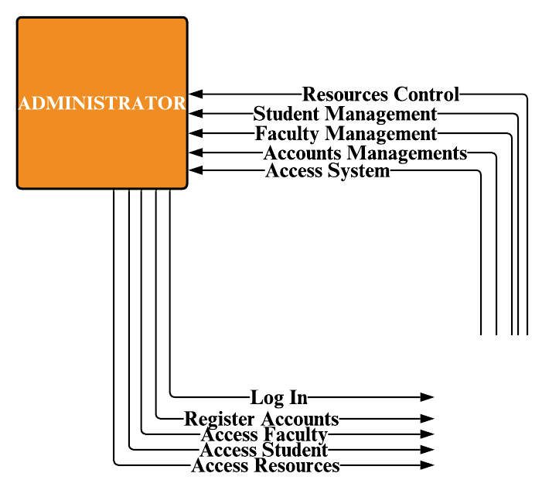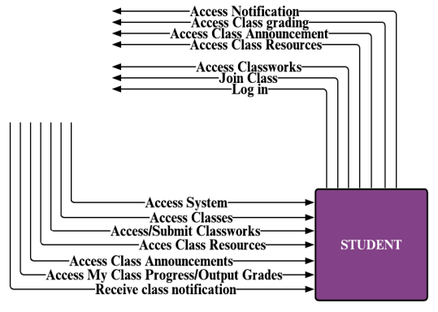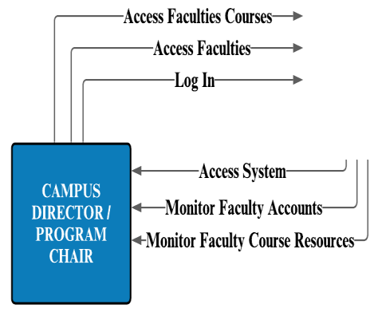

**ADMINISTRATOR**

**FACULTY**

**MEMBERS**

**CAMPUS**

**DIRECTOR /**

**PROGRAM CHAIR**

**STUDENT**

***Figure 35.*** *Zero Diagram or Context Diagram*

Figure 35 illustrates the zero or Context diagram of the Created Unified Learning

Management System coined ISUE ORANGE, which is composed of four types of users: Administrators, Faculty members, Students, and Campus director/Program Chair demonstrating separate sharing of knowledge among such four types of users.

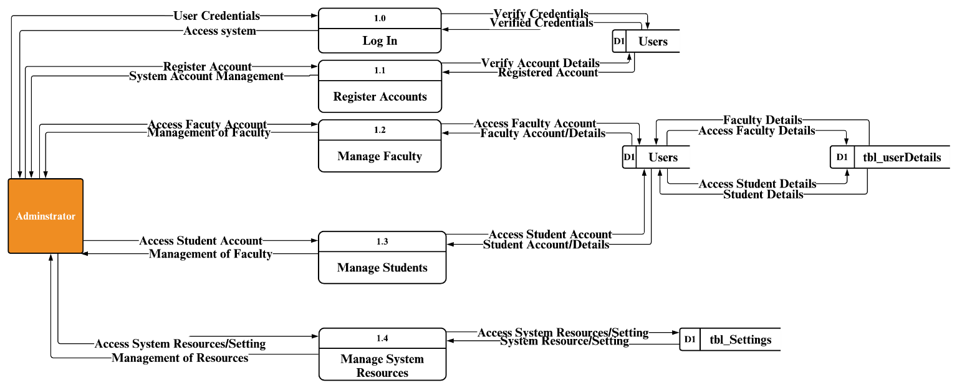

**Administrator**

###### **Figure 36.** Data Flow Diagram of Administrator

Figure 36 illustrates the extended data flow diagram for the Administrator side.

Administrators can access different users’ accounts such as faculty, students, systems resources, announcements, classes, classwork in different classes, and grading system. It contains all the Administrator's data analysis and the system's operation or input in response to the Administrator's demand.

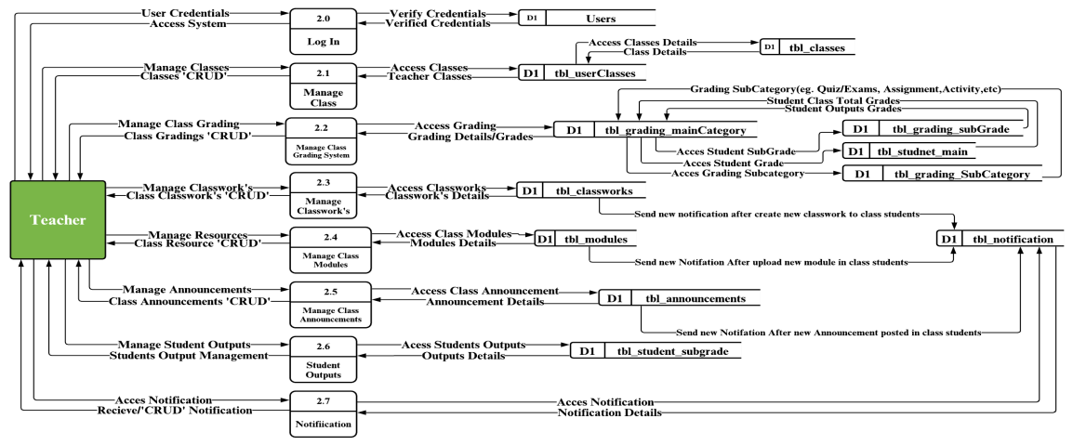

**Faculty**

***Figure 37.*** *Data Flow Diagram of Faculty member*

Figure 37 illustrates the extended data flow diagram for the Faculty member side. Where a faculty members has more privilege to manage class input and output. It allows faculty members to access different fields to view and manage the input and output of their students. It contains all the faculty members's data analysis and the system's operation or input in response to the faculty members's demand.

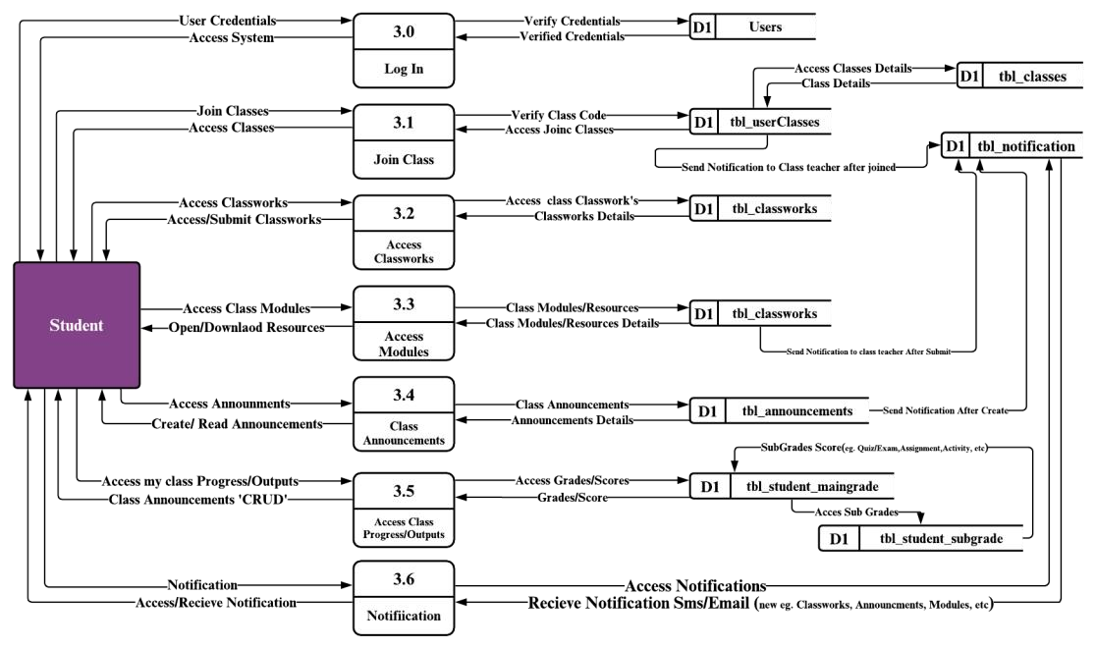

**Student**

###### **Figure 38**. Data Flow Diagram of Student

Figure above illustrates the extended data flow diagram for the student side. In this figure students are only allowed to view and access features such as classwork, modules, announcement, class progress/outputs and notifications, this feature can be only visible if the students are joined or already in a class. This contains all the student’s data analysis and the system's operation or input in response to the student’s demand.

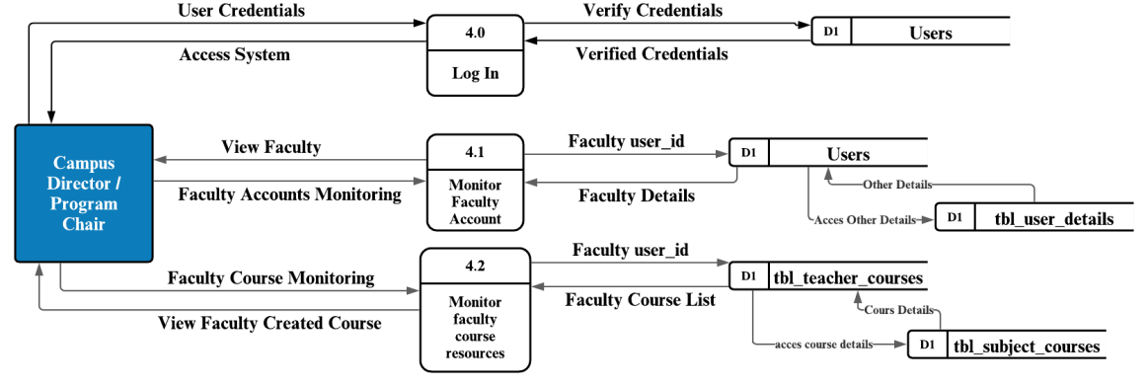**Campus**

**Director/**

**Program**

**Chair**

###### **Figure 39.** Data Flow Diagram of Program Chair / Campus Director

Above illustrates the extended data flow diagram for the Program Chair / Campus Director side. In this figure Program Chair / Campus Director are only allowed to view or monitor faculties accounts and faculty course resources this contains all to view or monitors the faculty’s details and Course details. Data analysis and the system's operation or input in response to the Program Chair / Campus Director demand.

### 3.6 Entity Relationship Diagram

The researchers used Entity Relationship Diagram (ERD); it is a graphical representation of an information system that shows the relationship between people, objects, places, concepts, or events within the system. An ERD is a data modeling technique that can help define business processes and be used as the foundation for a relational database.

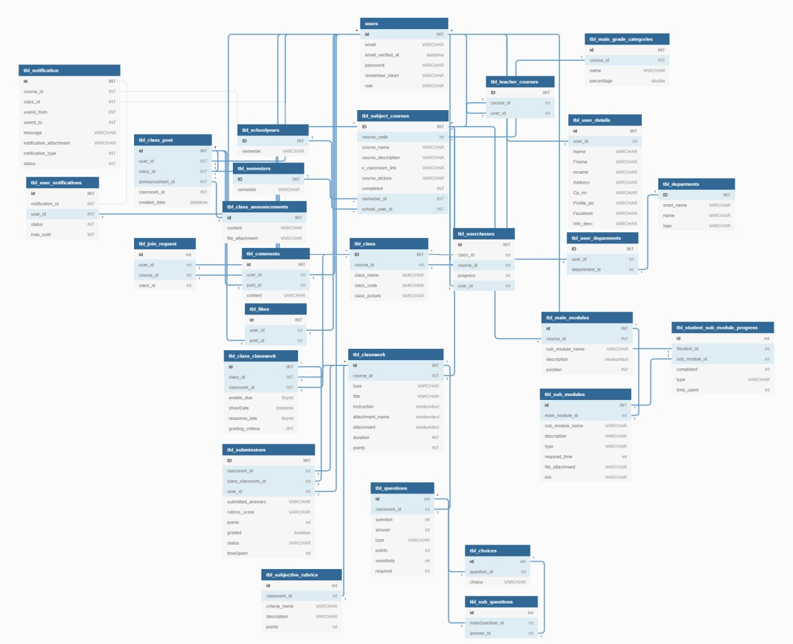

***Figure 40*.** *Entity Relationship Diagram*

Figure 40 shows the database of the system named **capstonesdb** with different names of the tables. The table parameters, connectivity, and relationships to one another are described in Data Dictionary.

### 3.7 Systems Design

3.7.1 System Development Methodology

The research development type that is used in this study, is a systematic investigation of the design, development, and assessment of educational programs, processes, and products that must meet internal quality and efficiency requirements.

Developmental research is especially relevant in the realm of instructional technology.

(Ritchie, 1994).

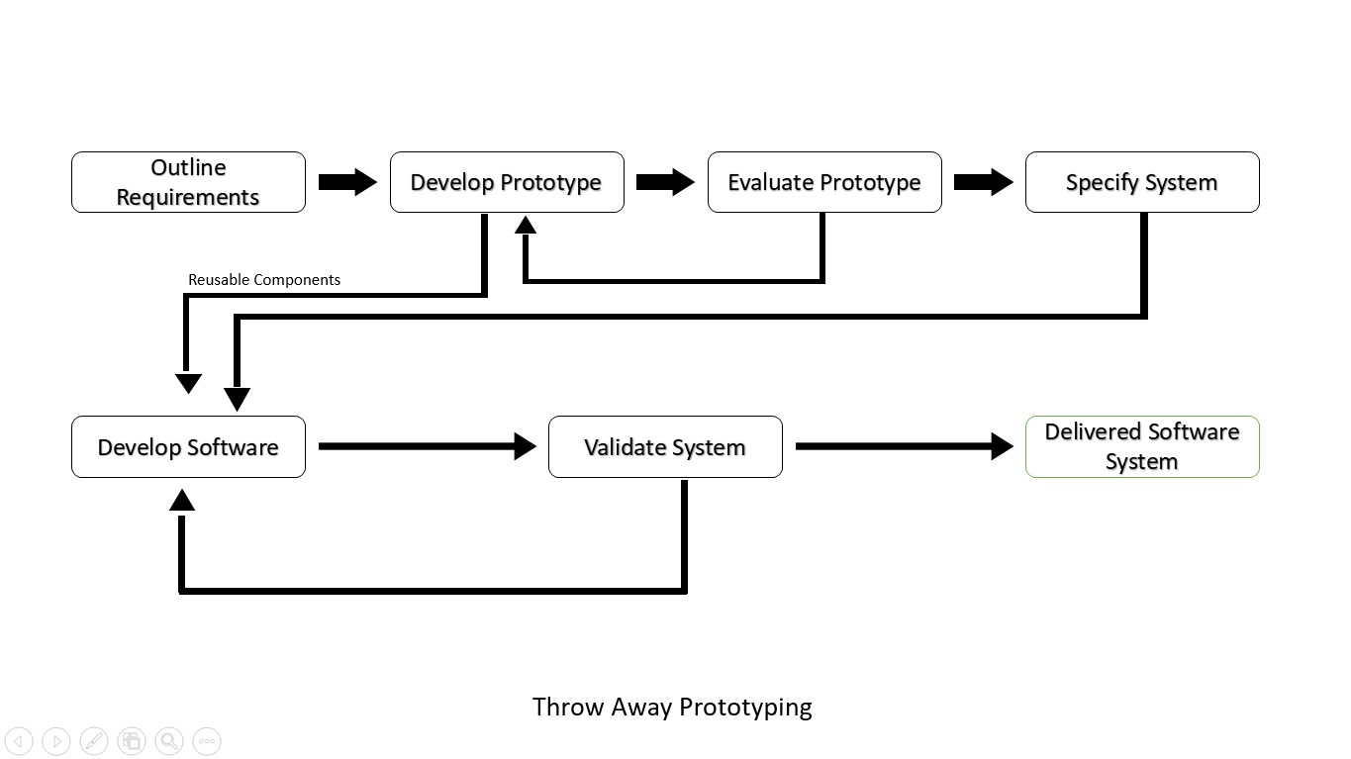

***Figure 41.*** *Throw Away Prototyping*

Rapid Application Development (RAD): Throw-away Prototype is the system methodology employed for this project. This strategy was chosen because the project was designed in such a manner that it prioritizes the data set collected from the survey for the GUI, and the Throwaway Prototype allows for going back to the previous stage to make changes and/or refine issues.

With RAD Throwaway Prototyping, any adjustments required in the previous stage may be easily re-done before moving on to the next step. The Figure above depicts a loop between developing software and validating the system, which allows for flexibility in executing the program and making abrupt modifications as needed.

### 3.8 Development and Testing

3.8.1 Data Gathering Procedure

* **Questionnaire** is a form that the researcher prepares, distributes and has the respondents fill out under his or her supervision. It was used to find out about the respondents' thoughts and feelings towards the system.
* **Observation** is a method of collecting data. Researchers use this procedure by observing people, events, or physical characteristics of the system. The researchers used this kind of procedure to find the loopholes and the respondents’ thoughts and suggestions befitting the system.
* **Interview** is a data collection procedure that is utilized to help the researcher explain, comprehend, and investigate the attitudes, actions, experiences, and occurrences of the research subjects.

3.8.2 Data Analysis

###### Likert Scale

The Likert scale was developed by (Rensis in 1932), and it is a five-point scale for measuring hypothetical notions. This scale ranks a group of individuals from least to most in terms of how much they agree or disagree, approve or disapprove, or believe something to be true or untrue, depending on how much they agree or disagree. For numerous reasons, the Likert scale was employed in this study. First, as one of the aspects that can be measured, the Likert scale is the most commonly used instrument to measure psychological constructs (Messik, 1989). Second, Likert concentrates on study-related difficulties such as reliability, validity, and so on. The Likert scale was also useful in determining single attitudes and responses to various investigations.

Likert Scale was being used to evaluate the outcome from the user and the hightech specialist. ***Table 33*.** *Likert Scale*

|  |  |  |
| --- | --- | --- |
| **Quality Rating** | **Range** | **Scale** |
| Strongly Agree | 4.21 - 5.0 | 5 |
| Agree | 3.41 - 4.20 | 4 |
| Neutral | 2.61 – 3.40 | 3 |
| Disagree | 1.81 – 2.60 | 2 |
| Strongly Disagree | 1.00 – 1.80 | 1 |

Table 33 Likert Scale expresses the quality rating, range, and scale of the five-point Likert scale. This kind of method was used for scrutinizing the criteria. For determining every individual quality rating in different parameters, the proponents used the following:

Strongly Agree (SA), Agree (A), Neutral (N), Disagree (D), and Strongly Disagree (SD). As a quality range for the individual mean of the parameters.

The table shows the conversion of rating that the proponents used in tabulating the final result of the conducted survey.

𝑆𝑢𝑚 𝑜𝑓 𝑟𝑒𝑠𝑝𝑜𝑛𝑠𝑒𝑠

𝑀𝑒𝑎𝑛 =

𝑇𝑜𝑡𝑎𝑙 𝑛𝑜. 𝑜𝑓 𝑟𝑒𝑠𝑝𝑜𝑛𝑑𝑒𝑛𝑡𝑠

This statistical analysis was used to calculate the mean of every criterion stated in the objectives of the project that can be viewed on the previous section.

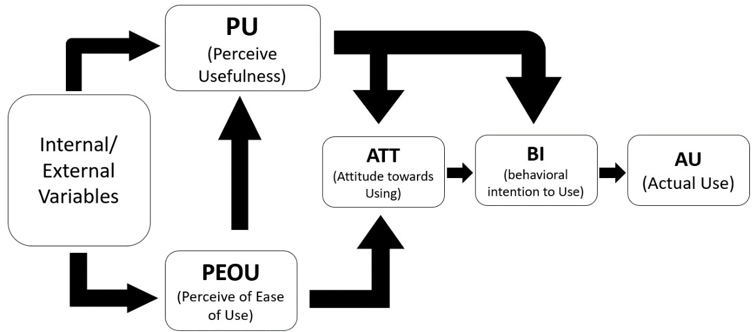

***Figure 42*.** *TAM Concepts*

###### Technology Acceptance Model (TAM)

The Technology Acceptance Model (TAM) by Davis (1989) is a theory of information systems that represent users’ acceptance and exploitation of technology. The TAM model was included in this study for several reasons. First, TAM is the most influential framework for predicting user technology adoption behavior. Tams have been used to describe or forecast individual actions across a wide variety of end-user computing technologies and user groups. Finally, earlier research has discovered that TAM is empirically strong and powerful and that it is the model most commonly used to examine information technology uptake and use. TAM was also beneficial in defining the user’s technological adoption behavior in various environmental contexts. TAM assumes that a variety of factors influence an individual’s technological acceptance behavior. Perceived usefulness is defined here as “the degree to which a person believes that using a particular system would enhance his or her job performance,” whereas perceived ease of use is defined as “the degree to which a person believes that using a particular system would be

free of effort”.

3.8.3 Population of the Study

The respondent of this study were the students and the faculty members of the College of Computing Science in Information Communication Technology (CCSICT). ***Table 34*.** *Total Population of the Study*

|  |  |
| --- | --- |
| **Respondents** | **Number of Respondents** |
| Student | 143 |
| Faculty members | 80 |
| I.T Professionals | 5 |
| **Total Respondents** | **228** |

###### **Table 35.** Gender Tabulation Result on Gender

|  |  |
| --- | --- |
| **Gender** | **Number of Respondents** |
| Male | 115 |
| Female | 113 |

Table 35 shows the respondents, gender and their total number. These respondents are the people that evaluated the system based on the criteria using the Technology Acceptance Model. The respondents of this study were elaborated in the table and categorized by their total number.

### 3.9 Software Testing

The proposed system will be carried out at the College of Computing Science in Information Communication Technology especially to the faculty members and students of the college so that the users will be well-informed of the potential of the system. The proposed system be tested by Login, Class List, Course List, Course Details, Course Overview, Course Announcement, Course Modules, Course Classwork, Classwork Question List, Classwork Submission List, and Course Modules, Gradebook, students' grades, students' modules, program, students' list, profile, and notification functions of the ISUE-ORANGE website.

The researchers performed a system test plan for an accurate performance testing result. The researchers used the Apache JMeter tool for the testing phase of the application. It tested the application environment, which was similar to the production environment. Researchers used the Apache JMeter. It created requests to target servers and simulates the number of users by sending requests to the target server. Once the server started responding to the requests, Apache JMeter saves all the responses. By using the response, Apache JMeter collected data to calculate statistical information. To achieve that, the whole system application infrastructure was thoroughly analyzed. The ISUE-ORANGE website, which was subjected to performance testing, was already in the production environment since it was a live website. To avoid conflicts with the external heavy load as much as possible, the best time for researchers to conduct the performance test was 10 p.m. as there were be fewer users accessing the ISUE-ORANGE website at that time. Performance testing was conducted using Apache JMeter to check the behavior of the ISUE-ORANGE website under different load conditions. There were two scenarios in the performance test. First, a performance test was conducted for 500 users with a 3000 second ramp-up period of (50 minutes). The second, performance test was conducted for 1000 users with a 3000 seconds ramp-up period of (50 minutes).

***Table 36.*** *Test Plan*

|  |  |
| --- | --- |
| **Document** | **Performance Test Plan** |
| **Project** | **Isabela State University Echague Online Resource for a New Guild of Education (ISUE ORANGE)** |
| **Objective:**  The objective of this document was to outline the environment and Performance test Plan for the ISUE-ORANGE website and to ensure if the current system architecture was optimal for handling increased traffic on the website and also, to figure out if there are any upgrades that need to be done. | |
| **Scope:**   * Test the Login, Class List, Course List, Course Details, Course Overview, Course   Announcement, Course Modules, Course Classwork, Classwork Question List, Classwork Submission List, and Course Modules, Gradebook, students' grades, students' modules, program, students' list, profile, and notification functions of the ISUE-ORANGE website.   * Analyze the test results. | |

3.9.1 Load Testing

A process of putting demand on a software system or computing device and measuring its response. Load testing was performed to determine a system's behavior under both normal and anticipated peak load conditions to identify the maximum operating capacity of an application as well as any bottlenecks and determine which element was causing degradation. The researchers used Apache JMeter as a tool to conduct load testing on the system. Apache JMeter (Rabiya Abbas, 2017) was the best option as it is free of charge. It took more time on one-time installation, but it had a broad set of options for result analysis, and it was good for different tests to be run simultaneously for both load testing and performance testing. In a recent study comparing all testing tools, it said that Apache JMeter was the best tool that can be used to test the load as it was free.

###### **Table 37.** Test Case Scenarios

|  |  |  |  |
| --- | --- | --- | --- |
| **No. of Scenario** | **Ramp-up period (seconds)** | **Loop Count** | **# of Threads (users)** |
| 1 | 3000 | 1 | 500 users |
| 2 | 3000 | 1 | 1000 users |

The table above depicts the number of testing scenarios that include two cases with the same ramp-up period and the number of loop counts, with the first scenario having a maximum of 500 threads (users) and the second having more than 1000 users as the parameter in the Apache JMeter.

3.9.2 Stress Testing

It is also known as endurance testing or torture testing. This is a software testing technique that determines the robustness of software by testing beyond the limits of normal operation. It emphasizes robustness, availability, and error handling under a heavy load rather than on what is considered correct behavior under normal situations.

The proponents used the Apache JMeter to conduct stress testing. The Apache JMeter application was open-source software and was a 100% pure Java application designed to put functional behavior through its paces and measure performance. It was originally designed in order to test Web applications. Stefano Mazzocchi of the Apache Software Foundation created it in the beginning, which was widely used for performance testing (Narinder Kaur, 2016). Moreover, (Vandana Chandel, 2013), it had a simple, clean UI that clearly showed what was going on without trying to do too much, and it offers great power and simplicity with its unique design.

###### **Table 38.** Test Case Scenarios

|  |  |  |  |
| --- | --- | --- | --- |
| **No. of Scenario** | **Ramp-up Period** | **Loop Count** | **Range of Threads** |
| 1 | 5 | 1 | 10-4000 Users |
| 2 | 15 | 1 | 10-4000 Users |

The table above depicts the number of testing scenarios in stress testing that include two cases with the same number of loop counts, and range of threads (users), but different ramp-up period these are the parameters used in the Apache JMeter.

### 3.10 Implementation Plan

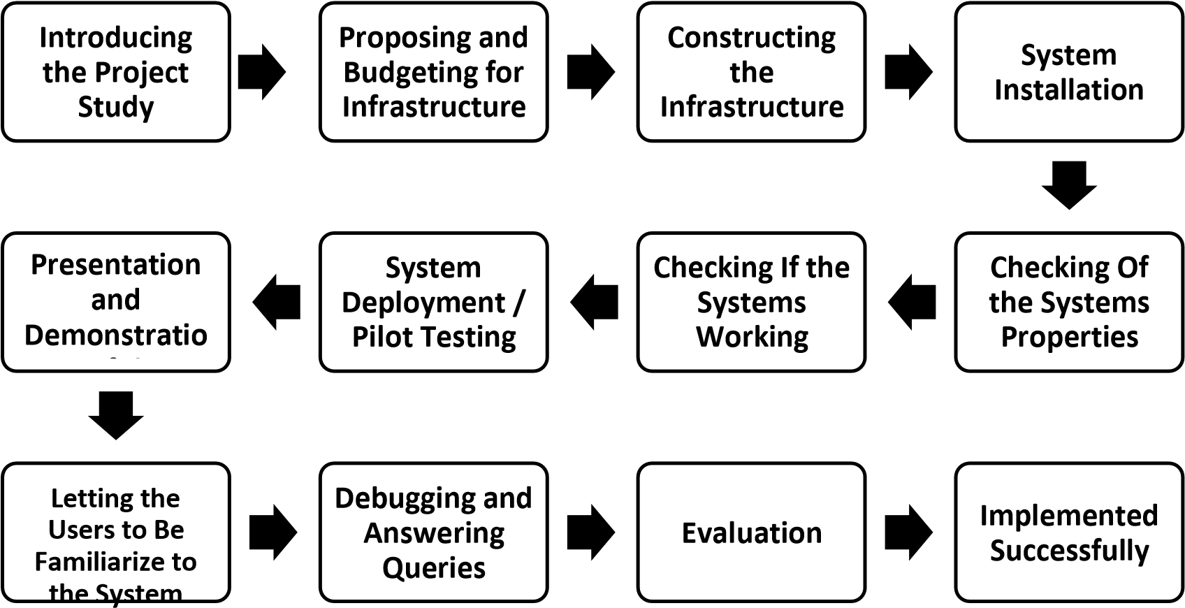

***Figure 43*.** *Implementation Plan*

Figure 43 displays the step-by-step process of the proposed project. The researchers together with the project adviser, introduced the project to the executive officer and with the deans, at the same time the orientation talked about the deployment of the proposed project dated May 04, 2021, and to conduct a pilot testing at the college of computing studies, information communication technology (CCSICT). The second step was the proposing and budgeting of expenses for the construction of the cloud infrastructure where the system was uploaded. Third, the researchers began constructing and finishing the infrastructure where the system was uploaded. Fourth, following brief planning and budgeting for the infrastructure, the proponents began to upload the system to the server and check if the properties were working properly; after uploading, the proponents also arrange the features and specifications of the server for the system to run steadily and deployed the system at CCSICT dated August 06, 2021; and while the system was running fluidly, the proponents began their presentation and demonstration of the system's features by conducting user training dated December 13-17, 2021, where the proponents introduced and guided the users on how to fully use the system's features, the proponents also let the users explored the system for them to become familiar with every function of the system. After the brief presentation and demonstration of the system, the proponents opened a forum for every user to raise questions and suggestions for the researchers to answer and gather data and information to improve the system. After a series of questions and answers, the researchers gave the evaluation form for them to assess the application based on user acceptance using the Technology Acceptance Model (TAM) based on different criteria on previous section and using the Likert scale. Lastly, the system had been implemented successfully.

# CHAPTER IV RESULTS AND DISCUSSIONS

This chapter outlines the outcomes acquired by the researchers in order to meet the project's objectives. The screenshots of the designed and created application, as well as the results of the objectives to evaluate the users’ acceptance of the system functionalities using the Technology Acceptance Model (TAM) and Likert scale, are shown below.

Developed Isabela State University Echague Online Resource for a New Guild of

Education (ISUE ORANGE): a web-based system with a mobile-first approach of Isabela State University Echague.

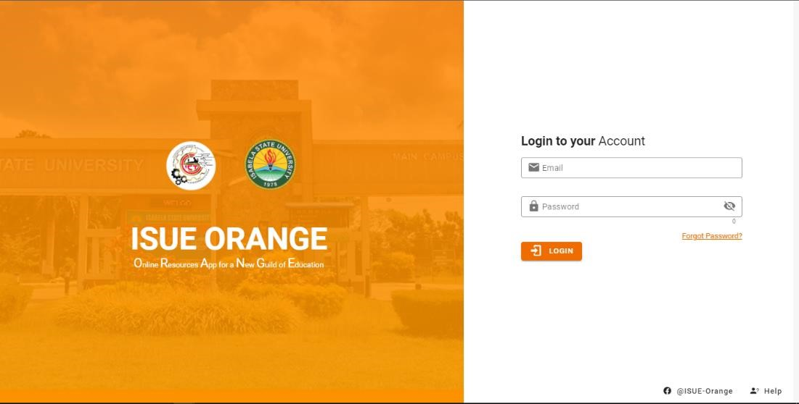

***Figure 44****. Developed ISUE ORANGE Login Page*

Figure 44 shows the Login page of the developed Isabela State University Echague Online Resource for a new Guild of Education. The page allowed users to input their valid account information, such as registered email and password. If the users successfully log in to the application by inputting their email and password and clicking the button "Log In", if ever the users forget their passwords, they can request a new one by clicking "Forgot Password”.

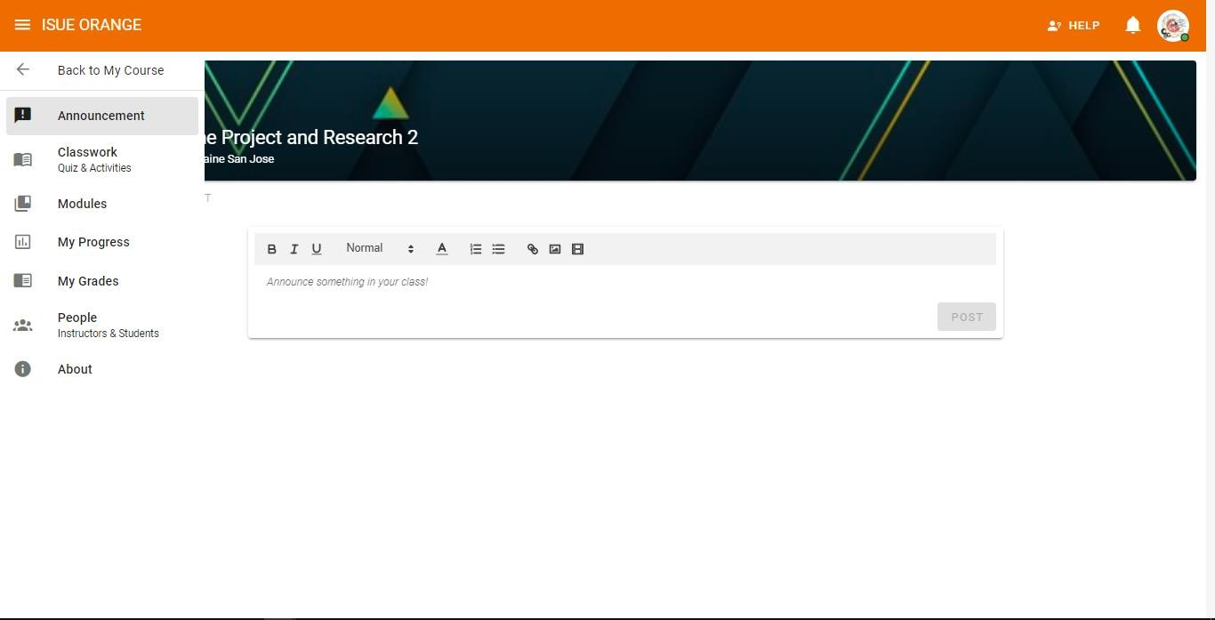

***Figure 45.*** *Students’ Homepage*

Figure 45 shows the homepage of the student. This can be seen by students who have a valid account and have successfully logged in. On the homepage, students can see the different functionalities that they can explore, such as Announcement, where you will see the class post or announcement of the users. Classwork where students view and take quizzes, exams, and activities. Students can view all the learning modules that their faculty members uploaded and track the students' time spent on each activity. My Progress, where students view their progress upon reading the learning materials in modules. My grades are where the students can view their computed grades in different categories that their faculty members created. People is where students can view the list of names in that class. And lastly, the "About" function, where they can view all the related descriptions in their class.

These functionalities can be interacted with by clicking the names of the functions.

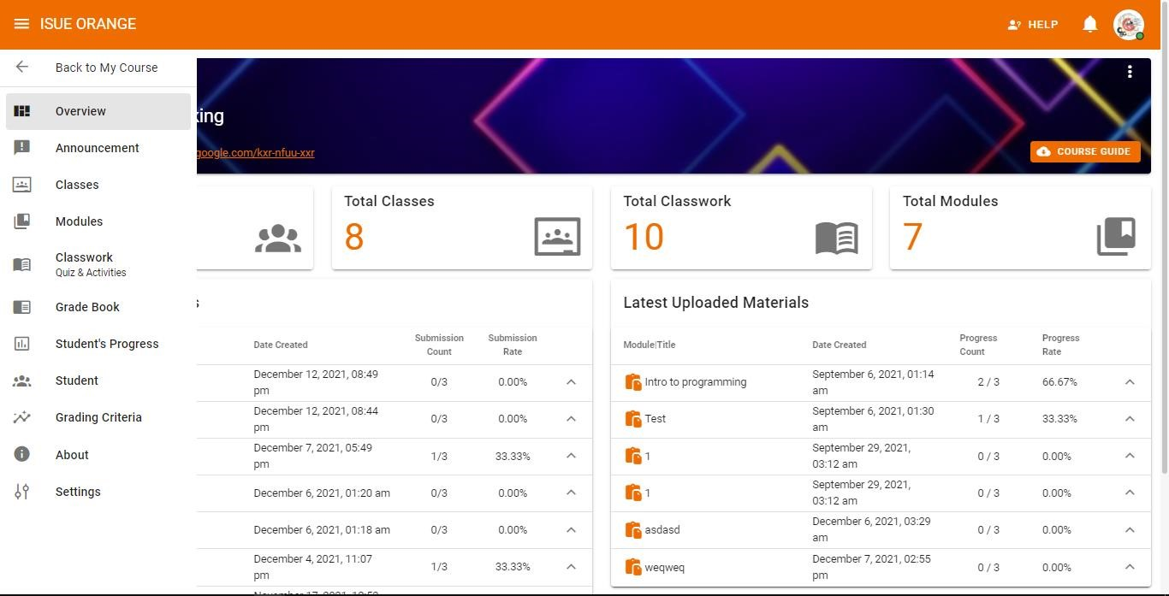

***Figure 46.*** *Faculty members Homepage*

Figure 46 shows the homepage of the faculty members. This can be seen by faculty members who have a valid account and successfully login. On the faculty members’ homepage, faculty members can see the different functionalities that they can explore, such as Overview, which is the first feature to be viewed by a faculty member after entering their course. They can view their recent activities such as uploads of learning materials and uploads of classwork. An announcement where the faculty members can view the users' posts in that particular class. Classes where faculty members can create and edit classes in that course. Modules are where faculty members upload and publish modules to the classes in the course. The Classwork Function is where faculty member create, publish, and check submission activities for their students. Faculty members can view all the students' grades or per criteria. Faculty members can also download or export the grading sheet of their class for editing the grades. Students' Progress is where the faculty members can view the student's reading progress in the learning materials that faculty members upload into the module. This feature displays the names of the students, and faculty members can move one student from class to class. Grading Criteria is where faculty members create, edit, delete, assign or allocate a percentage of the grade. For example, a prelim with a percentage rate of 10%. This kind of grading criteria can be viewed in grading criteria. In the About feature, faculty members can view the course description and related materials for that course. In the settings feature, faculty members can add or edit the details of the course they created. These functionalities can be interacted with by clicking the names of the functions.

### 4.1 Test the System Performance

A System Test Plan details the complete approach to the validation of the system under test. It refers to a detailed document that catalogs the test strategy, objectives, schedule, estimations, deadlines, and the resources required for completing that particular project. In formal situations, the document should answer all questions associated with the system test prior to the actual execution of the plan and, in formal situations, require stakeholders to sign off on it. The specification of the device and equipment that was utilized in conducting the load testing and stress testing were the following; Asus Laptop having a specification of Intel core i5 8250u, with a 16GB of Random-Access memory

(RAM), and 256 GB of Solid-State Drive (SSD).

4.1.1 Load Testing

The load testing was performed with 2 scenarios in which to determine the system’s performance in terms of CPU Usage, Bandwidth, Disk I/O, and the error rate.

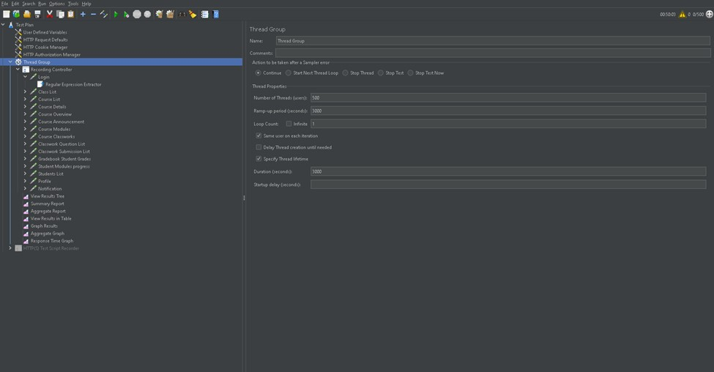

***Figure 47.*** *Sample Screenshot of Apache JMeter*

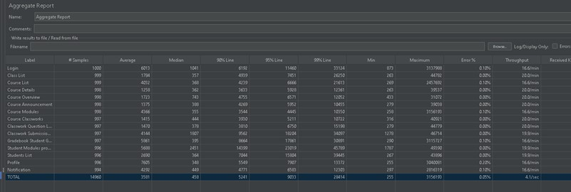

###### **Figure 48.** Apache JMeter’s Aggregate Result

Figure 47 is the sample screenshot result of the two tests, showing the number of threads used in the first test with a number of 500 threads/users with a 3000 second rampup period for 3000 seconds (50 minutes) and the second test with a number of 1000 threads/users with a 3000 second ramp-up period for 3000 seconds (50 minutes). Adding with a parameter of Login, Class list, Course List, Course Details, Course Overview,

Course Announcement, Course Modules, Course Classwork, Classwork Question List, Classwork Submission List, Gradebook Students Grade, Students Modules Program, Students List, Profile, Notification function list.

Figure 48 illustrates the sample screenshot and result of the Apache JMeter, aggregate report is used to generate reports, such as summary reports, and generates a table entry for each differently named request in our test. To acquire the greatest results from the report, the researchers have appropriately stated the label names such as Login, Class list,

Course List, Course Details, Course Overview, Course Announcement, Course Modules,

Course Classwork, Classwork Question List, Classwork Submission List, Gradebook Students Grade, Students Modules Program, Students List, Profile, Notification functions are the same for both scenarios. Furthermore, all data for samples, average, min, max, transmitted, received, standardized development, throughput, and average bytes differ due to network difficulties.

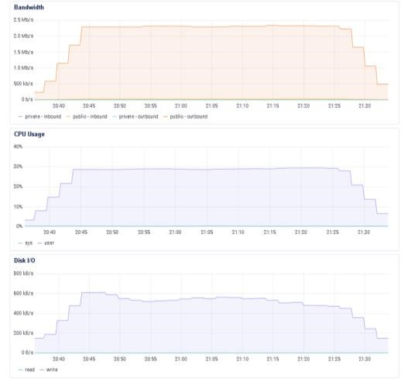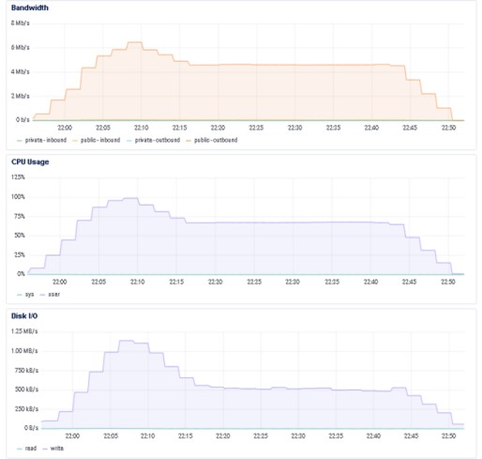

**a)**

**Scenario**

**1**



**a)**

**Scenario**

**2**

Figure 49 illustrates the results of the two scenarios in terms of the server’s Bandwidth, CPU usage, and Disk I/O during the load testing. The screenshots show the system's behavior in managing and handling processes or requests.

###### **Table 39**. Summary Result of Load Testing

|  |  |  |  |  |  |  |  |  |
| --- | --- | --- | --- | --- | --- | --- | --- | --- |
| **Scenario** | **No. Threads (Users)** | **CPU (%)**  **Avg &**  **Max** | | **Bandwidth**  **Avg & Max**  **(mb/s)** | | **Disk I/O**  **Avg & Max**  **(mb/s)** | | **Error Rate (%)** |
| **a** | **500** | **20.47** | **29** | **1.78** | **2.4** | **0.43** | **0.6** | **0** |
|  |  | **90.30** | **99** | **4.25** | **6.2** | **0.66** | **1.12** | **0.05** |
| **b** | **1000** |  |  |  |  |  |  |  |

Table 39 illustrates the summary result of the load testing in terms of the number of threads, CPU usage, bandwidth, disk I/O, and error rate. The researchers carried out the load testing using the Apache JMeter as the tool that was mentioned in the project's objectives. For the first scenario, the researchers observed that the website's performance was stable within 40 minutes of 50 minutes for 500 threads (users) and that the consumption and usage of the CPU were low, with a high transfer rate of data and a zeroerror rate. While for the second scenario, the website displays slow performance if there are more than 1000 threads (users) accessing the website within 0–10 seconds and the consumption of the CPU usage or the peak usage is nearly 100 percent, which results in long load times and saves times but high data transfer rates. For the two scenarios conducted by the researchers using Apache JMeter, the website decreases its performance with a different number of threads (users). This indicates that the website can't handle the high loads given, but as we see in two scenarios, the performance at the beginning is increasing, but as time passes, the website becomes stable.

4.1.2 Stress Testing

The researcher performed this software testing to confirm the stability and reliability of a software application. The purpose of stress testing was to assess software's robustness and error handling skills under extremely high load conditions, as well as to ensure that software does not crash in critical scenarios. It even goes beyond regular operating points to assess how the software performs in harsh settings.

###### **Table 40.** Scenario (a) Result with a Ramp-up period: 5, Loop count: 1 and a Range of threads (users) of 10-4000

|  |  |  |  |  |  |  |  |  |
| --- | --- | --- | --- | --- | --- | --- | --- | --- |
| **Test**  **ID** | **Threads**  **(Users)** | **CPU (%) Avg & Max** | | **Bandwidth**  **Avg &**  **Max** | | **Disk I/O**  **(mb/s)**  **Avg & Max** | | **Error Rate**  **(%)** |
| 1 | 10 | 9.38 | 13.93 | 0.24 | 0.24 | 0.14 | 0.304 | 0.00 |
| 2 | 100 | 45.40 | 100 | 1.60 | 2.59 | 0.62 | 1.19 | 5.20 |
| 3 | 300 | 70.80 | 100 | 2.10 | 2.19 | 1.06 | 1.56 | 35.52 |
| 4 | 800 | 78.71 | 100 | 3.02 | 2.82 | 2.2 | 3.20 | 85.98 |
| 5 | 1500 | 82.59 | 100 | 2.80 | 2.51 | 2.49 | 3.57 | 92.00 |
| 6 | 2000 | 85.50 | 100 | 4.35 | 7.73 | 1.45 | 1.75 | 96.06 |
| 7 | 2500 | 88.5 | 100 | 3.87 | 4.66 | 1.38 | 1.62 | 97.22 |
| 8 | 3000 | 92.4 | 100 | 4.2 | 5.00 | 2.16 | 4.50 | 97.86 |
| 9 | 4000 | 95.10 | 100 | 3.99 | 6.4 | 3.47 | 4.30 | 98.13 |

The table shows the result of the scenario (a) of the stress testing, the results of one of two situations with a range of 10–4000 are shown in the table above. Test 1 had a thread count of 10, an error rate of 0%, and a success rate of 100%. This demonstrated that test one had no errors or difficulties and handled the loads effectively. And for Test 2 with a thread of 100, the mistake rate was over 3.73 percent with a success rate of 96.27 percent. This means that while test two had a minor glitch or malfunction, the system was still operational. For test 3, in scenario 1, with a thread count of 300, the result of the test shows that it has a 35.52% error rate and a 64.48% success rate. This means that the test three also encounters a small error rate, but the software application successfully handles the load. Test four, with a thread count of 800, revealed an error rate of 85.98% and a success rate of 14.02%, indicating that test four encounters an issue and the software application performs slow functionalities. Test five, with a thread count of 1500, shows a 92% error rate and an 8% success rate in tests. This means that the software application had shown very slow performance. The result of test six showed that with 2000 threads using the system simultaneously, the system experienced a 96.06% error rate and a 3.94% success rate. This implied that the application can still handle the heavy load of work but was slower in performance than in the test five test performance. Test seven, with 2500 threads, showed a 97.86% error rate and a 2.78% success rate. This means that the system suffered much more and performed slower than the other tests. Test eight with a thread of 3000 showed that the error rate of the test was 97.86% with a 2.14% success rate, which indicates that test 8 experienced slower performance than the other tests. And lastly, for test 9 with a thread count of 4000, the test showed that the software application experiences a 98.13% error rate and had a 1.87% success rate. This means that the application encounters a lot of issues and errors while running the test and showed a very slow performance in handling a heavy workload.

###### **Table 41.** Scenario (b) Result with a Ramp up period: 15 seconds, Loop count: 1, Range of threads (users): 10-4000

|  |  |  |  |  |  |  |  |  |
| --- | --- | --- | --- | --- | --- | --- | --- | --- |
| **Test**  **ID** | **Threads**  **(Users)** | **CPU (%)**  **Avg &**  **Max** | | **Bandwidth**  **(mb/s)**  **Avg & Max** | | **Disk I/O**  **(mb/s)**  **Avg & Max** | | **Error Rate**  **(%)** |
| 1 | 10 | 12.33 | 15 | 0.30 | 0.51 | 0.25 | 0.48 | 0 |
| 2 | 100 | 70 | 95 | 1.75 | 2.45 | 1.22 | 1.52 | 0 |
| 3 | 300 | 72.43 | 100 | 1.53 | 3.0 | 13.12 | 1.80 | 25.80 |
| 4 | 800 | 71 | 100 | 3.34 | 5.4 | 1.44 | 1.80 | 67.55 |
| 5 | 1500 | 72.33 | 100 | 4.52 | 6.82 | 1.64 | 1.85 | 79.96 |
| 6 | 2000 | 88.3 | 100 | 4.27 | 6.12 | 1.70 | 1.88 | 91.25 |
| 7 | 2500 | 89.14 | 100 | 3.17 | 4.60 | 1. 95 | 2.96 | 92.89 |
| 8 | 3000 | 75.71 | 100 | 3.21 | 5.38 | 1.49 | 1.60 | 93.32 |
| 9 | 4000 | 84.90 | 100 | 0.90 | 0.91 | 1.28 | 1.74 | 97.28 |

The table above illustrates the scenario (b), and was conducted where the researchers conduct stress testing. The results of two out of four scenarios, with a range of 10–4000, are shown in the table above. Test 1 had a thread count of 10, which implied it had 150 requests overall, a 0% error rate, and a 100% success rate. This indicated that there were no errors or difficulties with the test ID, and it handled the loads effectively. In Test 2, with a thread of 100 and a request issued of 1,500, the error rate was over 0 percent and the success rate was 100 percent. This indicatesd that there was no problem or error in the second test, and the system was still operational. The outcome of test 3 in scenario 2 with a thread count of 300 showed that a total of 4,500 requests were issued, with a 38.84 percent error rate and a 61.16 percent success rate. This means that although test three fails, the software application still manages to handle the load. Test four, which has an error rate of 85.42 percent and a success rate of 14.58 percent and had a thread count of 800, indicates an error rate of 85.42 percent and a success rate of 14.58 percent, indicating that test four has a problem and the software program works slowly. With a thread count of 1500 and a total number of requests sent of 22, 5000, test number five had a 91.26 percent error rate and an 8.74 percent success rate. This indicated that the software application had performed very slowly. The outcome of test six showed that the system had a 96.49 percent error rate and a 3.51 percent success rate when 2000 threads used the system simultaneously, totaling 30,000 requests sent. This means that the program still managed a high volume of work, but it performs slower than in the previous five tests. With 2,500 threads and 37,500 requests issued, test number seven had a 97.03 percent error rate and a 2.97 percent success rate. This means the system was subjected to far more stress and performs much slower than in the previous tests. With a thread count of 3000 and a total request count of 45,000, test number eight exhibits a 97.66 percent error rate and a 2.34 percent success rate, indicating that test number eight performed slower than the others. Finally, test 9 shows that the software application had a 98.09 percent error rate and a 1.91 percent success rate, with a thread count of 4000 and a total request sent of 60,000. This indicated that the application had a high number of difficulties and errors during the test and performs very slowly when dealing with a large amount of data.

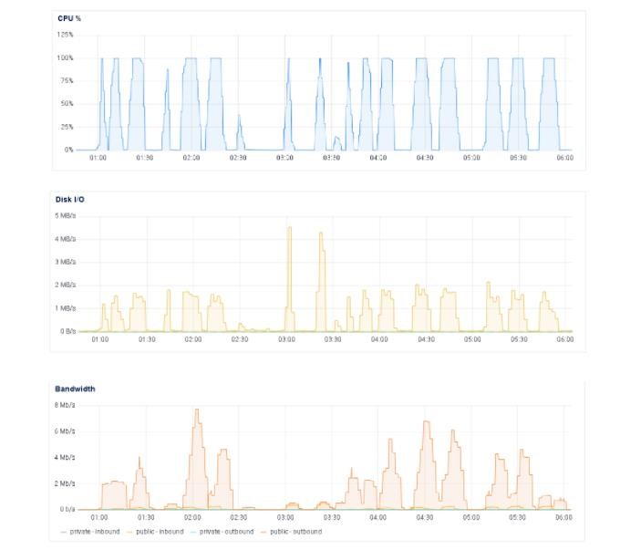

**(**

**a**

**)**



**(**

**b**

**)**



**(**

**c**

**)**

***Figure 50.*** *Test Scenario a & b graph in terms of (a) CPU Usage, (b) Disk I/O, and (c) Server’s Bandwidth at a ramp-up period of 15 seconds.*

Figure 50 illustrates the results of scenarios (a) & (b) in terms of the server’s Bandwidth, CPU usage, and Disk I/O during the load testing. The screenshots show the system's behavior in managing and handling processes or requests.

***Table 42.*** *Summary of Test Results in terms of number of threads, Bandwidth, Disk I/O, and Error Rate.*

|  |  |  |  |  |  |  |  |  |  |
| --- | --- | --- | --- | --- | --- | --- | --- | --- | --- |
| **Scenario** | **Threads (Users)** | **Ramp up Period**  **(seconds)** | **CPU (%) Avg. & Max** | | **Bandwidth**  **(mb/s)**  **Avg &**  **Max** | | **Disk I/O**  **(mb/s)**  **Avg &**  **Max** | | **Error**  **Rate**  **(%)** |
| **a** | **10 -**  **4000** | **5** | **72.04** | **90.44** | **2.91** | **3.79** | **1.56** | **2.44** | **67.55** |
| **b** | **10 -**  **4000** | **15** | **70.68** | **90.00** | **2.56** | **3.91** | **2.77** | **1.74** | **60.89** |

The overall report for the two stress test scenarios with the parameters is shown in Table 42. The stress testing was done with the use of Apache JMeter to test the system’s capacity to handle large numbers of HTTP requests during the "peak period." Result presented in table 44, the researchers observe that in two scenarios with 9 test cases, the website performance decreases as the range of threads (users) increases together with the HTTP request, reaching a peak CPU usage of 100% at test 3 to 9 for 10-15 seconds as the duration of the experiments was performed in different lengths of time. This indicated that the system or website performance was not stable yet, as time increases, the system performance gradually decreases. This showed the performance of the website was stable at the beginning, but as time increases the system tends to decline and some HTTP requests were not able to process.

### 4.2 Implementation Plan

The steps-by-steps process on the implementation plan of this project was described in the previous section. The system implementation was followed and successfully carried out from proposing of the project, deployment of the project, demonstration of the project together with the users training, system evaluation and implemented the project successfully.

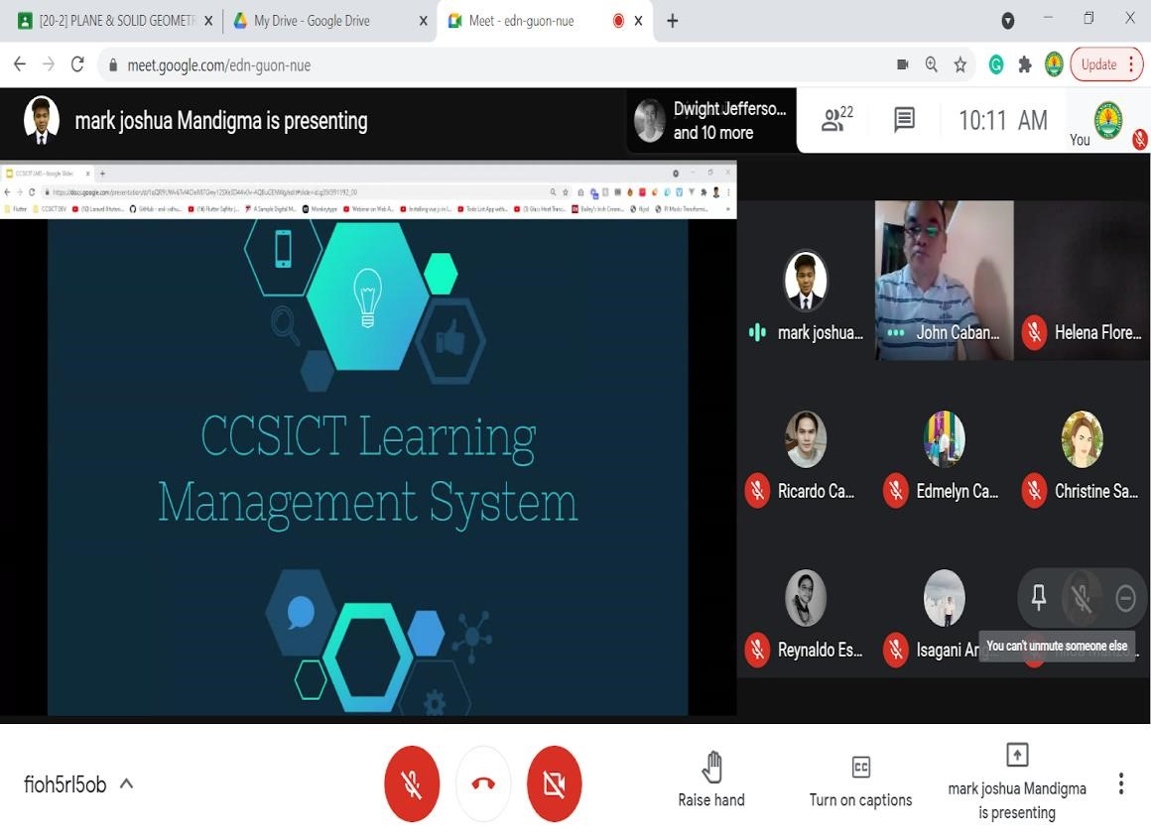

***Figure 51.*** *Introducing the project Study*

Figure 51 shows the introduction of the project was held through video conference and with the presence of the college deans and executive officer the website ISUE

ORANGE was introduced and talked about the goods and services of the project.

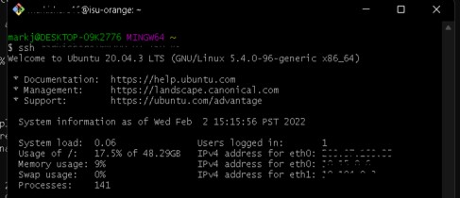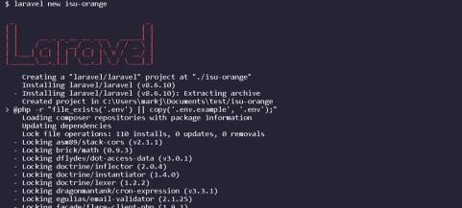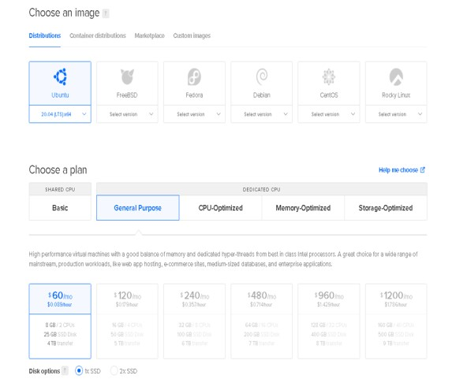

a.) Installation of Server in Digital Ocean



b.) Server’s CLI



c.) Installation of Laravel

and Vue.js

***Figure***

***52***

***.***

*System Installation (a) Insta*

*llati*

*on of Server in Digital Ocean, (b)*

*Server’s CLI and (c) Install*

*atio*

*n of Laravel and Vue.js*

Figure 52 shows the installation of the server in the digital ocean as the cloud server provider and it also shows installation of the necessary packages such as the Laravel for the backend of the web application and Vue.js for the front end.

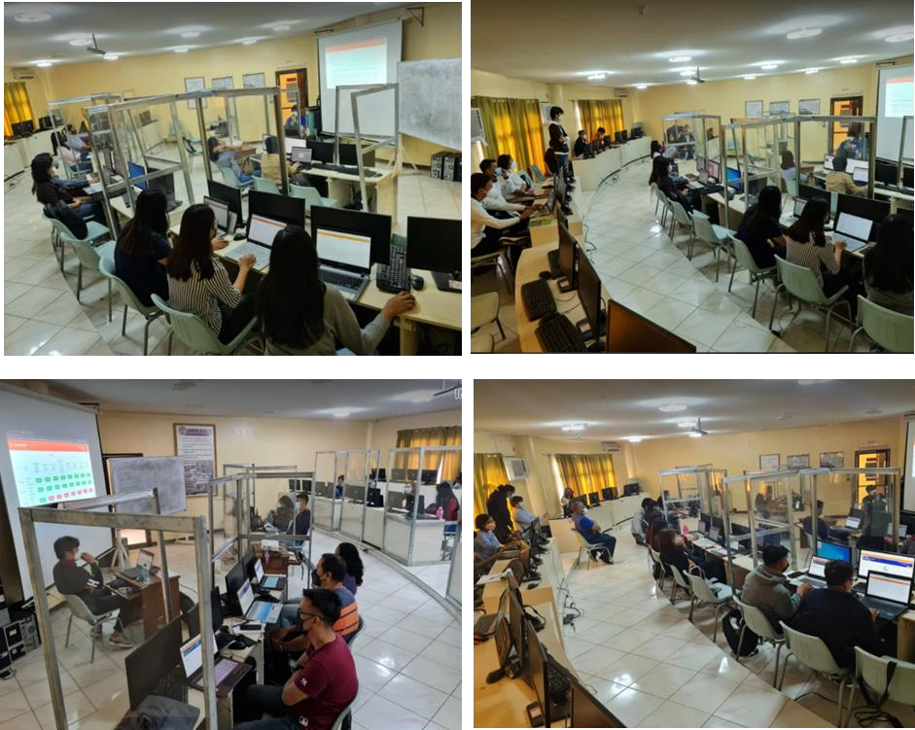

###### **Figure 53**. Presentation and Demonstration of the Systems Feature the System

Figure 53 shows the demonstration and presentation of the ISUE ORANGE to the respondents of the system dated December 13 through 17, 2021. On these dates, the researchers conducted a so-called user training to let the respondents familiarize themselves with the system’s functionalities. The researchers conducted the users' training to observe and answer the questions and suggestions that the respondents encounter while using the system. After a series of questions and answers, the researchers shared the evaluation form link to the respondents so that the respondents could criticize the system's functionality and suggested in the comments what other processes the researchers considered and applied.

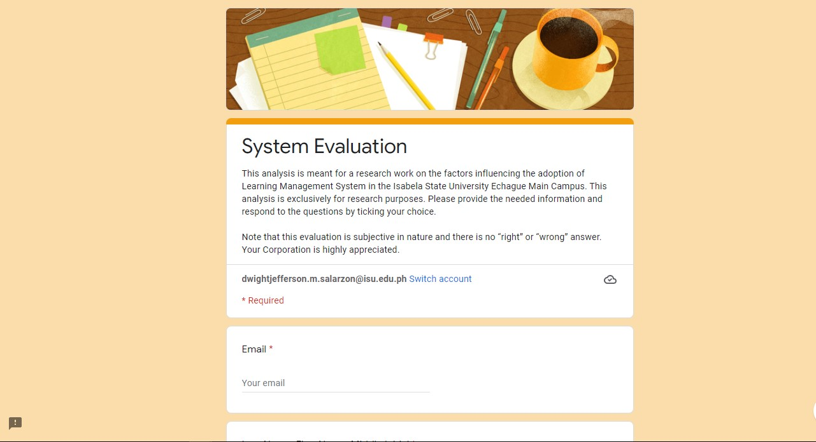

***Figure 54****. Evaluation of the System*

This figure shows the fourth specific objective of the project, which is to evaluate the user’s acceptance of the system functionalities using the Technology Acceptance Model (TAM) based on the following criteria that can be found on

https://forms.gle/f8J7tuJAJsipXZBw6. This form contains the list of sections with questions aligned with it such as the system's design and layout, content management, file administration and exchange, communication, gradebook and tracking, assessment and testing tools, mobility, and security, and the system was implemented successfully.

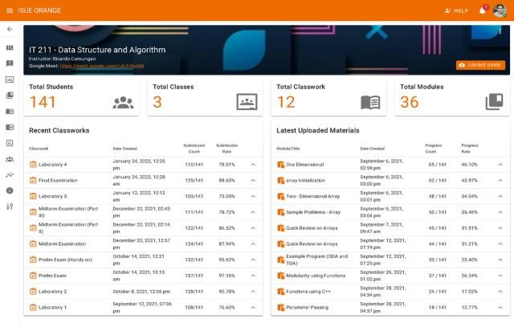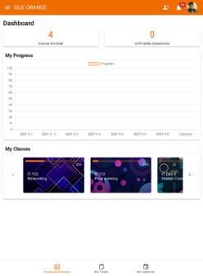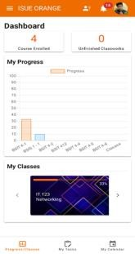

###### **Figure 55.** Successfully Implemented ISU ORANGE

Figure 55 displays the ISU ORANGE implemented system. The implemented system is a responsive website that can be viewed in different screen size devices. This website can be viewed by the domain: **isu-orange.com.**

### 4.3 Evaluation Result

The respondents of the system evaluation in this study were the students, faculty members, and IT professionals from the College of Computing Science in Information Communication Technology (CCSICT). The total number of respondents who participated in evaluating the system were described on previous section.

The proponents used Technology Acceptance Model (TAM) in evaluating the user’s acceptance of system functionalities; they used the questionnaire and observation test which measures an individual understanding or responsiveness to the system. The result of the respondent’s evaluation form is shown below.

###### **Table 43.** Design and Layout Evaluation Result

|  |  |  |
| --- | --- | --- |
| **Questionnaires** | **Mean**  **Value** | **Rating** |
| Design and Layout |  |  |
| Responsive design (easy to use on different devices and mobile-friendly) | 4.5 | Strongly  Agree |
| User experience (UX) and usability | 4.6 | Strongly  Agree |
| It allowed for customization and personalization. | 4.6 | Strongly  Agree |
| Use a template to protect certain settings or content (for example, use a specific font throughout all courses). | 4.5 | Strongly  Agree |
| Total mean | 4.6 | Strongly  Agree |

Table 43 shows the result of the user's evaluation as to Design and Layout of the system, which obtained a strongly agree rating. Based on the result, the system is proven that the system has a good user interface and has a responsive design. ***Table 44.*** *Content Management/Organization Evaluation Result*

|  |  |  |
| --- | --- | --- |
| **Questionnaires** | **Mean**  **Value** | **Rating** |
| Content Management/Organization |  |  |
| The solution included an auto-save function to ensure that any work in progress is not lost due to an unforeseen incident. | 4.4 | Strongly  Agree |
| The ability to play a wide variety of multimedia file formats across mobile, web, browser, and operating system platforms. | 4.6 | Strongly  Agree |
| Provision of a utility for embedding multimedia, video, music,  URLs, files, and so on | 4.6 | Strongly  Agree |
| The ability of the user to have access to view "Student  Progress" and "Student Grades" of the courses | 4.7 | Strongly  Agree |
| The solution encourages the usage of ISUE ORANGE in organizational and development settings. | 4.6 | Strongly  Agree |
| The course content was organized and well planned. | 4.6 | Strongly  Agree |
| The course was organized to allow all students to participate fully. | 4.6 | Strongly  Agree |
| Total mean | 4.6 | Strongly  Agree |

###### **Table 45.** File Administration and Exchange Evaluation Result

|  |  |  |
| --- | --- | --- |
| **Questionnaires** | **Mean**  **Value** | **Rating** |
| File Administration and Exchange |  |  |
| It allowed for downloads or uploads of files. | 4.5 | Strongly  Agree |
| All major word processors were supported, including Google Docs, Sheets, and Slides. | 4.5 | Strongly  Agree |
| It allowed users to select and delete files (e.g., audio, video, etc.). | 4.6 | Strongly  Agree |
| Total mean | 4.5 | Strongly  Agree |

Table 45 shows the result of the user’s evaluation as to File Administration and

Exchange of the system, which obtained a strongly agree rating in user’s perspective. Based on the evaluation result, the system’s performance provides a fast and functional management of files.

###### **Table 46.** Communication Evaluation Result

|  |  |  |
| --- | --- | --- |
| **Questionnaires** | **Mean**  **Value** | **Rating** |
| Communication |  |  |
| Sent messages on early intervention to improve student performance, with the option of alerting students who were either missing or falling below a predetermined grade threshold. | 4.6 | Strongly  Agree |
| Inclusion of a calendar/schedule component in conjunction with course tools that allowed for course calendar, recurring calendar entries, and calendar filtering by date or month. | 4.6 | Strongly  Agree |
| It provided an announcement/news utility that allowed users to create, edit, and delete announcements and feedback that could be distinguished by course and section. | 4.7 | Strongly  Agree |
| Provided notice, such as the ability to receive impending classwork dates and courses via a variety of email notifications. | 4.6 | Strongly  Agree |
| Total mean | 4.6 | Strongly  Agree |

Table 46 shows the result of the user’s evaluation as to Communication of the system, which obtained a strongly agree rating in user’s evaluation. Based on the results of the communication of the system, that the system utilities and communication are working and helps the faculty members and students on monitoring their academic progress.

***Table 47.*** *Gradebook, Grading Criteria and Tracking Evaluation Result.*

|  |  |  |
| --- | --- | --- |
| **Questionnaires** | **Mean**  **Value** | **Rating** |
| Gradebook, Grading Criteria and Tracking | | |
| It was a highly functional grade book that is easy to use. | 4.6 | Strongly  Agree |
| Grades were exported to a spreadsheet. | 4.7 | Strongly  Agree |
| A clear and simple tracking tool was offered for all user activities, such as student grades and progress, question analytics, and so on. | 4.6 | Strongly  Agree |
| Ability to search and sort columns in the grade book, not just to adjust the row per page. | 4.6 | Strongly  Agree |
| The ability of the users to view the gradebook per grading criteria | 4.7 | Strongly  Agree |
| The ability to view the reading progress per learning material as well as the number of modules completed | 4.7 | Strongly  Agree |
| With the ability to add, edit, and delete certain grading categories with a flexible computation of total grading criteria of 100%. | 4.7 | Strongly  Agree |
| Total mean | 4.6 | Strongly  Agree |

Table 47 shows the result of the user's evaluation as to Gradebook, Grading Criteria and Tracking of the system, which obtained a unanimously strongly agree rating in user’s evaluation. As a result, shown above the Gradebook, Grading Criteria and Tracking of the system has provided the necessary and surpassed the needs of faculty members in monitoring and exporting their class records.

###### **Table 48.** Testing and Assessment tool Evaluation Result

|  |  |  |
| --- | --- | --- |
| **Questionnaires** | **Mean**  **Value** | **Rating** |
| Testing and Assessment tool |  |  |
| Simple assessment tool for adding various types of questions (e.g., multiple choice, true/false, etc.). | 4.3 | Strongly  Agree |
| Capabilities for calculation beyond +-*/. (For example, engineering equations) | 4.0 | Agree |
| The ability to include images or diagrams in queries | 4.3 | Strongly  Agree |
| The ease of use and user-friendliness of the system provide a visual presentation. | 4.3 | Strongly  Agree |
| Preview documents in modules (e.g. pdf viewer) | 4.3 | Strongly  Agree |
| Robust rubric integration. | 4.3 | Strongly  Agree |
| A test can provide immediate feedback with tips for remediation. | 4.3 | Strongly  Agree |
| Possibility of incorporating social media integration | 4.3 | Strongly  Agree |
| The ability to sort courses by school year and semester | 4.3 | Strongly  Agree |
| The ability of the testing tool to randomize quiz questions | 4.3 | Strongly  Agree |
| The ability to track reading progress on learning materials | 4.3 | Strongly  Agree |
| Total mean | 4.2 | Strongly  Agree |

Table 48 shows the result of the user’s evaluation of the Testing and Assessment tool of the system, which obtained a strongly agree rating in user’s evaluation. As a result of the evaluation shown above the Testing and Assessment tool of the system had performed and provides ease of guiding and helping users in different functionalities of the system.

***Table 49.*** *Mobility Evaluation Result.*

|  |  |  |
| --- | --- | --- |
| **Questionnaires** | **Mean**  **Value** | **Rating** |
| Mobility |  |  |
| Ability to use mobile devices to access course content. | 4.5 | Strongly  Agree |
| All course tools were available on the mobile client. | 4.5 | Strongly  Agree |
| Available tools in the mobile client have the same functionality as the web version. | 4.4 | Strongly  Agree |
| The mobile experience (app or browser) approximates the desktop experience. | 4.4 | Strongly  Agree |
| A mobile app that leverages notifications to keep users informed of new coursework, submissions, and announcements. | 4.4 | Strongly  Agree |
| Total mean | 4.4 | Strongly  Agree |

Table 49 shows the result of the user’s evaluation as to Mobility of the system, which obtained a strongly agree rating in user’s evaluation. As a result, the system was fully compatible with mobile devices and performs all the functional features that can be used in a web version.

***Table 50.*** *Security Evaluation Result.*

|  |  |  |
| --- | --- | --- |
| **Questionnaires** | **Mean**  **Value** | **Rating** |
| Security |  |  |
| The ability of the system to prevent unauthorized accounts | 4.4 | Strongly  Agree |
| Ability of the system to prevent users from cheating. | 4.5 | Strongly  Agree |
| The ability of the system to validate users' email addresses | 4.5 | Strongly  Agree |
| The ability of the system to send private email that contains its own information to the user who wants to change their password | 4.5 | Strongly  Agree |
| Provision of application security (i.e., password protection, encryption, etc.) | 4.6 | Strongly  Agree |
| Total mean | 4.5 | Strongly  Agree |

Table 50 shows the result of the user’s evaluation as to the security of the system, which obtained a strongly Agree rating in the user’s evaluation. As a result, the system security was approved and tested through validation, prevention, and internal security by the evaluators.

###### **Table 51.** System Evaluation Result

|  |  |  |
| --- | --- | --- |
| **Criteria** | **Mean value** | **Rating** |
| Design and Layout | 4.6 | Strongly Agree |
| Content Management/Organization | 4.6 | Strongly Agree |
| File Administration and Exchange | 4.5 | Strongly Agree |
| Communication | 4.6 | Strongly Agree |
| Gradebook, Grading Criteria and Tracking | 4.6 | Strongly Agree |
| Testing and Assessment tool | 4.2 | Strongly Agree |
| Mobility | 4.4 | Strongly Agree |
| Security | 4.5 | Strongly Agree |
| **Grand Mean** | **4.53** | **Strongly Agree** |

Table 51 shows the overall rating of the application as regards to the criteria above. The researchers used statistical methods to total all of the total mean values, and the grand mean of all the criteria is 4.53, which is equivalent to strongly agree.

As illustrated in Table 51, the system was evaluated in terms of its functions. There were 228 respondents who rated the system, and the total mean was 4.53, which corresponds to the descriptive term "Strongly Agree." This indicated that respondents were satisfied with the system's design and layout, content management, file administration and exchange, communication, gradebook and tracking, assessment and testing tools, mobility, and security. Thus, the system fulfilled its stated purpose of providing services to the users.

# CHAPTER V SUMMARY, CONCLUSIONS AND RECOMMENDATIONS

This chapter examines the project summary, which describes all of the actions involved in the project's development as well as the many tools used. It also includes the conclusion, in which all of the system's primary functionalities provide the proper solution to the difficulties encountered by the company. The study also made ideas for future system improvements.

## 5.1 Summary

ISUE ORANGE is a project for the College of Computing Studies, Information and Communication Technology (CCSICT) main campus. This project focuses on providing a platform for managing learning activities for both students and faculty, realizing that quality education can still be delivered in the midst of a pandemic. The main objectives of this study is to design and develop a unified learning management system that improved the traditional method of online learning, and used to evaluate and track student's academic performance.

The researchers employed a variety of development technologies to create the "Isabela State University Echague Online Resources App for a New Guild of Education (ISUE ORANGE)," The languages and frameworks utilized are Visual Studio Code, Postman, GitHub, Laravel, and Vue.js. It enables programmers to create a system that is both responsive and user-friendly. It is the most often used programming language by the majority of programmers, and it is utilized for simple yet reliable applications. The database utilized by the researchers for the system that determines the structure for storing information is MySQL. There are tables in the database that contain rows, columns, and cells. Databases are extremely handy for categorizing information.

In developing the system, researchers use the System Architecture, or Conceptual Framework, of the system to show the graphic depiction of the interactions among elements of the system. Input-Process-Output (IPO) is used in the project to show the requirements in modeling the system based on each user's functional requirements. The System Development Life Cycle (SLDC) and Rapid Application Development are both used in the study (RAD) for compressing analysis, design, development, and testing phases into a series of short, interactive development cycles, and it allows developers to make multiple iterations and updates to a software quickly without the need to restart a development schedule from scratch every time. The Fishbone Diagram, is used to show the cause and effect, or the main problem, of the online learning system. A Gantt chart is used by the researchers to show the visual presentation of the project time and accomplishment. A Functional Decomposition Diagram is used to show the individual functional requirements of the users. A Data Flow Diagram is used by the researchers to show how the data flow is stored into the databases. An Entity Relationship diagram shows the relationship and connection of every table. Software testing is used in evaluating and verifying the software or application's capability and integrity.

The study's goal is to create and build a unified learning management system that improved traditional online learning methods and is used to evaluate and track faculty members’ and students' academic achievement, making it easier to handle the records and files of all users in the system.

ISUE ORANGE is for tracking the academic performance of the student. When using the system, the data is analyzed automatically by the system in graphical, tabular, and excel format. The exportation of reports is done by the computer automatically. The rates of students' progress and their gradebooks are easily viewed and computed by the system. The data is organized, and the records of the various rates are saved in the database and can be exported.

The system is evaluated using the Technology Acceptance Model (TAM) and Likert scale based on the following criteria: based on the user's acceptance of the system's functions: Design and Layout, Content management, File Administration and Content, Communication, Gradebook and Grading Criteria Management, Testing and Assessment Tool Management, Mobility, Security, and overall evaluation in terms of functionality, usability, dependability, and security. As a result, the ISUE ORANGE is unanimously approved by the evaluators in terms of functionality, user acceptance, and overall effectiveness. Furthermore, the system is examined based on its compatibility with various devices, and all of the devices utilized indicated that the system is compatible and responsive. For the first time, the system is successfully deployed and implemented at Isabela State University's main campus's CCSICT.

## 5.2 Conclusion

The following are derived based on the methodologies and results discussed in the previous chapters of this study:

1. This paper presents the developed unified learning management system coined as

Isabela State University Echague – Online Resource for A New Guild of Education.

1. As a result of the software testing presented on software testing, this implies that the stress testing and load testing with different parameters and with the use of the testing tool Apache JMeter, the results of the two tests scenario on load testing showed that the system can handle 500 users simultaneously and manifest a good performance, while in the second test expressed a bit difference in terms of handling 1000 users. This indicates that the system manifests good performance under heavy load work upon 1000 and less users simultaneously. The stress testing shows the result of the two test scenarios that are described in the previous section. The result of the first scenario with the different parameters shows that the system can handle intense operations with a minimal number of threads (users) of 10–1500, but the system experiences minimal system slowdown. However, in the second scenario of the stress testing, it is shown on previous section of this study that the system's stability responds slowly and the system also shows a great increase in usage in different parameters such as bandwidth, CPU usage, and disk I/O. As a result of the software testing, the system handled a minimum number of users simultaneously and work efficiently under heavy load exposure. The testing exhibits the full endurance of the system. The system can be deployed widely for campus purposes with the recommendation and suggestion of the researchers and technical advisers to acquire a higher or greater specification of the cloud infrastructure.
2. The ISUE ORANGE is implemented successfully as presented and discussed in the previous sections. This implies that the system is fully functional and ready for deployment or turn over.
3. As a result of system evaluation using the Technology Acceptance Model (TAM), the overall result is obtained from the evaluation of the users, which has a grand mean of 4.53, which is equivalent to "Strongly Agree." This indicates that the system is fully approved, fully functional, performed efficiently, and meets the users' demand for monitoring students' and faculty members' academic performance.

## 5.3 Recommendations

The following recommendations are considered and intended as a new

enhancement for future researchers:

* Consider a third-party application for editing of documents and to save cloud storage.
* Include a customization of transmutation grades for ease of editing grade and accurate grades.
* Conversion from web application to a complete mobile application for easy navigation and opening of the system
* Consider a built-in backpack for student offline reading and storing learning materials in the backpack.

# References

Chuttur, M. (2009). *Overview of the Technology Acceptance Model: Origins.* Retrieved from Retrieved from Google Scholar:

http://adam.co/lab/pdf/test/pdfs/TAMReview.pdf

Dellosa , R., Prospero, M., & Rodriguez, J. (2012). *Learning Management System for LPU-*

*Laguna.* Retrieved from Google Scholar:

https://scholar.google.com/scholar?as_sdt=0,5&q=Learning+Management+Syste m+for+LPU-+Laguna&hl=en&as_vis=1

Ebardo, R. A., & Valderama, A. C. (2009, December 17-18). *The Effect of Web-Based*

*Learning.* Retrieved from Google Scholar:

http://www.ijcim.th.org/SpecialEditions/v17nSP3/09_Full_Ryan%20A.%20Ebard o.pdf

Ebardo, R. A., & Valderama, A. C. (2010, January 17-18). *he Effect of Web-Based Learning Management System on Knowledge Acquisition of Information Technology Students at Jose Rizal University.* Retrieved from ResearchGate: https://www.researchgate.net/publication/228920307_The_Effect_of_WebBased_Learning_Management_System_on_Knowledge_Acquisition_of_Informat ion_Technology_Students_at_Jose_Rizal_University

Garcia, M. B. (2017). *E-Learning Technology Adoption in the Philippines: An Investigation of Factors.* Retrieved from Google Scholar:

https://manuelgarcia.info/media/full_paper/elearning-philippines.pdf

Mohammadi, M. M., Mohibbi, A. A., & Hedayati, M. H. (2021, Aprl 7). *Investigating the challenges and factors infuencing.* Retrieved from ResearchGate: https://link.springer.com/content/pdf/10.1007/s10639-021-10517-z.pdf

Mohammadi, M., Mohibbi , A., & Hedayati , M. (2021, April 07). *Investigating the challenges and factors influencing the use of the learning management system during the Covid-19 pandemic in Afghanistan.* Retrieved from Springer Link: https://link.springer.com/article/10.1007/s10639-021-10517-z#citeas

Monika Sharma, S. (2016,, February 2). *Comparative Study on Load.* Retrieved from Google Scholar: https://d1wqtxts1xzle7.cloudfront.net/51028932/IJIRCCEV40202216_A_Comparative_Study_On_Load_Testing_Tools-with-cover-pagev2.pdf?Expires=1641463903&Signature=JH8P~owecn0Bp~jtkx38mhguP8Ed3R

Oxvogu-MSkbrtJL-

ERiKweiKJLTv1TUcUveSbvtutS9RdMNRDKpzri6zBzeRqiqTzN

Montemayor, M. T. (2020, December 31). *Education goes on amid Covid-19 thru DepEd's continuity plan.* Retrieved from Republic of the Philippines: Philippine News

Agency: https://www.pna.gov.ph/articles/1126058

Narinder Kaur, K. B. (2016, April). *Performance Testing Of Insititute Website Using Jmeter.* Retrieved from International Research Journal of Advanced Engineering and Science: http://ijiset.com/vol3/v3s4/IJISET_V3_I4_80.pdf

###### Rabiya Abbas, Z. S. (2017, July). Comparative Study of Load Testing Tools: Apache JMeter, HP LoadRunner, Microsoft Visual Studio (TFS), Siege. Retrieved from

Google Scholar: http://journal.iba-

suk.edu.pk:8089/SIBAJournals/index.php/sjcms/article/view/24/17

###### Vandana Chandel, S. P. (2013 , May 3 ). Comparative Study of Testing Tools: Apache

*JMeter and Load Runner .* Retrieved from Google Scholar: https://www.ijccr.com/May2013/3.pdf

Ventayen, R., Estira, K. A., De Guzman, M., Cabaluna, ,. C., & Espinosa, N. (2017, December 06). *sability Evaluation of Google Classroom: Basis for the Adaptation of GSuite E-Learning.* Retrieved from Google Scholar:

http://apjeas.apjmr.com/wp-content/uploads/2017/12/APJEAS-2018.5.1.05.pdf

Brioso, J. O. (2017). An E-classroom Management System. Retrieved from Google Scholar: https://scholar.google.com/scholar?hl=en&as_sdt=0%2C5&q=An+Eclassroom+Management+System+Implementation%3A+Contextualization%2C+ Perception%2C+and+Usability+&btnG=

Dellosa , R. M., Prospero , M. R., & Rodriguez, J. L. (2012). Learning Management System for LPU-Laguna. Retrieved from Google Scholar:

https://scholar.google.com/scholar?as_sdt=0,5&q=Learning+Management+Syste m+for+LPU-+Laguna&hl=en&as_vis=1

Garcia, M. B. (2017). E-Learning Technology Adoption in the Philippines: An Investigation of Factors. Retrieved from Google Scholar:

https://manuelgarcia.info/media/full_paper/elearning-philippines.pdf

Iteit Spamast-Malita (Southern Philippines Agribusiness and Marine and Aquatic School of Technology). (2018, May). SPAMAST Mobile Grade Inquiry System. Retrieved from Google Scholar:

https://www.researchgate.net/publication/325465279_SPAMAST_Mobile_Grade _Inquiry_System

Javier, B. S., & Dirain, E. L. (2019, June 6). EDMODO as Supplemental Tool to Blended Learning: The Case of Filipino University Students. Retrieved from Google Scholar:

https://scholar.google.com.ph/scholar?hl=en&as_sdt=0%2C5&as_vis=1&q=ED MODO+as+Supplemental+Tool+to+Blended+Learning%3A+The+Case+of+Filip ino+University+Students&btnG=

Mohammadi, M. M. (2021, March 21). Investigating the challenges and factors influencing the use of the learning management system during the Covid-19 pandemic in Afghanistan. Retrieved from Google Scholar:

https://link.springer.com/article/10.1007/s10639-021-10517-z

Resuello, J. L. (2017, January 04). Android-Based Class Record System. Retrieved from Google Scholar: https://www.researchgate.net/publication/315466895_AndroidBased_Class_Record_System

Sanchez, G. S., Sebastiá, A., Molina, G. S., & Saiz, C. (2018, July 2-4). SCHOOLOGY

AS AN ALTERNATIVE TO TRADITIONAL TEACHING. Retrieved from

Google Scholar: https://www.researchgate.net/profile/Luis-Fermin-SanchezGarcia/publication/326368646_Schoology_as_an_alternative_to_traditional_teach ing_tools_for_university_students/links/5b5af960a6fdccf0b2f9a8ae/Schoologyas-an-alternative-to-traditional-teaching-tool

Ventayen, R., Estira, K. A., De Guzman, M., Cabaluna, C., & Espinosa, N. N. (2017, December 06). Usability Evaluation of Google Classroom: Basis for the Adaptation of GSuite E-Learning. Retrieved from Google Scholar:

https://d1wqtxts1xzle7.cloudfront.net/63115026/APJEAS-2018.5.1.0520200427-

124716-cp3e4a.pdf?1588042127=&response-contentdisposition=inline%3B+filename%3DUsability_Evaluation_of_Google_Classroo m.pdf&Expires=1621095978&Signature=g2pxT1enlug8b574n8oPzm2NI9B

# Appendicies

**APPENDIX A.**

#### RELEVANT SOURCE CODE

Front-end Source Code

<template>

<v-app >

<sidebar :UserDetails="get_CurrentUser" :role='get_UserRole' :drawer="drawer"></sidebar>

<v-main>

<v-container fluid width="100%">

<router-view :UserDetails='get_CurrentUser' :role='get_UserRole'></routerview>

</v-container>

</v-main>

</v-app>

</template>

<style lang="scss" scoped>

.md-app { height: 100vh;

}

</style>

<script> import topHeader from "./layout/header"; import sidebar from "./layout/sidebar"; import evaluation from "./evaluation_modal/evaluation_dialog"; import { mapGetters, mapActions } from "vuex"; export default { data: () => ({ UserDetails: [],

drawer: null, menuVisible: false,

role: '', ipAdd: null, evaluation_dialog: true,

}),

components: { topHeader, sidebar, evaluation

},

computed: mapGetters(["get_UserRole", "get_CurrentUser","get_evaluation_dialog"]), methods: {

...mapActions(['setUserRole','setAsOffline']), getUserDetails(){ axios.get('/api/profile/details').then((res) => { this.role = res.data.role; localStorage.setItem(btoa('user_role'), btoa(res.data.role)); this.UserDetails = res.data;

}).catch((error) => {

});

}, isOffline(event) { this.setAsOffline(); location.reload();

},

setEvaluationDialog(){ this.$store.dispatch('setEvaulationDialog');

}

},

beforeDestroy(){ window.removeEventListener('offline', this.isOffline)

},

}

</script>

<template>

<div>

<teacherCoursePage v-if="role == 'Teacher'" />

<studentClassPage v-if="role == 'Student'" />

</div>

</template>

<script> const teacherCoursePage = () => import("./class-type/teacher-coursePage") const studentClassPage = () => import("./class-type/student-classPage") export default { title: 'Courses', props: ['role'], components: { teacherCoursePage, studentClassPage

},

}

</script>

<template>

<div>

<v-overlay :value="isLeaving">

<v-progress-circular indeterminate size="64"></v-progress-circular>

</v-overlay>

<v-dialog v-model="Archivedialog" persistent max-width="400">

<confirmArchiveCourse v-on:toggleCancelDialog="Archivedialog =

!Archivedialog" v-on:toggleconfirm="archiveCourse()" :ArchiveDetails="ArchiveDetails" vif="Archivedialog">

</confirmArchiveCourse>

</v-dialog>

<v-dialog v-model="deleteDiaglog" persistent max-width="400">

<confirmDeleteCourse v-on:toggleCancelDialog="deleteDiaglog =

!deleteDiaglog" v-on:toggleconfirm="deleteCourse()" :ArchiveDetails="ArchiveDetails" vif="deleteDiaglog">

</confirmDeleteCourse>

</v-dialog>

<v-row align="center" justify="center" class="pt-10" v-if="coursesLength == 0">

<v-col cols="12" sm="8" md="4" class="text-center">

<v-icon style="font-size:14rem"> mdi-book-variant-multiple

</v-icon>

<h1> Create your first Course </h1>

<p> Creating Course, you'll be able to Create Classes, manage Learning Materials, Create Quiz and

Assignment and etc. </p>

<v-btn color="primary" @click="openAddmodal()"> CREATE COURSE </vbtn>

</v-col>

</v-row>

<v-dialog persistent v-model="dialog" width="400px">

<v-card>

<v-form @submit.prevent="validate()" ref="form" v-model="valid" lazyvalidation>

<vue-element-loading :active="isloading" spinner="bar-fade-scale" />

<v-card-title>

Create Course

</v-card-title>

<v-container>

<v-row class="mx-2">

<v-col cols="12" class="pa-0 ma-0">

<v-text-field :rules="Coderules" v-model="form.course_code" filled color="primary" label="Course Code">

</v-text-field>

</v-col>

<v-col cols="12" class="pa-0 ma-0">

<v-text-field :rules="Namerules" v-model="form.course_name" filled color="primary" label="Course Name">

</v-text-field>

</v-col>

</v-row>

</v-container>

<v-card-actions>

<v-spacer></v-spacer>

<v-btn text color="secondary" @click="dialog = false,$refs.form.resetValidation()">Cancel</v-btn>

<v-btn text :disabled="isloading" color="primary" type="submit">

{{isloading ? 'Saving...' : 'Save'}}</v-btn>

</v-card-actions>

</v-form>

</v-card>

</v-dialog>

<div v-if="isGetting" >

<v-row v-if="isGetting" >

<v-col :height="$vuetify.breakpoint.lgAndUp ? 200 : 140" v-for="n in 4" :key="n" cols="12" xl="3" lg="3" md="6">

<v-skeleton-loader type="image, article"></v-skeleton-loader>

</v-col>

</v-row>

</div>

<div v-if="coursesLength != 0 && isGetting == false">

<v-tooltip top>

<template v-slot:activator="{ on, attrs }">

<v-btn v-bind="attrs" v-on="on" bottom color="primary" dark fab fixed right @click="openAddmodal()">

<v-icon>mdi-plus</v-icon>

</v-btn>

</template>

<span>Add New Course</span>

</v-tooltip>

<v-row style="margin-bottom: -40px;" >

<v-col class="mb-0 pb-0" cols="12" md="12" lg="8">

<h2>My Courses</h2>

</v-col>

<!-- <v-col lg="2" class="text-right">

<v-btn icon @click="fetchCourses" v-if="school_year_id != 0 || semester_id !=0 ">

<v-icon> mdi-close

</v-icon>

</v-btn>

</v-col> -->

<v-col lg="2" class="text-right">

<v-select class="mr-2 my-0" dense :items="school_year" itemtext="schoolyear" item-value="id" label="School Year" v-model="school_year_id" outlined small @change=" schoolYearFilter()">

</v-select>

</v-col>

<v-col class="text-right" lg="2">

<v-select class="mr-2 my-0" dense :items="semester" item-text="semester" item-value="id" label="Semester" v-model="semester_id" outlined small @change="semesterFilter()"

:disabled="school_year_id == 0"></v-select>

</v-col>

</v-row>

<v-row class="mt-3" >

<v-col cols="12" xl="3" lg="3" md="6" v-for="(item, i) in allCoursesData" :key="'course'+i">

<div class="card-expansion">

<v-card class="mx-auto">

<v-img

:src="CheckBackgroundPath(item.course_picture)" height="200px" link gradient="to bottom, rgba(0,0,0,.1), rgba(0,0,0,.5)" class="white--text grey lighten-2"

aspect-ratio="1">

<v-menu transition="slide-y-transition" bottom >

<template v-slot:activator="{ on, attrs }">

<v-btn icon v-bind="attrs" v-on="on" class="float-right" color="white" >

<v-icon> mdi-dots-vertical

</v-icon>

</v-btn>

</template>

<v-list class="pa-1">

<v-list-item link :to="{name: 'settings', params: {id: item.id}}">

<v-list-item-title>Edit</v-list-item-title>

</v-list-item>

<v-list-item link

@click="archiveConfirm(item.course_name,item.id)">

<v-list-item-title>Archive</v-list-item-title>

</v-list-item>

<v-list-item @click="DeleteConfirm(item.course_name, item.id)" v-if="item.student_count == 0" link>

<v-list-item-title>Delete</v-list-item-title>

</v-list-item>

</v-list>

</v-menu>

<v-spacer></v-spacer>

<template v-slot:placeholder>

<v-row class="fill-height ma-0" align="center" justify="center" > <v-progress-circular indeterminate color="grey lighten-5"></v-progress-circular>

</v-row>

</template>

</v-img>

<v-hover v-slot="{ hover }">

<v-card-subtitle class="mt-0 pt-0 pl-0 ml-0">

<router-link @click="$store.dispatch('clearClassesNames')" :to="item.completed == 1 ? {name: 'coursePage', params: {id: item.id}} : {name:

'courseSetup', params: {id: item.id}}"

style="text-decoration: none">

<v-list class="ml-0 pl-0">

<v-list-item :class="hover ? 'blue--text' : 'primary--text'">

<v-list-item-content >

<v-list-item-title class="primary--text">

<p class="mb-0 pb-0 mb-2"

:style="$vuetify.breakpoint.lgAndUp ? 'font-size: 16px;text-overflow: ellipsis;overflow:

hidden; ' : 'font-size: 14px;text-overflow: ellipsis;overflow: hidden; '">{{item.course_code }}

<br>

<span style="text-overflow: ellipsis;overflow: hidden;

">{{ item.course_name}}</span>

</p>

</v-list-item-title>

<!-- <v-list-item-subtitle >

<div class="text-body-1" style="text-overflow: ellipsis;overflow: hidden; ">{{ item.course_name}}</div>

</v-list-item-subtitle> -->

</v-list-item-content>

</v-list-item>

</v-list>

</router-link>

<hr>

<div class="pl-4">

{{item.student_count+' students'}} <br>

{{item.class_count+' class'}}

</div>

</v-card-subtitle>

</v-hover>

</v-card>

</div>

</v-col>

</v-row>

</div>

</div>

</template>

<script> const confirmArchiveCourse = () => import("./dialog/confirmArchiveCourse") const confirmDeleteCourse = () => import("./dialog/confirmDeleteCourse") import { mapGetters,

mapActions } from "vuex"; export default { components: { confirmArchiveCourse, confirmDeleteCourse

}, data() { return { school_year: [], semester: [], school_year_id: 0, semester_id: 0, coursesLength: null, isGetting: false, dialog: false, isloading: false, modalType: '', isPageLoading: false, class_code: null, form: { id: '', course_name: '', course_id: '', class_description: '', course_picture: '', course_code: '',

},

Archivedialog: false,

ArchiveDetails: {}, allCoursesData: [], isLeaving: false, Coderules: [ v => !!v || 'Course code is required',

],

Namerules: [ v => !!v || 'Course name is required',

], valid: true, deleteDiaglog:false,

}

},

computed: mapGetters(['allCourse']), methods: {

...mapActions(['fetchCourseList']), validate () {

if( this.$refs.form.validate()){ this.createCourse();

}

},

toastSuccess(message, icon) { return this.$toasted.success(message, { theme: "toasted-primary", position: "top-center", icon: "done", duration: 5000

});

},

archiveConfirm(name, id) { this.ArchiveDetails.course_id = id; this.ArchiveDetails.name = name; this.Archivedialog = !this.Archivedialog

},

DeleteConfirm(name, id) { this.ArchiveDetails.course_id = id; this.ArchiveDetails.name = name; this.deleteDiaglog = !this.deleteDiaglog

},

archiveCourse() { axios.delete('/api/course/archiveCourse/' + this.ArchiveDetails.course_id)

.then(res => { this.fetchCourses(); this.Archivedialog = !this.Archivedialog;

})

},

deleteCourse() { axios.delete('/api/course/delete/' + this.ArchiveDetails.course_id)

.then(res => { if(res.data.success == true){ this.deleteDiaglog = !this.deleteDiaglog this.fetchCourses(); this.toastSuccess("Successfully deleted!");

} else{ this.deleteDiaglog = !this.deleteDiaglog this.toastInfo(res.data.message);

}

}).catch((e)=>{

this.toastError('Something went wrong while deleting the course!'); this.deleteDiaglog = !this.deleteDiaglog;

})

},

openAddmodal() { this.dialog = !this.dialog; this.form.course_name = ""; this.form.course_code = ""; this.modalType = "add";

},

openEditmodal(course_id) { this.dialog = !this.dialog; this.modalType = "update"; var selectedCourse = this.allCourse.find(x => x.id === course_id); this.form.id = course_id; this.form.course_name = selectedCourse.course_name; this.form.course_code = selectedCourse.course_code; this.form.course_id = selectedCourse.course_id;

},

createCourse() { this.isloading = true; if (this.form.course_name != "" && this.form.course_code != "") { this.$store.dispatch('createCourse', this.form).then((res) => { this.dialog = false; let id = res.id; this.toastSuccess("Your course has been Added", 'done'); this.isLeaving = true; this.$router.push({

name: 'courseSetup', params: { id: id

}

})

});

}

},

connect(){ let newVm = this; this.fetchCourses(); window.Echo.private("newuserclass") .listen('newuserclass', e => { newVm.fetchCourses();

})

},

fetchCourses() { this.school_year_id = 0; this.semester_id = 0; this.isGetting = true; this.$store.dispatch('fetchCourseList').then(() => { this.allCoursesData = this.allCourse; this.coursesLength = this.allCourse.length; this.isGetting = false;

});

},

fetchAllSchoolyear_semester() { axios.get('/api/admin/schoolyears_semesters/all') .then((res) => { this.school_year = res.data.school_year; this.semester = res.data.semester;

})

},

schoolYearFilter() { var data = [];

////console.log(this.semester_id.length); for (var key in this.allCourse) { if (this.semester_id != '') { if (this.allCourse[key].school_year_id == this.school_year_id && this.allCourse[key]

.semester_id == this.semester_id) { data.push(this.allCourse[key]);

}

} else { if (this.allCourse[key].school_year_id == this.school_year_id) { data.push(this.allCourse[key]);

}

}

}

this.allCoursesData = data;

},

semesterFilter() { var data = []; for (var key in this.allCourse) { if (this.allCourse[key].school_year_id == this.school_year_id && this.allCourse[key].semester_id ==

this.semester_id) {

data.push(this.allCourse[key]);

}

}

this.allCoursesData = data;

},

CheckBackgroundPath(path){ if(path != null){ if(path.includes('https://orangestr.sgp1.cdn.digitaloceanspaces.com')){ let str = path.replace('.cdn', ''); return str;

} else{ return '../images/' + path;

}

}

}

},

mounted() { this.$store.dispatch('clearClassesNames'); this.fetchCourses(); this.fetchAllSchoolyear_semester();

},

}

</script>

Sample Codes Back-End

<?php namespace App\Http\Controllers\api; use App\Http\Controllers\Controller; use Illuminate\Http\Request; use Illuminate\Support\Facades\DB; use App\Models\User; use App\Models\Tbl_class; use App\Models\tbl_userclass; use App\Models\tbl_classwork; use App\Models\tbl_classClassworks; use App\Models\tbl_teacher_course; use App\Models\tbl_subject_course; use App\Models\tbl_userDetails; use App\Models\tbl_join_request; use Carbon\Carbon; use Validator,Redirect,Response,File; use Illuminate\Support\Facades\Storage; class SubjectCourseController extends Controller

{ public function index()

{

$totalProgress = 0;

$userId = auth("sanctum")->id();

$allCourseSubject =

tbl_teacher_course::whereNull("tbl_teacher_courses.deleted_at")

->where("tbl_teacher_courses.user_id", $userId)

->select("tbl_teacher_courses.id as

useClass_id","tbl_subject_courses.id","tbl_subject_courses.course_code",

"tbl_subject_courses.course_name","tbl_subject_courses.course_description","tbl_subjec t_courses.id as course_id",

"tbl_subject_courses.course_picture","tbl_subject_courses.completed","tbl_subject_cours es.created_at", "tbl_subject_courses.school_year_id", "tbl_subject_courses.semester_id","tbl_subject_courses.department","tbl_subject_courses .course_guide")

->selectRaw("count(tbl_userclasses.course_id ) as student_count")

->leftJoin("tbl_subject_courses", "tbl_teacher_courses.course_id", "=", "tbl_subject_courses.id")

->leftJoin("tbl_userclasses",

"tbl_userclasses.course_id","=","tbl_subject_courses.id")

->leftJoin("users", "users.id","=","tbl_userclasses.user_id" )

-

>groupBy("tbl_teacher_courses.id","tbl_subject_courses.id","tbl_subject_courses.course _code",

"tbl_subject_courses.course_name","tbl_subject_courses.course_description","tbl_subjec t_courses.id",

"tbl_subject_courses.course_picture","tbl_subject_courses.completed","tbl_subject_cours es.created_at")

->orderBy("created_at", "ASC")

->get();

foreach($allCourseSubject as $item){

$countClass = tbl_userclass::where("tbl_userclasses.course_id", $item->id)

->where("tbl_userclasses.user_id", $userId )

->count();

$item->class_count = $countClass;

$StudentCount = tbl_userclass::where("tbl_userclasses.course_id", $item->id)

->where("tbl_userclasses.user_id","!=" ,$userId )

->count();

$item->student_count = $StudentCount;

}

return $allCourseSubject;

}

public function CourseDetails($id)

{

$userId = auth("sanctum")->id(); if(auth("sanctum")->user()->role == "Student"){

$ShowCourseDetails = tbl_subject_course::where("tbl_subject_courses.id", $id)

->select("tbl_subject_courses.id",

"tbl_subject_courses.course_code",

"tbl_subject_courses.course_name",

"tbl_subject_courses.course_description",

"tbl_subject_courses.course_picture",

"tbl_subject_courses.v_classroom_link",

"tbl_subject_courses.course_guide",

DB::raw("CONCAT(tbl_user_details.firstName,' ',tbl_user_details.lastName) as name"),

"school_year_id",

"semester_id",

"completed")

->leftjoin("tbl_userclasses",

"tbl_userclasses.course_id","=","tbl_subject_courses.id")

->leftjoin("users", "users.id","=","tbl_userclasses.user_id")

->leftjoin("tbl_user_details", "tbl_user_details.user_id","=","users.id")

->where("users.role", "Teacher")

->first();

$class = tbl_userclass::where('tbl_userclasses.course_id',$id)

->select('tbl_classes.meeting_link')

->leftJoin('tbl_classes', 'tbl_classes.id','=','tbl_userclasses.class_id')

->where('tbl_userclasses.user_id', $userId)

->first();

$ShowCourseDetails->v_classroom_link = $class->meeting_link; return $ShowCourseDetails;

} else{

$ShowCourseDetails = tbl_subject_course::where("tbl_subject_courses.id", $id)

->select("tbl_subject_courses.id",

"tbl_subject_courses.course_code", "tbl_subject_courses.course_name",

"tbl_subject_courses.course_description",

"tbl_subject_courses.course_picture",

"tbl_subject_courses.v_classroom_link",

"school_year_id",

"semester_id",

"tbl_subject_courses.department",

"tbl_subject_courses.course_guide",

"completed")

->first();

$join_request = tbl_join_request::where('tbl_join_requests.course_id',$id)>count();

$ShowCourseDetails->join_request_count = $join_request;

$name = tbl_userDetails::where("user_id", $userId)->first();

$UserFullName = $name->firstName." ". $name ->lastName;

$ShowCourseDetails->name = $UserFullName; return $ShowCourseDetails;

}

}

public function CheckCourseStatus()

{

$userId = auth("sanctum")->id();

$courseStatus; if(auth("sanctum")->user()->role == "Student"){

$courseStatus = tbl_userclass::whereNull("tbl_userclasses.deleted_at")

->select("tbl_subject_courses.id", "tbl_subject_courses.completed as status")

->leftjoin("tbl_subject_courses",

"tbl_subject_courses.id","=","tbl_userclasses.course_id")

->where("tbl_userclasses.user_id", $userId)

->get();

}else{

$courseStatus = tbl_teacher_course::whereNull("tbl_teacher_courses.deleted_at")

->select("tbl_subject_courses.id", "tbl_subject_courses.completed as status")

->leftjoin("tbl_subject_courses",

"tbl_subject_courses.id","=","tbl_teacher_courses.course_id")

->where("tbl_teacher_courses.user_id", $userId)

->get();

}

return $courseStatus;

}

public function store(Request $request)

{

$userId = auth("sanctum")->id();

$Newcourse = new tbl_subject_course;

$coursePic =

["theme1.jpg","theme2.jpg","theme3.jpg","theme4.jpg","theme5.jpg","theme6.jpg","them e7.jpg","theme8.jpg"]; shuffle($coursePic);

$Newcourse->course_name = $request->courseItem["course_name"];

$Newcourse->course_code = $request->courseItem["course_code"];

$Newcourse->course_description ="";

$Newcourse->course_picture = $coursePic[0];

$Newcourse->save();

$teacherSubjectCourse = new tbl_teacher_course;

$teacherSubjectCourse->course_id = $Newcourse->id;

$teacherSubjectCourse->user_id = $userId;

$teacherSubjectCourse->save();

return $Newcourse;

}

public function ArchiveCourse($id)

{

$CheckCourse = tbl_teacher_course::where("course_id", $id)->first(); if($CheckCourse){

$CheckClass = tbl_userclass::where("course_id", $id)

->delete();

$CheckCourse->delete(); return "Course Archive";

}

return "Course not found!";

}

public function DeleteCourse($id){ $userId = auth("sanctum")->id();

$CheckClass = tbl_userclass::where("course_id", $id)

->where('user_id','!=', $userId)

->count(); if($CheckClass == 0){

$CheckCourse = tbl_teacher_course::where("course_id", $id)->first(); if($CheckCourse){

$class = tbl_userclass::where("course_id", $id)->forceDelete();

$course = tbl_subject_course::find($id);

$course->forceDelete(); $CheckCourse->forceDelete(); return response()->json([

"success"=>true,

"message"=> 'Course Deleted'

]);

}

return "Course not found!";

}else{ return response()->json([

"success"=>false,

"message"=> 'This course already have student!'

]);

}

}

public function update(Request $request, $id)

{

$currentTime = Carbon::now()->format('YmdHs');

$existingCourse = tbl_subject_course::find($id); $courseItem = json_decode($request->courseItem, true); if($existingCourse) { if($request->file != 'null' && $request->file != 'undefined') { $file_extension = $request->file->extension();

$file_mime_type = $request->file->getClientMimeType();

$original_file_name = $request->file->getClientOriginalName();

//name_time.extension

$name=preg_replace('/\\.[^.\\s]{3,4}$/', '', $original_file_name);

$filename = $name. '_' . $currentTime . '.' . $file_extension ; $file = $request->file->storeAs('public/upload/courses/' .$id,$filename ); $existingCourse->course_guide = preg_replace('/\bpublic\/\b/', '', $file);;

}

$existingCourse->course_name = $courseItem["course_name"];

$existingCourse->course_code = $courseItem["course_code"];

$existingCourse->course_description =$courseItem["course_description"];

$existingCourse->v_classroom_link = $courseItem["v_classroom_link"];

$existingCourse->school_year_id =$courseItem["school_year_id"];

$existingCourse->semester_id = $courseItem["semester_id"];

$existingCourse->department = $courseItem["department"];

$existingCourse->save(); return $existingCourse;

}

return $request->courseItem;

}

public function courseCompleted($id) {

$userId = auth("sanctum")->id();

$existingCourse = tbl_subject_course::find($id); if($existingCourse) {

$existingCourse->completed = 1; $existingCourse->save(); return $existingCourse;

} return 1;

}

public function RemoveUploadedFile(Request $request, $id)

{

$removeUpload = tbl_subject_course::find($id);

if($removeUpload){ unlink(storage_path('app/public/'.$request->course_guide));

$removeUpload->course_guide =null;

$removeUpload->save(); return 'File Successfully Deleted';

}

}

}

**APPENDIX B.**

#### USER’S MANUAL

**Login**

First go to [isu-orange.com/login.](https://isu-orange.com/login) The first time you arrive at ORANGE you will see the login page. Input your email and password and click login.

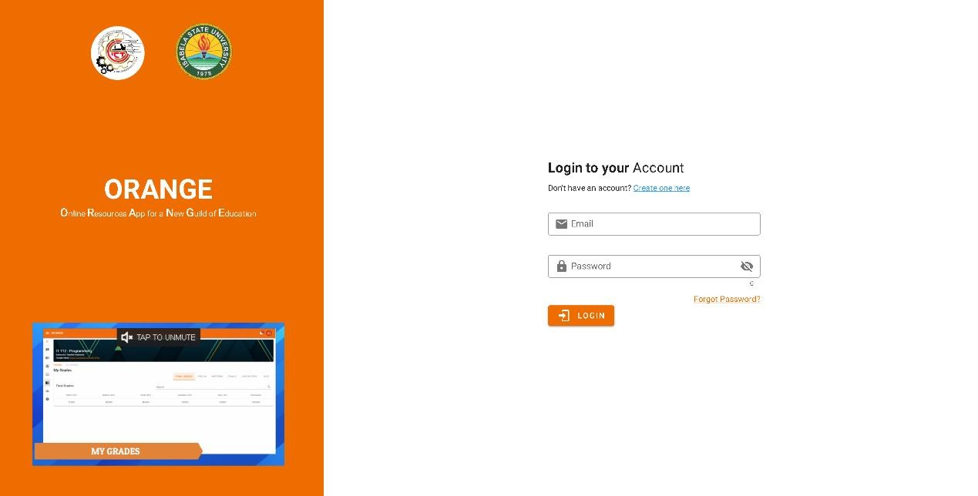

**Faculty Member’s Side**

**Create Course**

Go to [isu-orange.com/courses](https://isu-orange.com/courses) or hover the side navigation and click the **course page**.

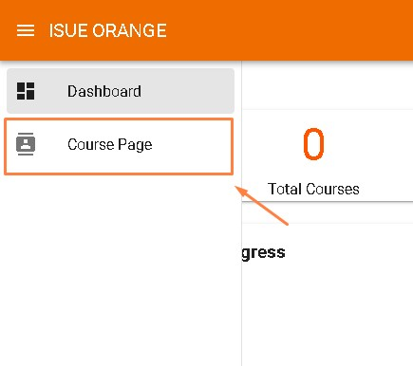

**Step 1**: Click **Create Course**.

The first time you view the course page you will see this figure "**Create your first Course**"

**Step 2**: Input the **Course Code** and **Course Name** and click **save**.

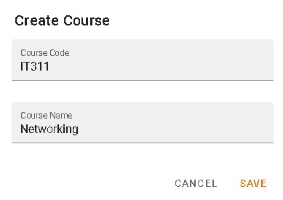

After hitting save you will be redirected to the course setup.

1. **Course Setup** Course Details

Here you need to add additional information about your course and add a video conference link such as google meet, zoom etc.

* 1. Course Code
  2. Course Title
  3. Video Conference Link
  4. School Year
  5. Semester
  6. Course Guide

7.

Course Description

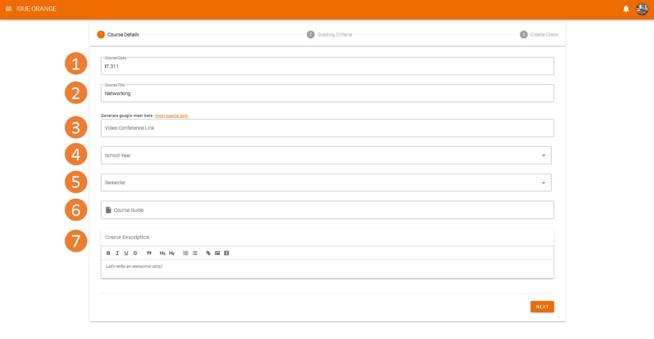

1. **Grading Criteria**

Here is where you can create your own dynamic grading criteria for your course.

There are two fields in creating the grading criteria.

* + 1. **Criteria Name** - e.g. Prelim, Midterm, Finals, Quizzes, Assignment etc.
    2. **Percentage** - the weight percentage of the grading criteria

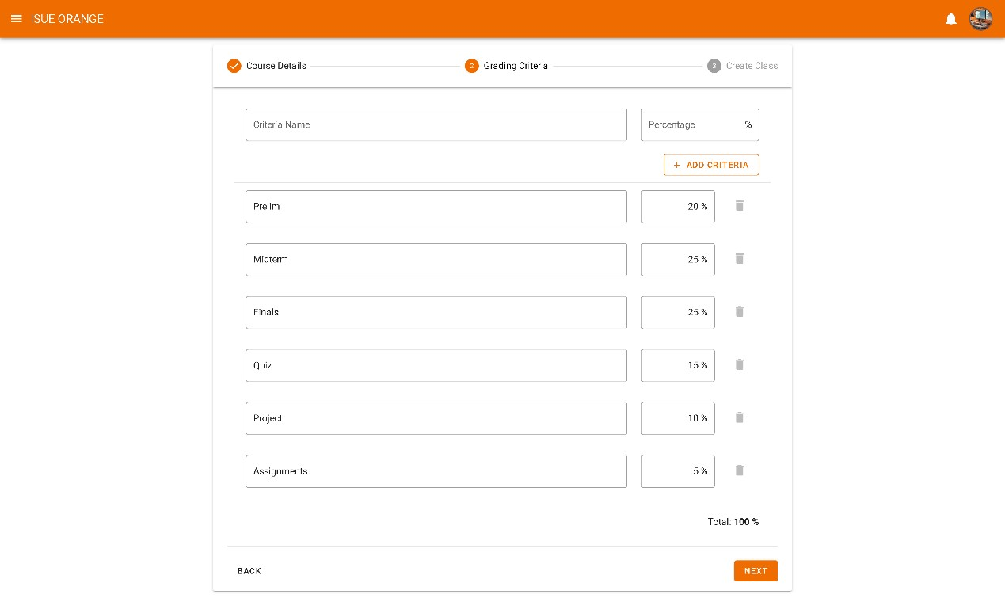

***Note****: You need to have a total of 100% to proceed to the next step.*

1. **Create Class**

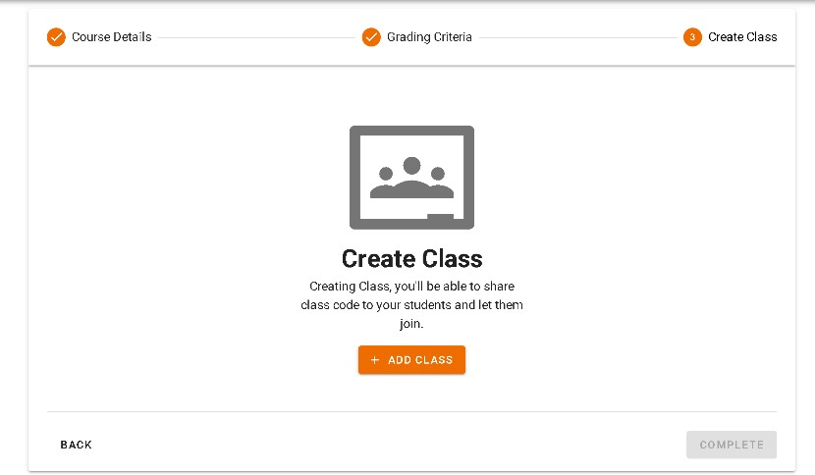

Creating class, you'll be able to share class code to your students and let them join.

* 1. Click **ADD CLASS** and a popup will appear.

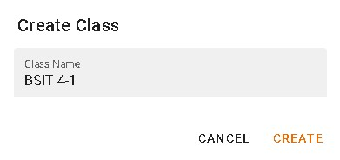

* 1. Input the **Class Name** of your class and click **create**.

* 1. Click **complete** to finish the course setup.

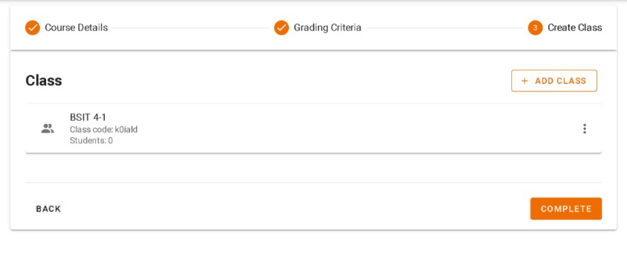

***Note****: You need to create at least one class to complete the course setup.*

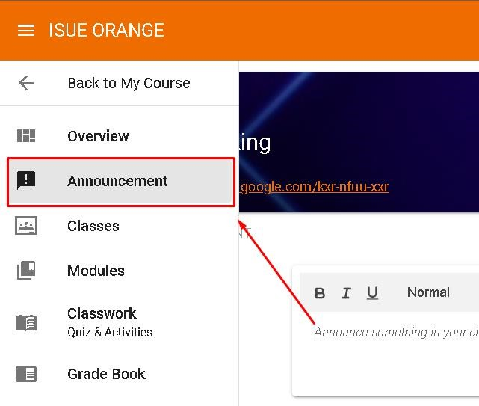

**How to create an announcement** First go to **Announcement tab** inside your course.

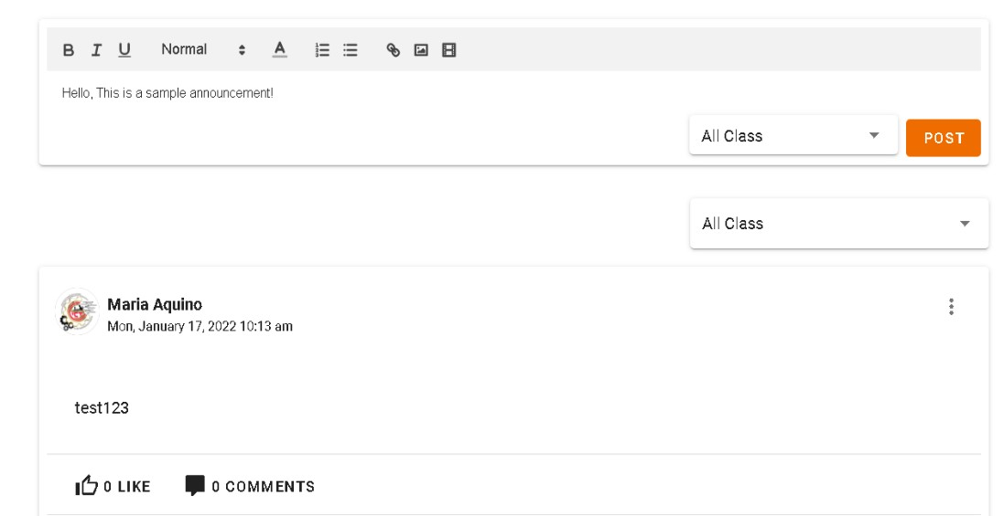

. Tool bar

1



2

. Text field



3

. Class



4

. Post Button

1. **Toolbar** - This contains different button for customizing the announcement such as bold, Italic, underline, Formatting, Text Color, Numbered list format, Bullet list Format, Insert Link, Insert Image and Insert Video.
2. **Text Field –** this is where you composed your post or announcement and can be customize using the toolbar buttons.
3. **Class –** Contains all the list of your classes and you can select here which class you want to publish your announcement and you can also select “**All Class** “ to publish it in all of your classes.
4. **Post Button-** Finally if you are now all set and finished composing your post or announcement just click **“POST”** to publish your announcements to your selected classes.

Modules

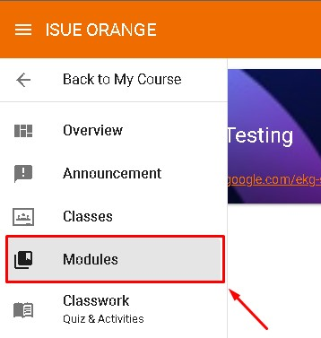

**Create Modules**

**Step 1:** Go to **Modules** page inside your course.

The first time you view the **Modules Page** you will see this figure "**Empty Course Module".**

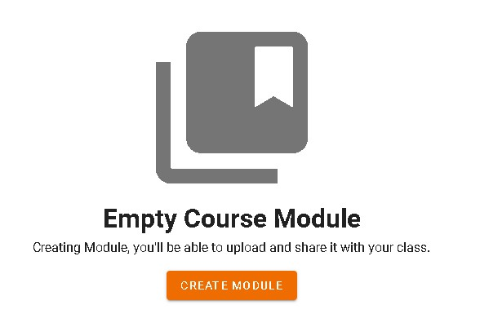

**Step 2**. Click **CREATE MODULE**.

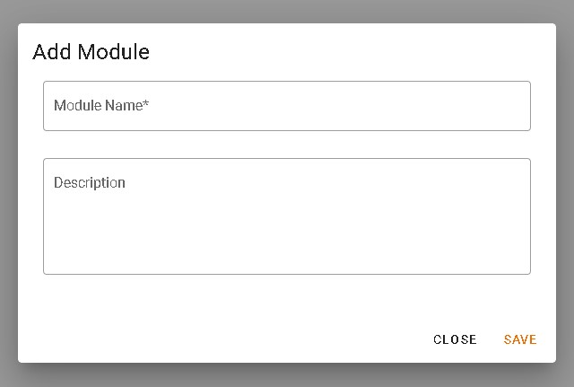

**Step 3**. Input **Module Name** and **Description** and click **SAVE**.

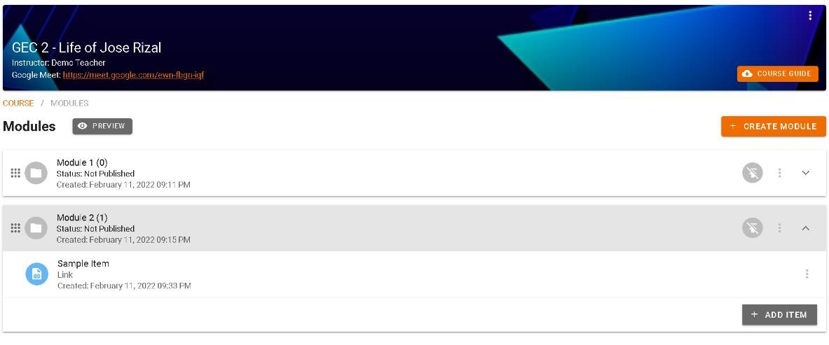

**Modules**



**Module Item/s**



**Publish Button**

**Edit Module**

To delete Module click

**the 3 dots icon**

and a menu will pop up and click

**Edit**

and you can now update your module’s name and description.

**Delete Module**

To delete a Module click

**the**

**3**

**dots icon**

to open the menu for the module and click

**Delete**

.

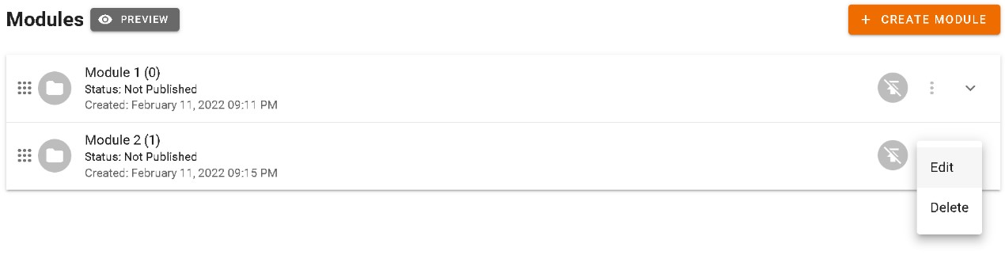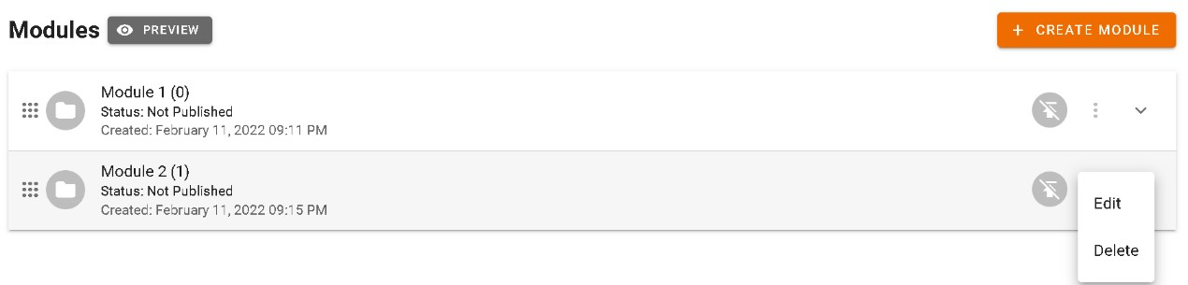

**Add Items to Module**

**Step 1:** Click a module you wish to add an item.

**Step 2:** Click + **ADD ITEM** button

**Step 3:**

Choose an Item type (

**File**

or

**Link**

).

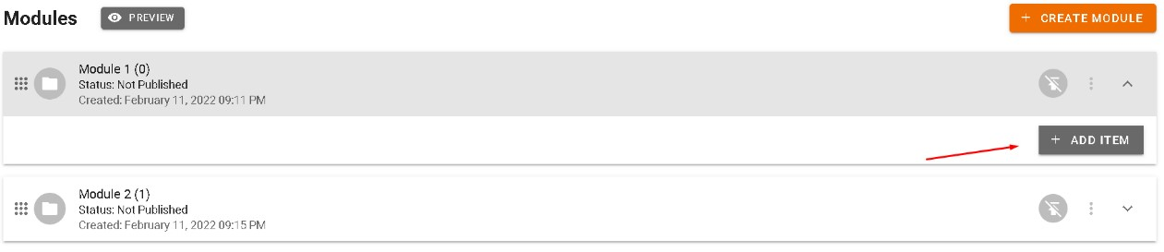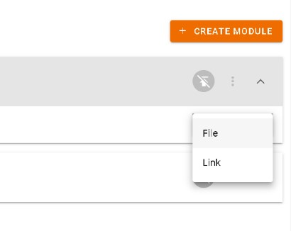

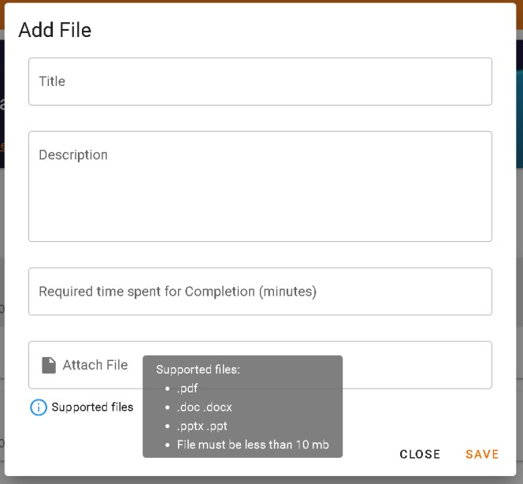**File**

This image shows modal for the adding of **file** on a module.

It contains the following:

* **Title-** title of the file/item
* **Descriptions** - additional information about the file
* **Required Time Spent** – the amount of time you require for the students to complete this item and it should be in minutes.
* **Supported files –** .pdf, .doc,

.docx, .pptx, .ppt and the file must be less than 10 MB.

Fill up all the fields and click **SAVE** to add file on your module.

**Link**

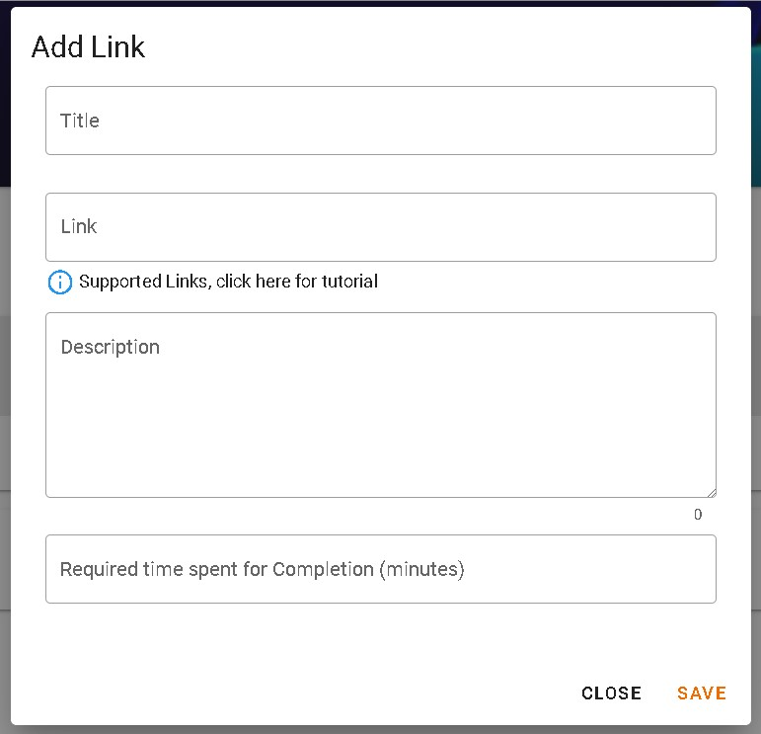This image shows modal for the adding of link on a module.

It contains the following:

* **Title-** title of the link/item
* **Descriptions -** additional information about the file
* **Required Time Spent** – the amount of time you require for the students to complete this item and it should be in minutes.
* **Supported Links–** https://www.youtube.com/watch?v=[video-id] https://docs.google.com/presentation/d/[document-id] https://docs.google.com/ducument/d/[document-id] or any google drive links.

Fill up all the fields and click SAVE to add link on your module.

**Publish Modules**

Here are the steps in publishing your modules.

**Step 1:**

Click this

icon to o

pen the publish settings

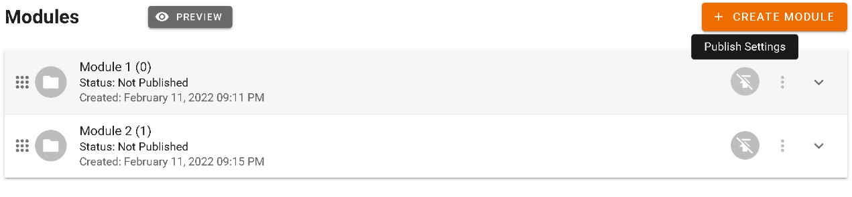

Step 2: Choose your desired settings on the publish settings.

* Always available – the module can be access by your students anytime
* Set Date (From – to) – making your module available on a specific range of dates only.
* Unpublished – making the module unavailable to your students.

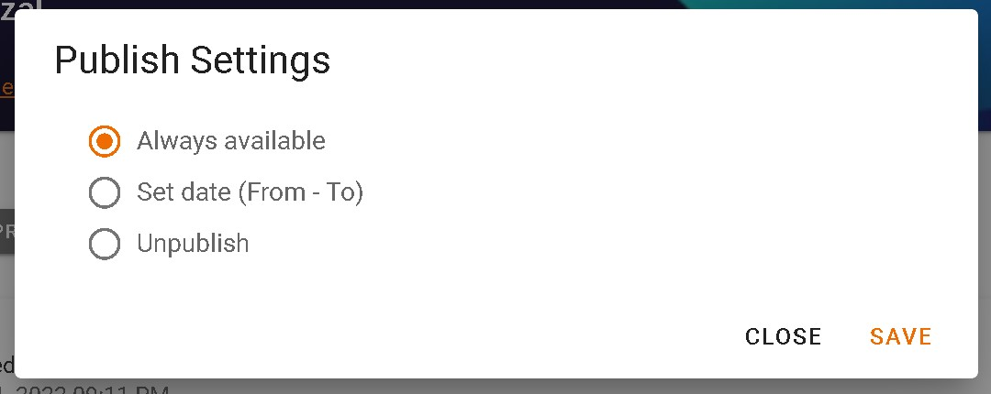

**Edit an Item on a Module**

**Step 1:** Click  the **3 dots icon menu** on the right most part of the item.

**Step 2:** Click **Edit** and a modal will popup item.

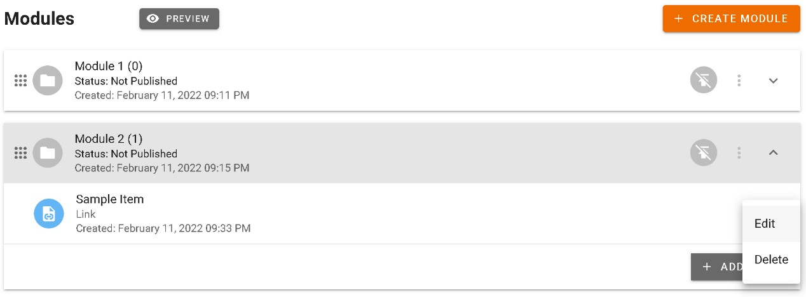

**Step 3:** After editing the item fields click **SAVE** to save changes.

**Delete an Item on a Module**

**Step 1:**

Click the

**3**

**dots icon menu**

on

the right most part of the item.

**Step 2:**

Click

**Delete**

to delete the item.

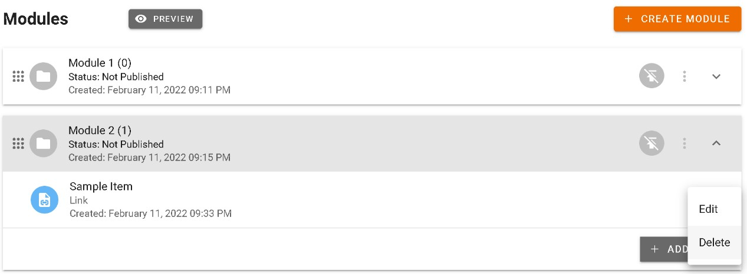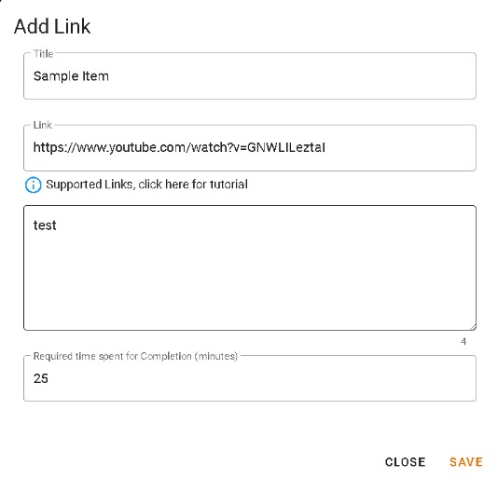

Note: In deleting a module’s item make sure that the module is **not published** and students in your course doesn’t have progress yet on that item.

**Gradebook**

- Gradebooks contains all the grades of the students including their Finals Grades, total grades per grading criteria and also their scores in their classwork activities.

-The faculty members are also able to download all the grades of the students per class in an excel file format.

**Sample screenshot of the exported grades:** [**https://prnt.sc/26ty15n**](https://prnt.sc/26ty15n)

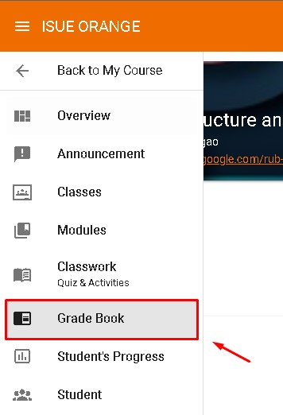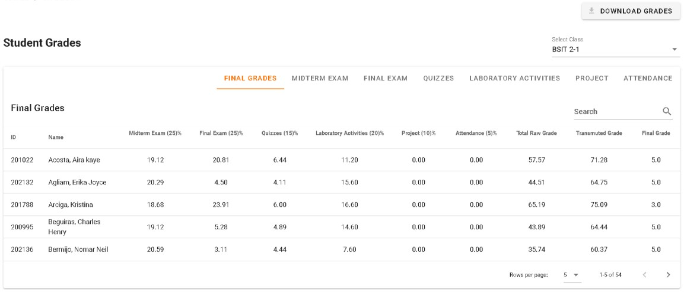

**Sample screenshot of the faculty members’ gradebook**

**Student Progress**

•

This displays the student's progress

when a module is selected. The faculty

members can view the students’

progress on the learning material that is

inside the selected modules.

•

Faculty members can also see the time

spent of the students per learning

mate

rials and if the background color of

the time spent is green this means that

the student has reached the time spent

requirement that is set by the faculty

members and when the background

color is red this means that the student

did not reach the required t

ime spent.

•

Faculty members are also able to see

the total accumulated time spent of the

students in the selected modules

.

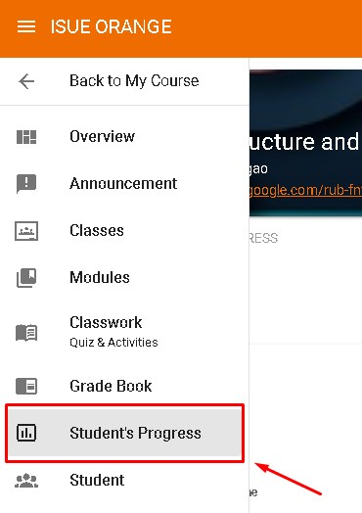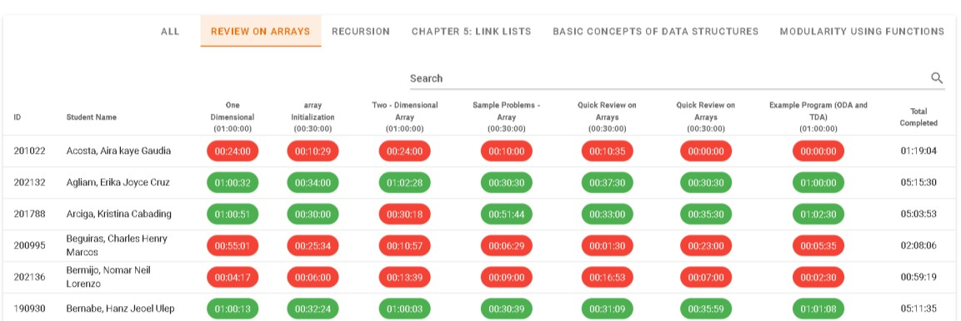

**Screenshot of the Student’s Progress for Module**

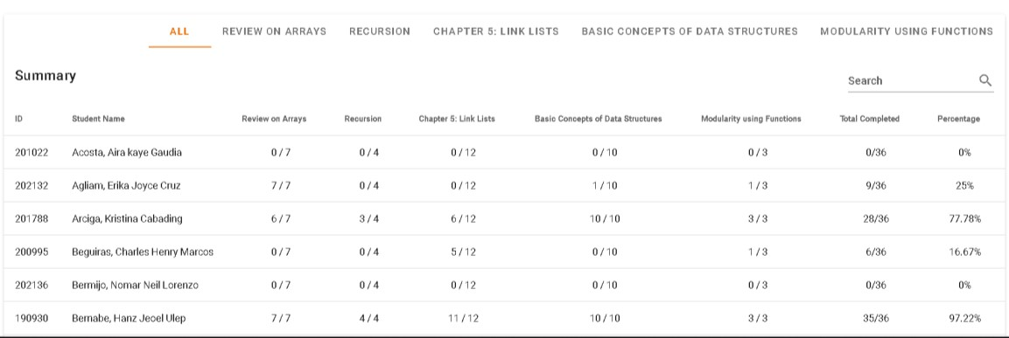

**Screenshot of the Student’s Progress Summary**

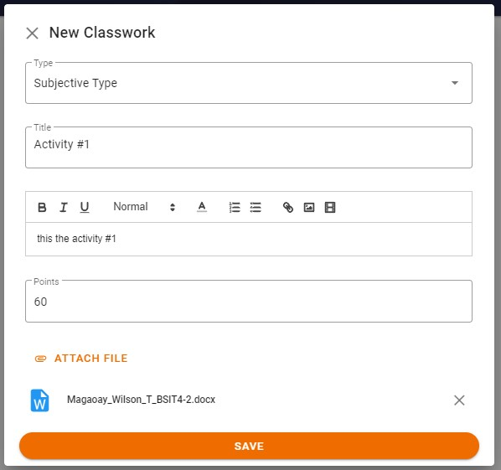**How to create Classwork** First go to **Classwork tab** inside your course.

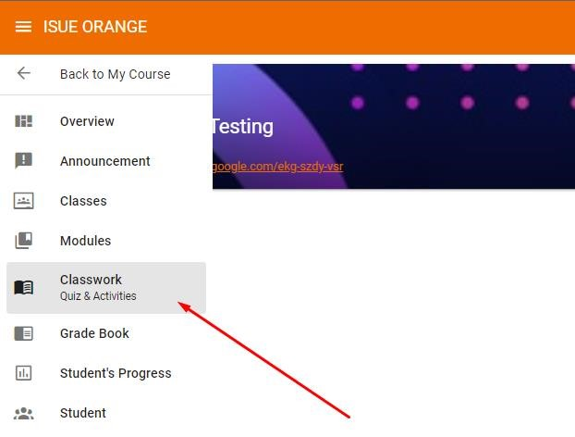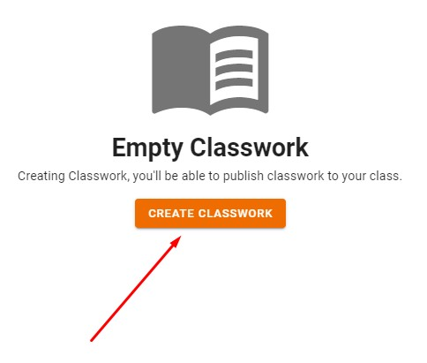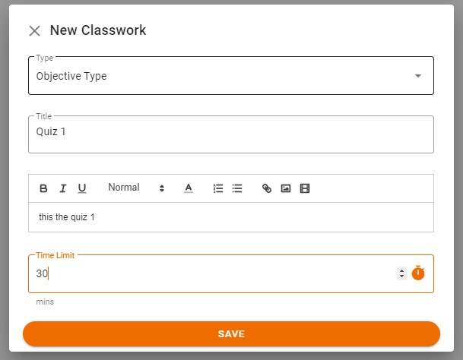

**Step 1: Click Create Classwork Button.**

The first time you view the classwork page you will see this figure "**Empty Classwork**"

**Step 2: Select Classwork Type objective or subjective type classwork.** Input **Title, Instruction, and Time Limit** for objective classwork, **Points** and **Attach File** for subjective type classwork.

After hitting save you will be redirected to the question tab where in you can add question in your classwork if your classwork is objective type and classwork details tab where you can edit the details of your classwork if your classwork is subjective type.

1. **Classwork Details**

Here is where you can double check and update details of your created classwork

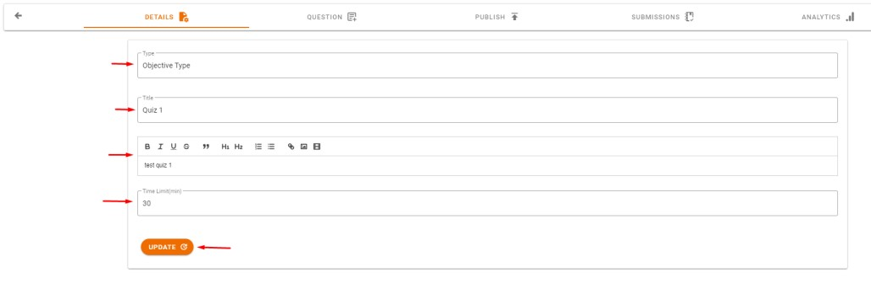

5

. Update Button

4

. Time Limit

3

. Instruction

2

. Title

1

. Classwo

rk Type

* 1. **Classwork Type**
  2. **Title** – the title or the name of your classwork.
  3. **Instruction** – additional information or instructions about your classwork.
  4. **Time limit** – time limit for your objective type classwork in minutes.
  5. **Update Button** if all details are set you click this this button to update the details of your classwork.

1. **Adding Question in Objective Type Classwork**

**Step 1: Click Add Question Button.**

The first time you view the question tab you will see this figure "Empty Question"

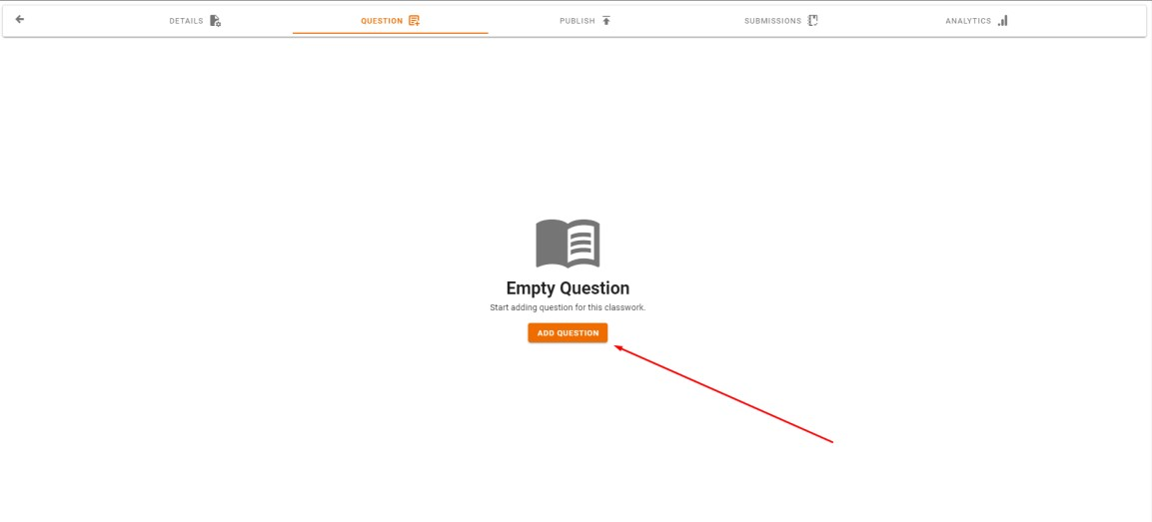

**Step 2: After Clicking the Add Question button.**

A new question will be added you can now Input the Change Points and Question Type of question and Input the Question and the Options.

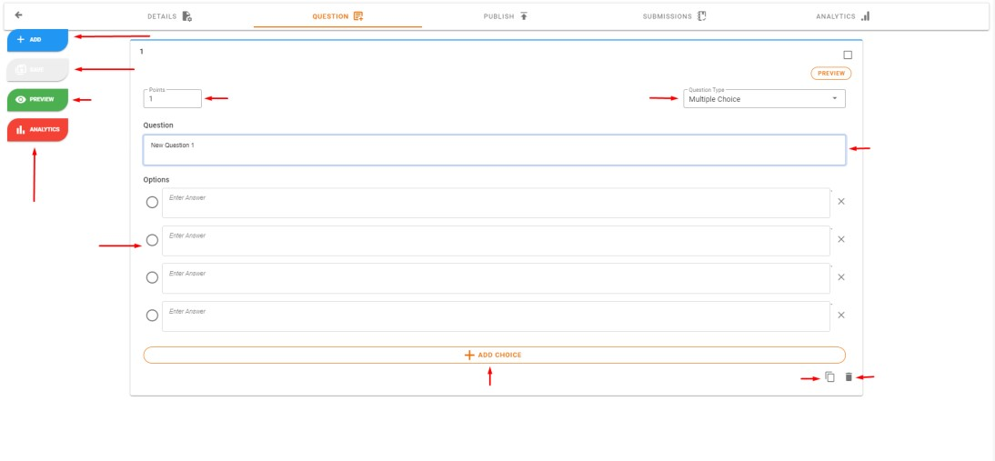

1

. Add Question



. Save

2



5

. Question Points



3

. Preview

Question



4

. Question Analytics



8

. Options



7

. Question

Description



. Delete

11

Question



10

. Clone Question



9

. Add Choices



6

. Question Type

1. **Add Question** - clicking this button will add another question to list.
2. **Save** **button -** this button is used to save all change you made in your question list, once new change is done the button will change color to orange means there is new changes that are not save yet.
3. **Preview** **button** - once you are done adding question you can click the preview to view what the student side can view when they are taking you classwork questions.
4. **Analytics button** – clicking this button you will be redirected to the analytics tab where you can view your classwork’s analytics.
5. **Points** - it shows the points of each question in your list, you can change point value in each question
6. **Question** Type you can change type of question such as multiple choice, Identification, True or False, Matching Type and Essay.
7. **Question Description**
8. **Options** you can add the options description and select the answer by clicking the radio button of the correct answer.
9. **Add Choice** – in multiple choice you can add additional choices
10. **Clone Question**-if you are making quiz with same question type you can just click this button and clone the question and change its details
11. **Delete Question**

1. **Publishing Classwork**

Here is where you can publish your classwork in your class, for your student to access your classwork.

To publish your classwork here are the following steps:

**Step 1: Click Publish Classwork Button.**

To start publishing your classwork you need to click this button and a dialog will show

**Step 2:**

Select if you want to review

the question

of your classwork

before publishing or just continue in

publishing your classwork

**Step 3:**

After reviewing or

Continue Publish your classwork

you can now select the Class

where you want to publish your

classwork, Select Grading

Criteria where your clas

swork

will belong to, set the

Availability your classwork and

set the review answer if you want

to your classwork answer to

show to your student.

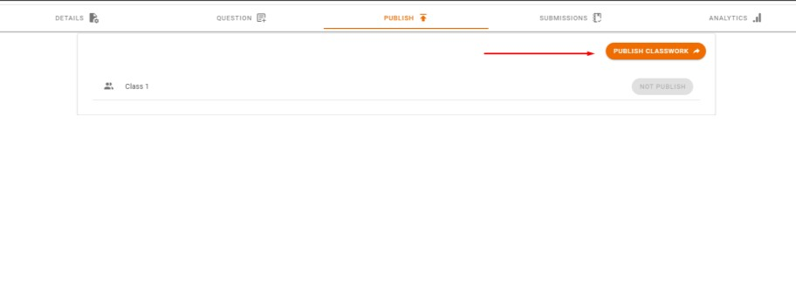

. Publish Classwork

1

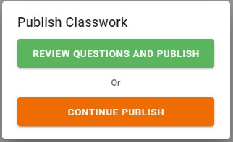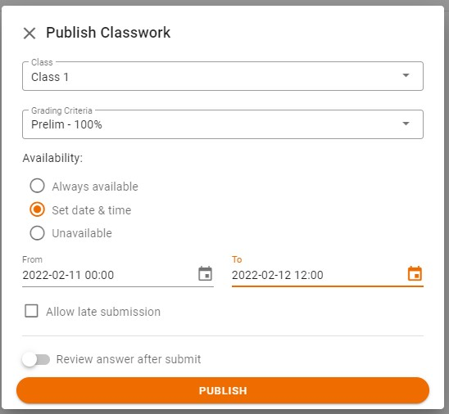

1. **Classwork Submission**

Here is where you can see all submission of student in your created classwork publish your classwork in your class, for your student to access your classwork.

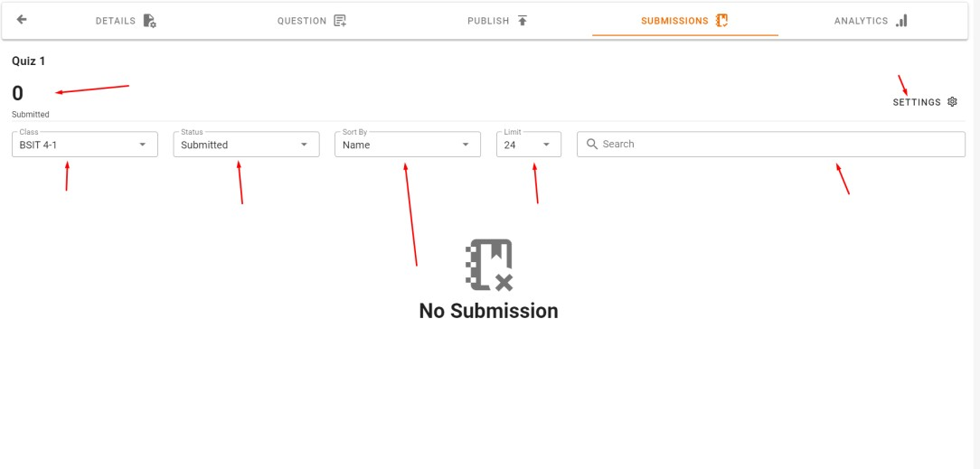

.

1

Submission Count



2

.

Class



. Status

3



4

. Sort



5

. Limit



6

. Search



. Setting

7

* 1. **Submission Count** the total submitted student
  2. **Class** you can select which class submission will only show
  3. **Status** you select submission status such as **Submitted**, **Submitting**, **No** **Submission**
  4. **Sort**
  5. **Limit** by default limit is set 24 submissions but you change limit to all to show all submission.
  6. **Search** student in list of submissions
  7. **Settings** click to reset or alert student about the classwork.

1. **Analytics**

Here is where you can view the simple analytics of the question in your classwork, you see the number of correct and incorrect student in each question.

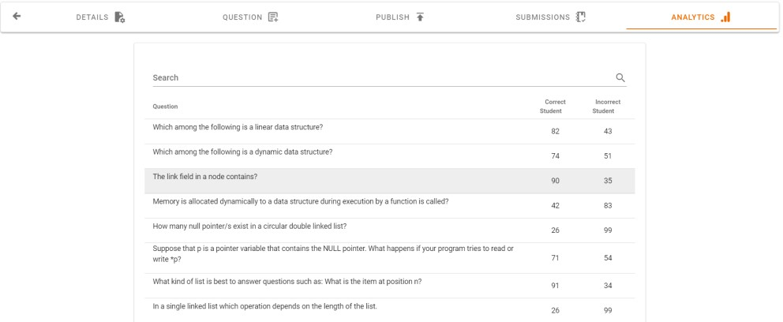

**How to view submission of student**

First go to **Submission Tab** inside your **Classwork**.

**Step 1**: Click **Student Submission**.

To view student submission, you need to click a student in list

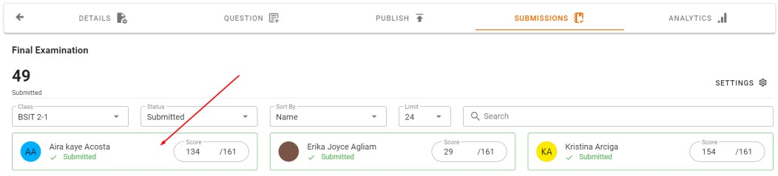

Student Submission

**Step 2**: After clicking **Student in list**.

You can now see all the answers of student in the question of your classwork if your classwork is Objective. You can also see the activities of student during examination taking

1. **Objective Type Classwork Submission Viewing**

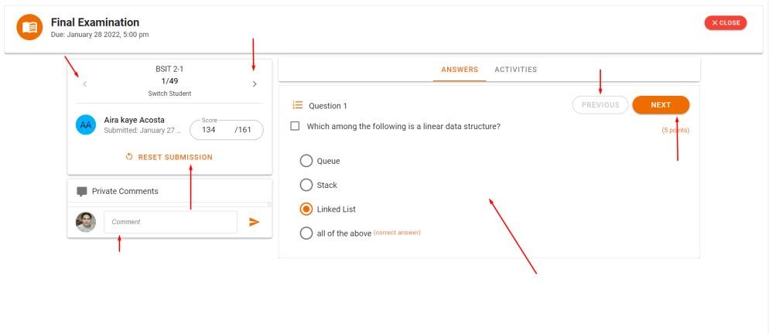

2

. Next Student



1

. Previous Student



3

. Reset

Submission



4

. Comment



7

. Submitted Answers and Activities



6

. Next



. Previous

5

* 1. **Previous Student** click to go to previous student in list.
  2. **Next Student** click to go to next student in list
  3. **Reset Submission** click to reset the submission of the student you are viewing.
  4. **Comment** write private comment in your classwork
  5. **Previous Question** click to go to previous question
  6. **Next Question** click to go to next question
  7. **Submitted Answers and Activities** view students answers and examination activities

1. **Subjective Type Classwork Submission Viewing**

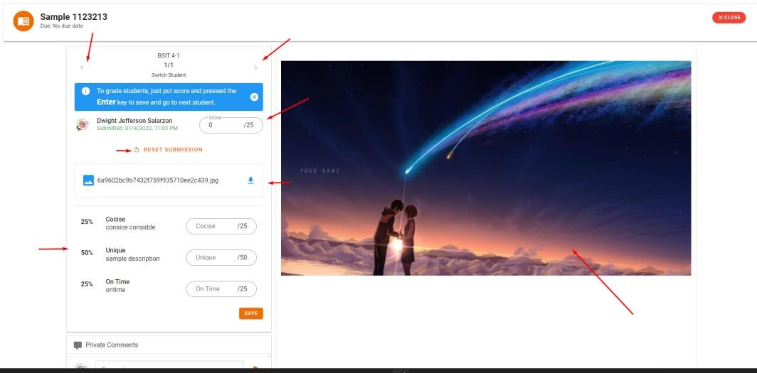

1

. Previous Student



2

. Next Student



. Score

3



. Submitted File

5



.

6

Criteria



7

. File Viewer

* 1. **Previous Student** click to go to previous student in list.
  2. **Next Student** click to go to next student in list
  3. **Score** this where you can put score of students after checking his submitted file.
  4. **Reset Submission** click to reset the submission of the student you are viewing.
  5. **Submitted File** this is the list of files the student submitted.
  6. **Criteria**
  7. **File Viewer**

**Student Page**

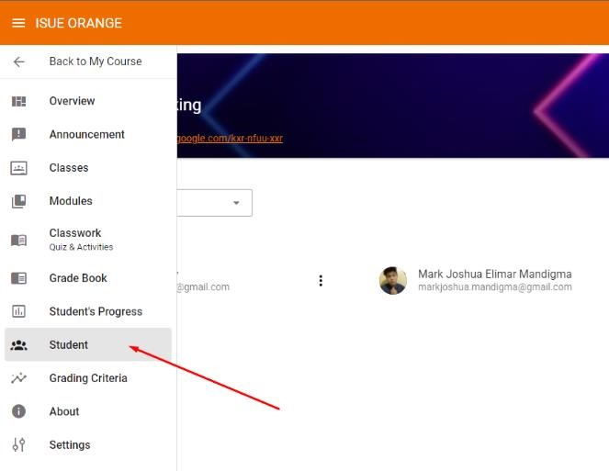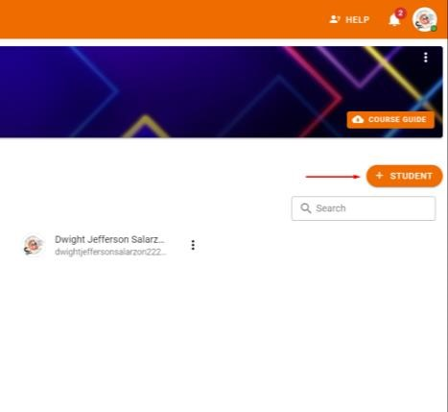

Add Student

Here you can add, move, and remove the student in your course.

1.**Adding Student**

**Step 1**: Click **Student with plus Icon**.

.

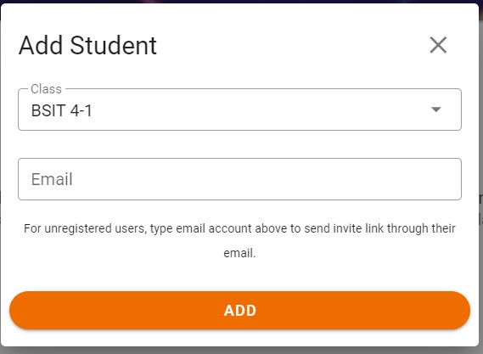

**Step 2**: Select which **Class** the student will be added and Input the **Email** of Student and click **Add**.

**2**

**. Moving Student**

**Step 1**

:

Click

**3**

**Dots Icon**

in right side of the

Student you want to move and click the

**Move Student**

.

**Step 2**

:

Select the

**Course**

and

**Class**

where you want to move the student and

click

**Confirm**

.

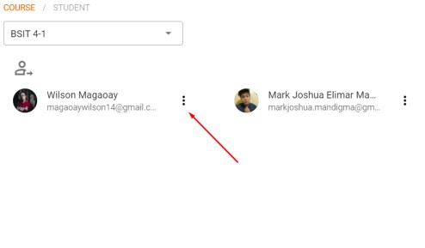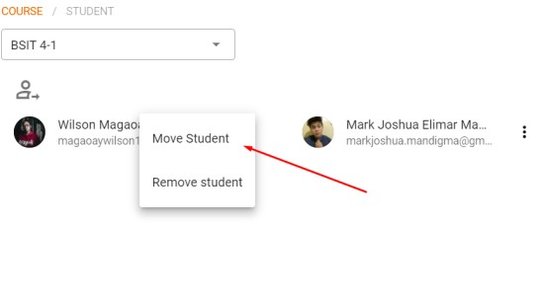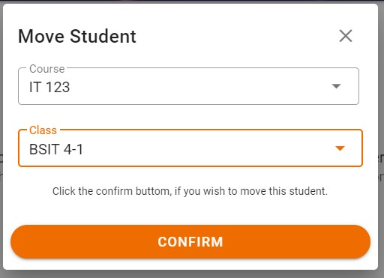

**3**

**. Removing Student**

**Step 1**

:

Click

**3**

**Dots Icon**

in right side of the

Student you want to remove and click the

**Remove Student**

.

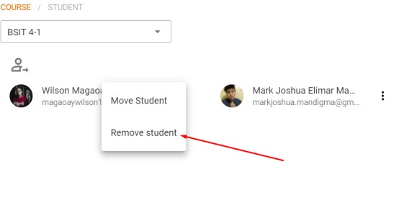

**Step 2**: Click the **Confirm** to remove student.

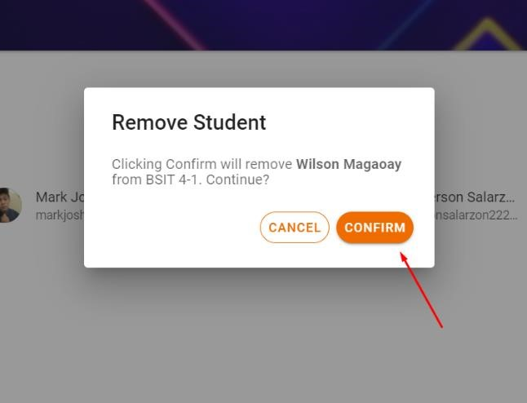

**Grading Criteria**

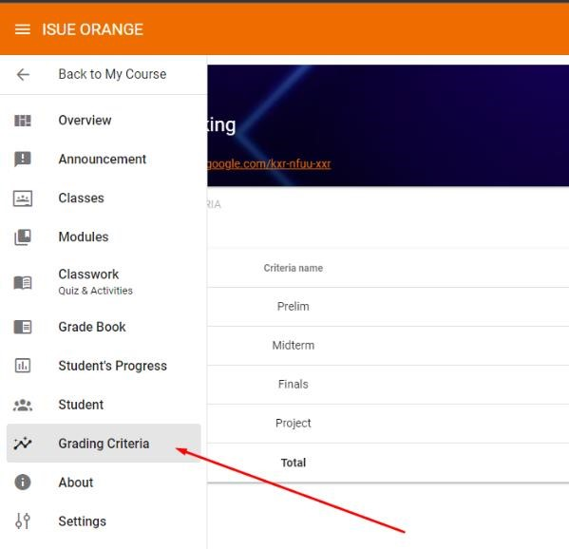

Here you can add, update, and delete the grading criteria of your course.

**Adding New Grading Criteria Step 1**: Click the **button on the bottom right** to add new grading criteria.

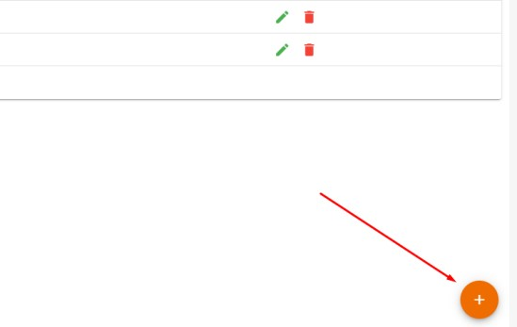

Add Button

***Note****: This button will only show up if the total grading criteria of course is below 100%.*

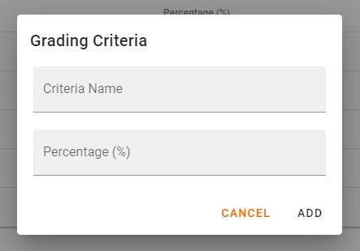**Step 2**: Input the **Criteria Name** and **Percentage** of this criteria and click **Add**.

**Updating Criteria Step 1**: Click the **Pencil Icon** of criteria that you want to update.

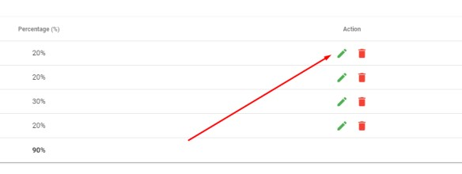

Edit Button

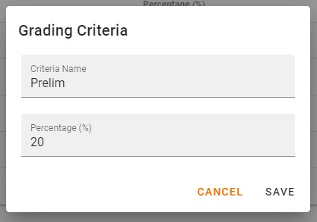

**Step 2**: After clicking the update button you can put the new **Criteria Name** and new **Percentage** for the criteria and click **Save**.

**Delete Grading Criteria Step 1**: Click the **Trash Bin Icon** of criteria that you want to delete.

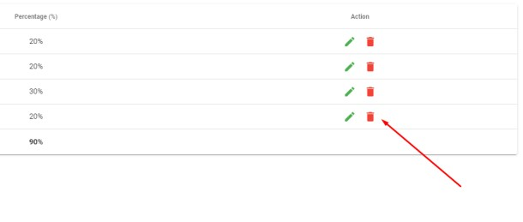

Delete Button

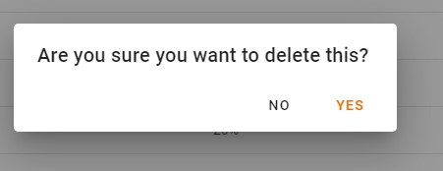

**Step 2**: After clicking the delete button a new dialog will show up and just click the **Yes** to delete criteria.

##### STUDENT’S SIDE

**Dashboard Page**

After successfully logging in you will be directed to the dashboard were you can view the summary in every course they’ve enrolled. You can also view the events on their calendar and the task assigned to them.

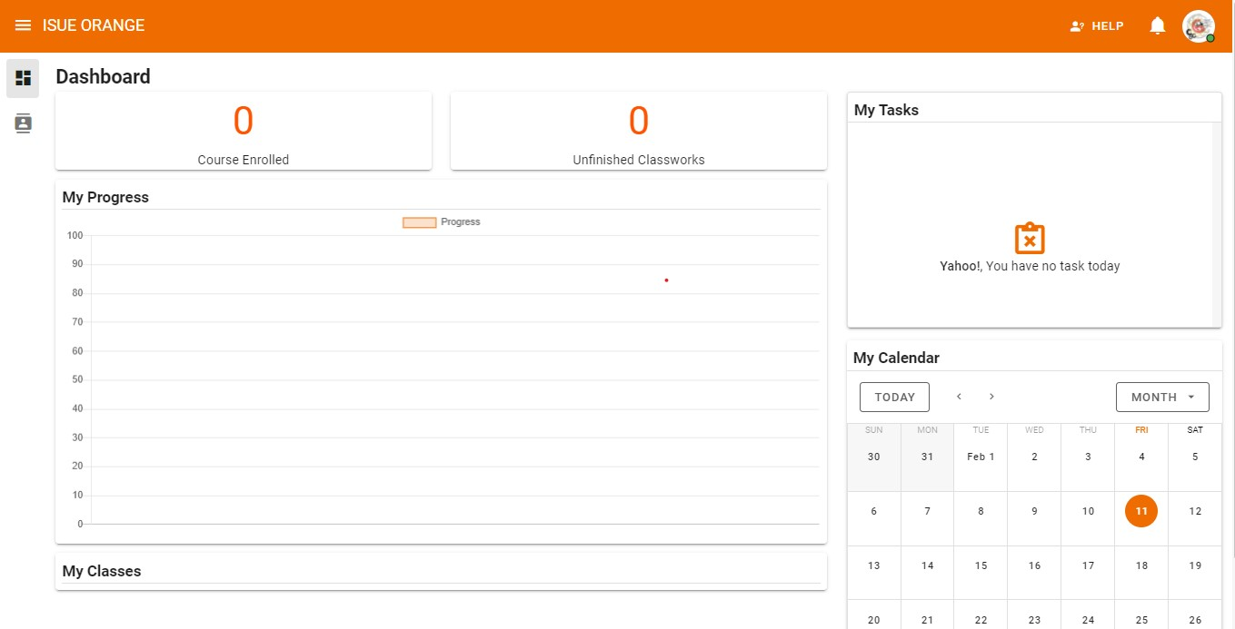

***Student’s Classes Page***

To proceed on your Course **Page** you must hover and click the Classes button on the left pane of the website **Classes Page**

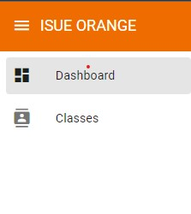

Displays all your classes you are joined in and this page also allows you to join classes.

**How to Join Class?**

Here are the following steps to join a class.

***Step 1: Click Join Class*.**



***Step 2: Enter class code* –** Enter the class that is provided by your teacher. And click **JOIN** button to join the class.

the you wish to open on your classes page. As shown on the number 1.

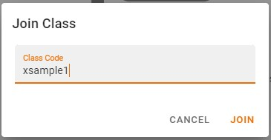

1

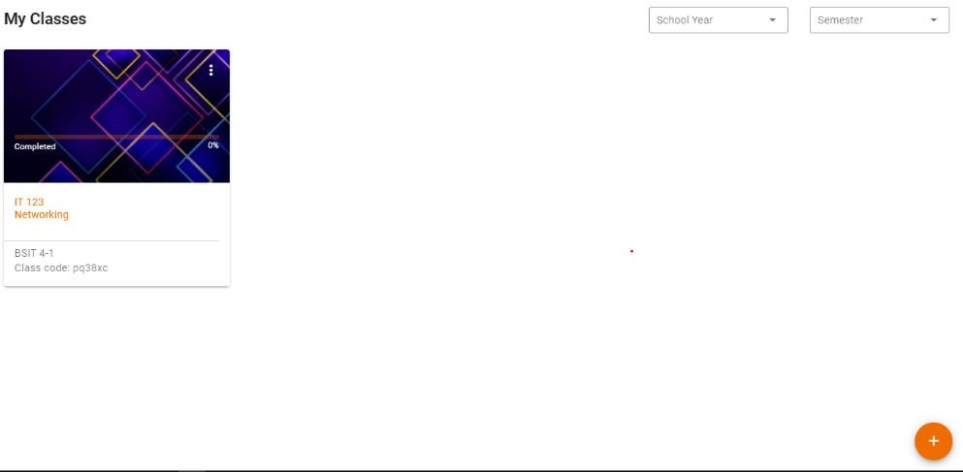

1



2



3

**How to open my Class?**

-To open your class just click class

**Note:**

*You can also filter your classes by selecting* ***school year*** *and* ***semester*** *that is shown in number 2.*

***To join to another class just click the plus icon on the bottom right of the system as shown on the number 3.***

**Announcement Page**

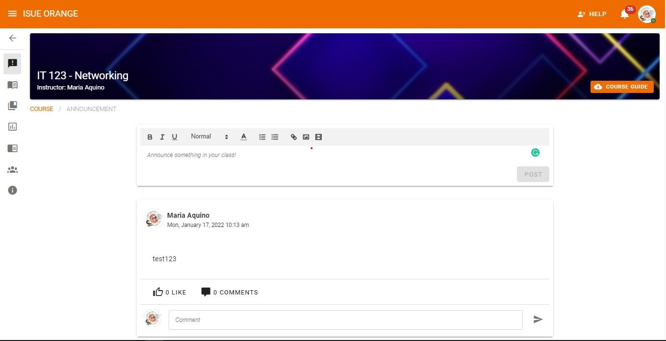

1

**How to post an announcement?**

*Step 1:*Click the text field and input your announcement.

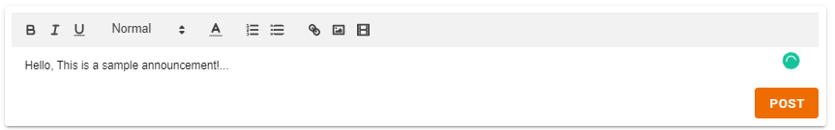

2



3

*Step 2*: To **Edit** or **Customize** the things inside the **field**, you can use the **Buttons** above such as **B** for bolding the letters, ***I***for styling the letters to italic, **U** for underlying the letters, you can also choose from different types of **heading** from **normal**, **1 to 5**, **A** choose a color for the letters, and **bulllets** and **numbering**.

*Step 3*:After editing and customizing and you ready to post it click the **post button** to post in that course.

***Note:******student’s*** *and* ***Faculty member*** *can Like and Comment on your Post so* ***“Think before You Click”*** *before Posting.*

**Classwork:**

**Quiz and Activities Page**

To view and take

**Classwork**

, hover your

mouse on the left pane of the website and

**click Classwork**

.

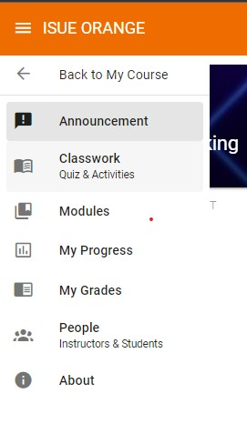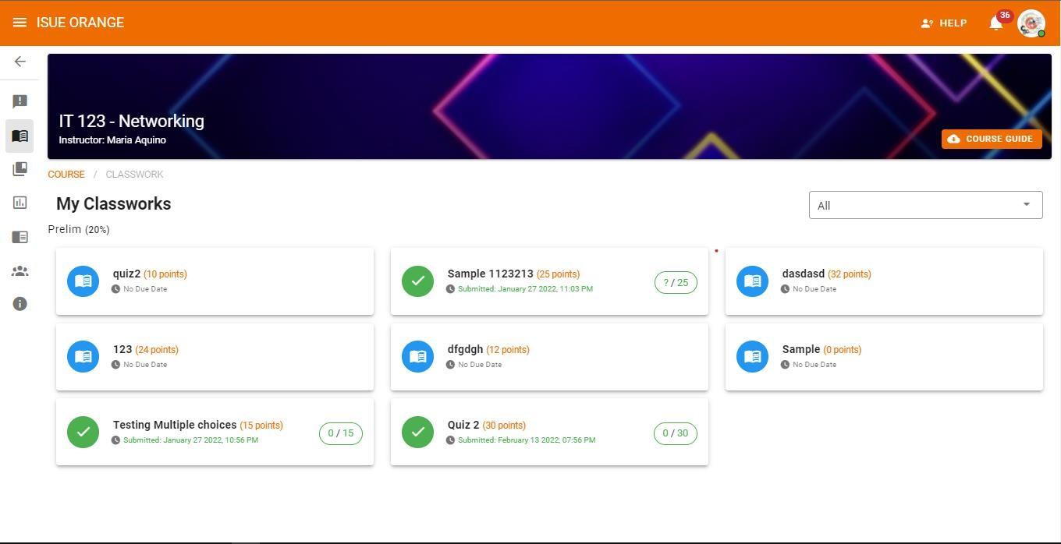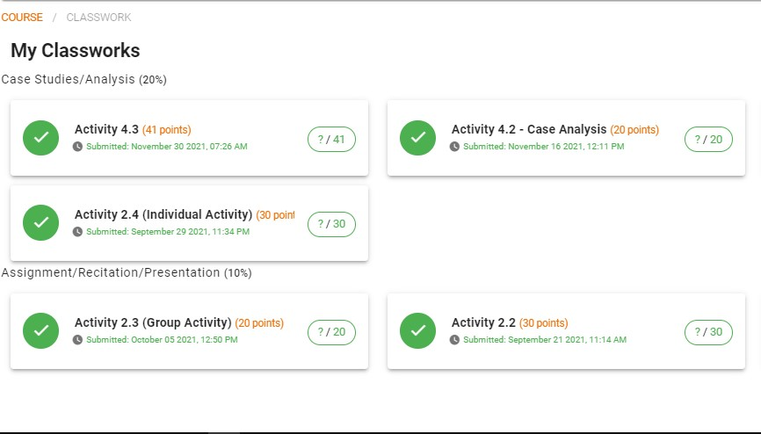

***Screenshot of Classwork page***

**How to take Quiz or Activities**

***Step 1***

**:**

To take Quiz or

Activities, click the

assigned quiz

or activities.

***Step 2:***

A modal will pop

up containing the

description of the classwork. Click

the

**view quiz**

to proceed.

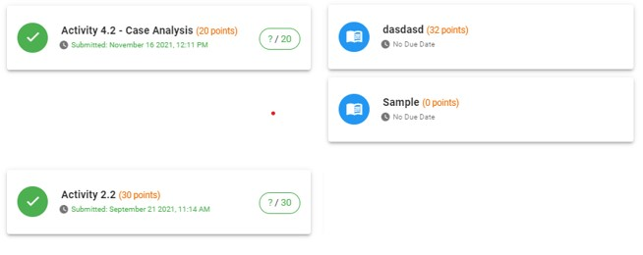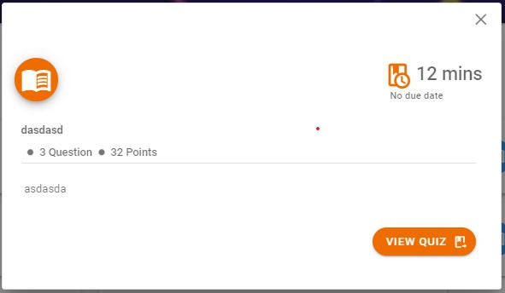

***Step 3:*** On this page you will be able to view the description of the activity, time limit, the due date, the title of the classwork, and how many questions and points it contains. After viewing the content and being ready to take the activity you can click the take quiz button to proceed, you can also interact with the faculty member by messaging them privately if there’s something wrong with the activity before or after taking it.

***Step 4***

**:**

after hitting the take quiz a pop

message showing. If you are ready to

take it click the

**start**

to proceed and

cancel if not ready.

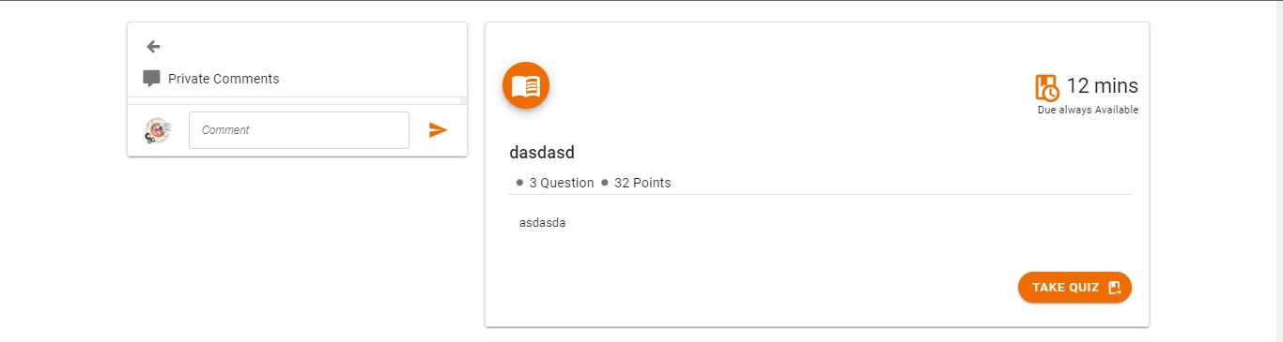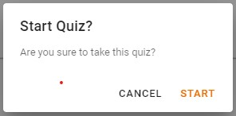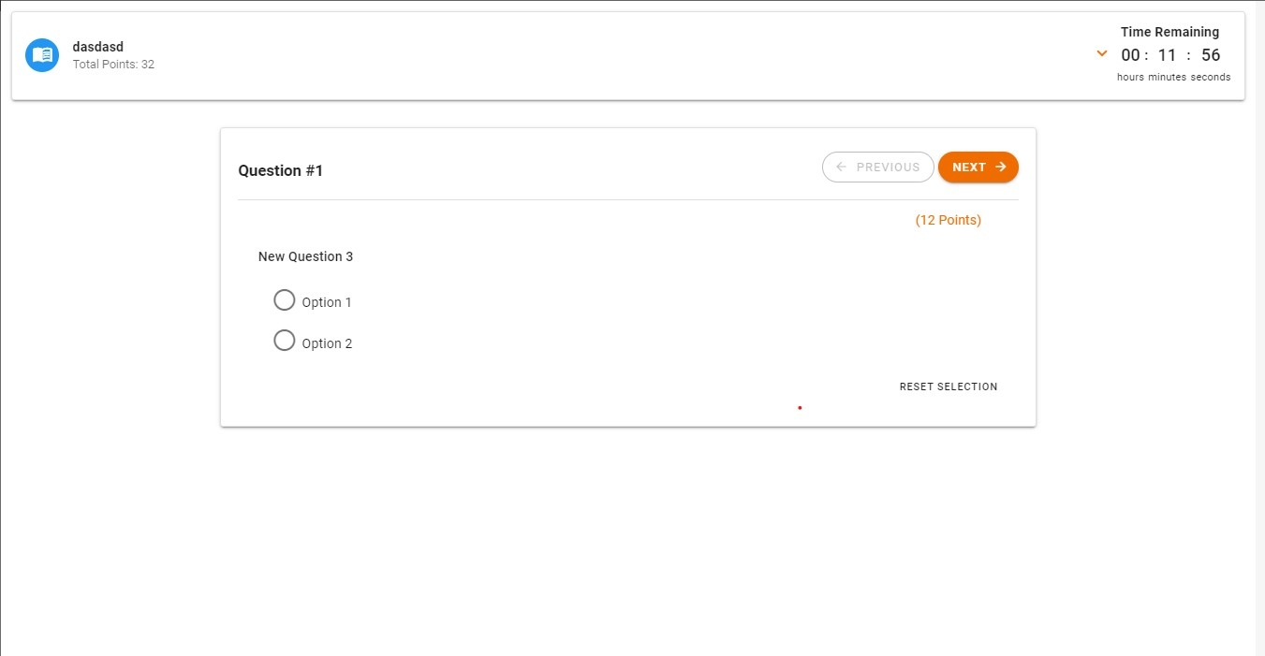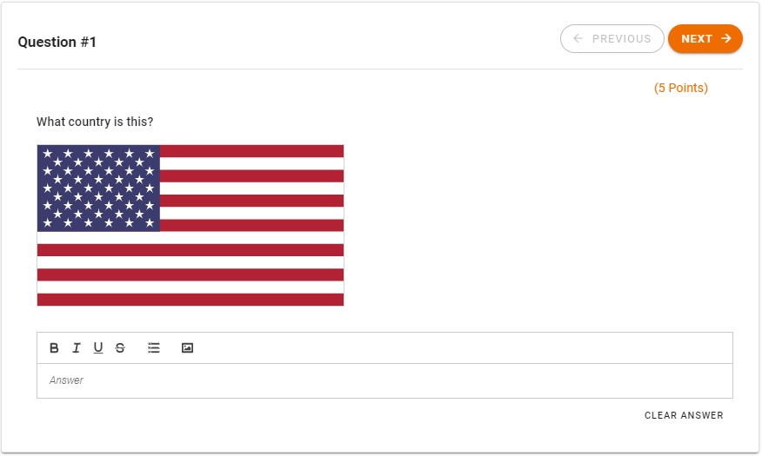

**1**



3



6



**2**



4



5



7

8

1. **Title**: Displays the title of the activity and the total points.
2. **Time Remaining**: Displays the remaining time of taking the activity.
3. **Number of Question**: Displays the current question number.
4. **Previous and Next**: This serves as the forward and backward button.
5. **Points**: Display the points in every questions.
6. **Question**: this part shows the question’s description.
7. **Clear Answer**: this clear the answers you inputted.
8. **Answer Field**: this part shows different type according to the type of question.

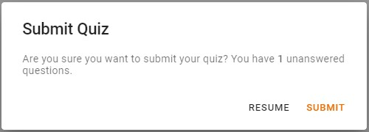***Step 5:***after answering all the questions, you can now submit your answers.

And a pop up message will show like the image below.

After submitting you will be moved to the viewing page of the activity together with their totaled score.

***Note***

*:*

*While you*

*are taking the exam, if you*

*leave the examination page or (open another*

*page or application) or switch tabs you will*

*receive a warning message saying. Your*

*activities during are recorded and can be*

*viewed by your subject instructor.*

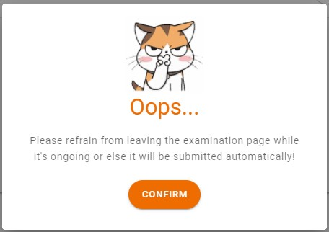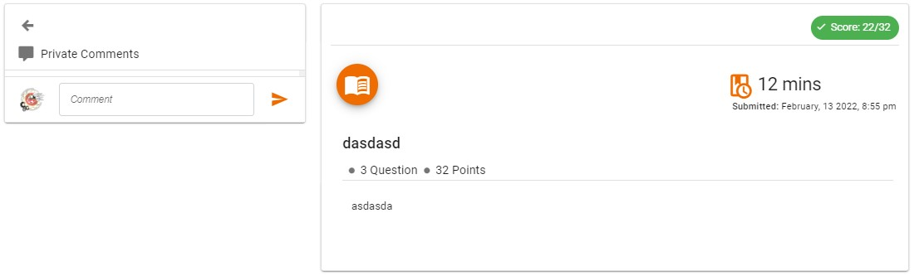

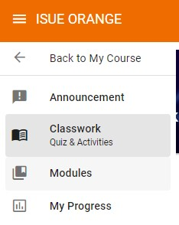**Modules**

To view **Modules** hover your mouse on the left side pane of the website and **click Modules.**

##### Modules Page

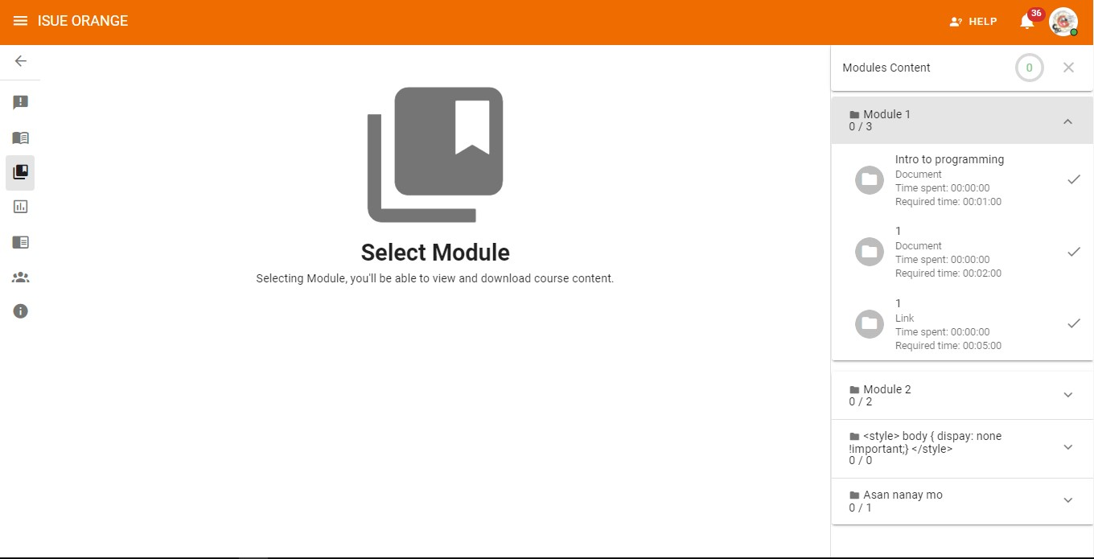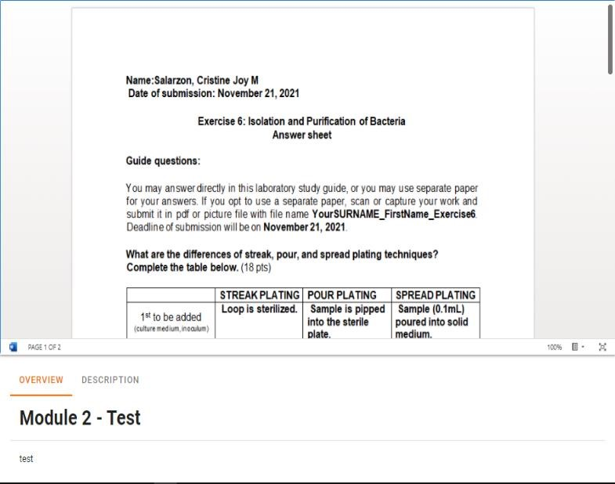

**Total Percentage**



**Module**



**Module**

**Items**



**Viewing Section**

1. **Total Percentage:** Displays the total percentage completed.
2. **Module:** Displays the name and how many items it contain.
3. **Module Items:** Displays the Name, Time Spent, and the required time to complete the item.
4. **Viewing Section:** Displays the content of the item selected.

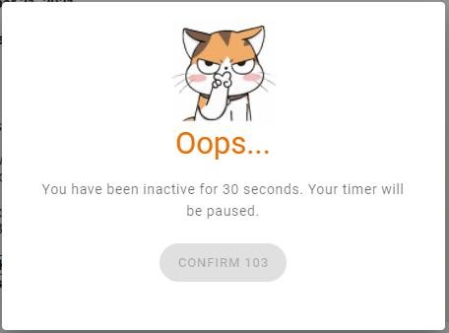***Note:*** *if you leave the page, lost focus or became idle while reading an item the you will receive a warning message as shown in this picture.*

**M**

**y Progress**

To view

**My Progress**

hover your mouse on the

left and

**click**

**My Progress**

and you will be

redirected to

the my progress page as shown

below.

The

**ALL tab**

Display the total

**Completed**

and

the total

**Percentage**

in every

**module.**

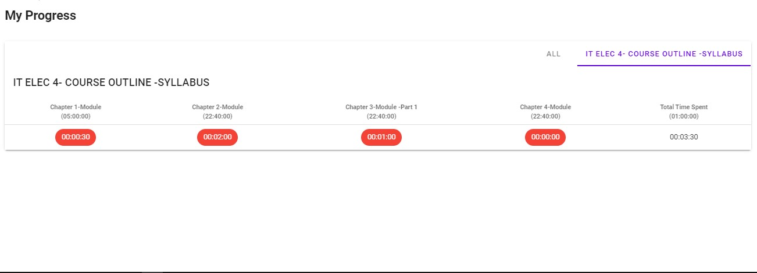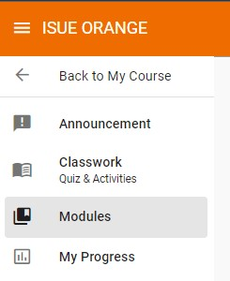

***Note****: the red color in every Module item indicates you does’nt met the required time on that module module’s item.*

***My Grades***

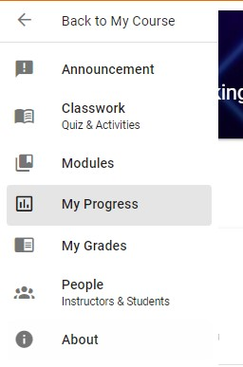

To view and take **My Grades** hover your mouse on the left side bar and click **My Grades** and you will be moved to the My Grades page as shown below.

The **FINAL GRADES** part Display the total **Percentage** in every **criteria that faculy member created.**The **Grading Criteria such as QUIZ, FINAL EXAM, PRELIM and etc** arethe criterias created by the faculty member in that course.

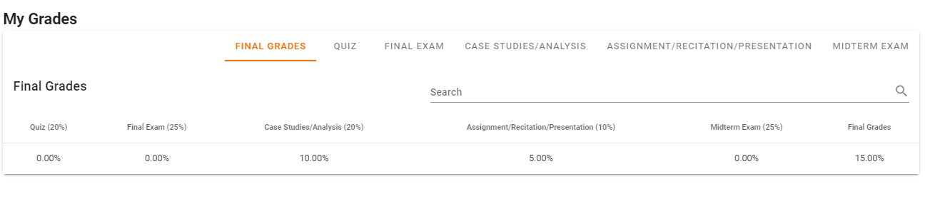

The x symbol on the when a certain criteria is selected indicates that the you didn’t submit or take the actvity.

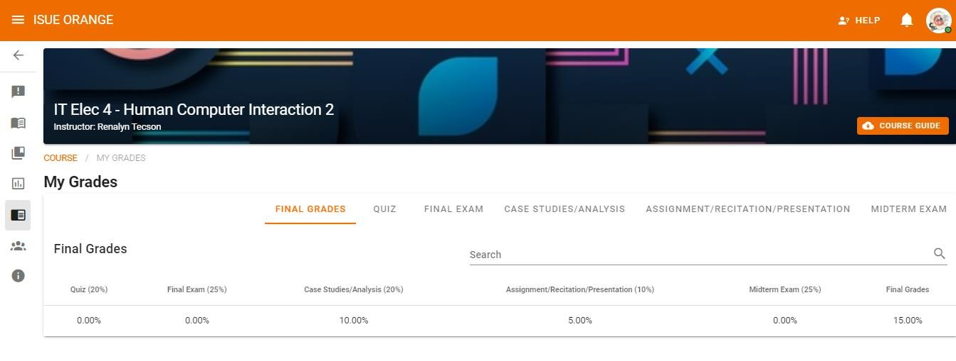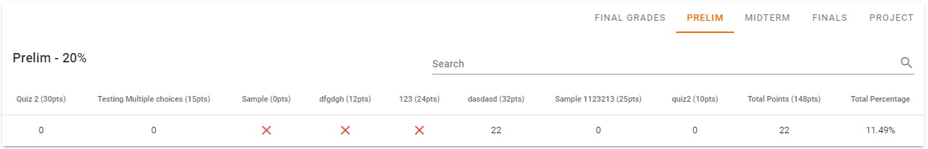

**People: Instructors & Students**

To view **People’s page** hover your mouse on the left pane of the website and **click** People.

After clicking of the People the student will be move to the People page as shown below.

The **People Page** displays all the student that joined in that course and your teacher.

**About**

To view about page hover your cursor on the left pane of the website and click **About**.

After clicking of the About the you will be moved to the About page as shown below.

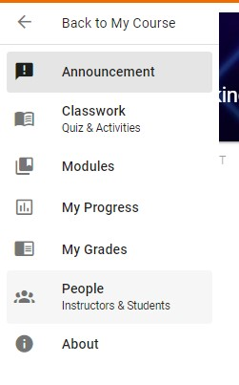

The **About** Page displays the **description** about the course and **Grading Criteria** of the course as shown in the image below.

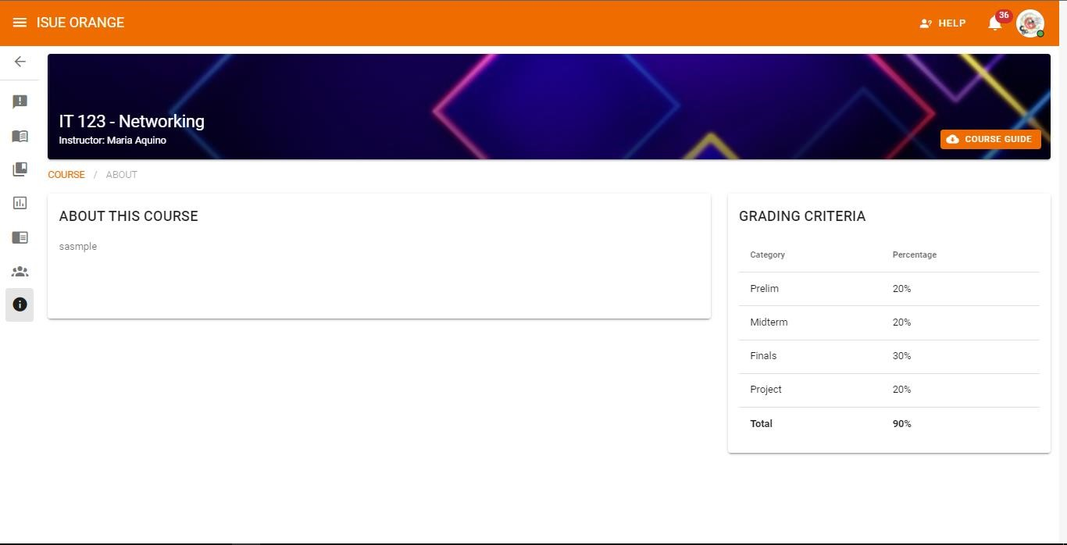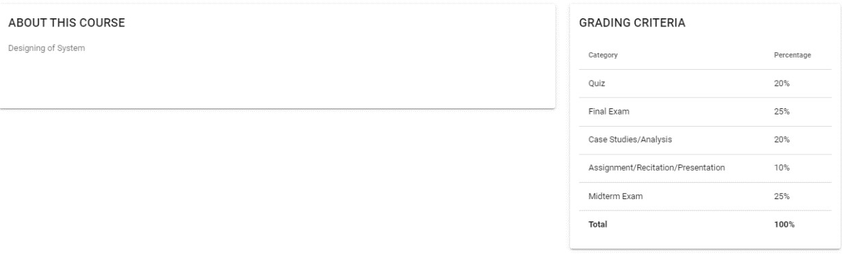

##### Program Chair

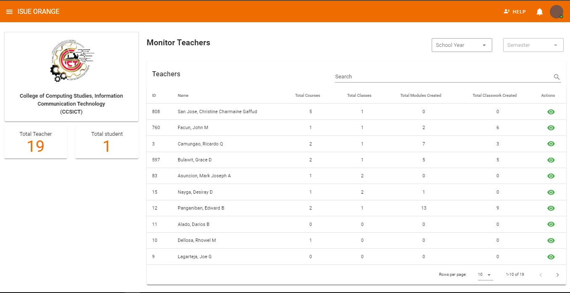

After logging in successfully the Program Chair view the faculty members that are under his/her supervision. The program chair can view every faculty member from their total course, classes, modules created. Program Chair can also search names of the faulty members. The program chair can also view the action of every faculty members. Program chair need to click the eye icon on the right side of every faculty member to view their actions.

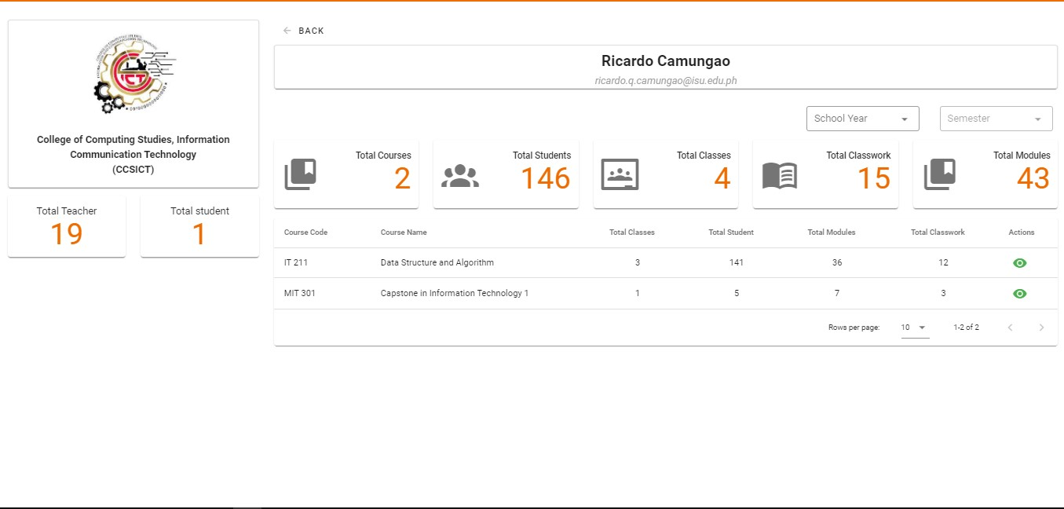

In this page the program chair can view the faculty member’s total courses, students, classes, classwork’s, and modules. The program chair can also view the courses a faculty member created. The program chair can also view the course that faculty members created by sorting the school year and semester.

**How to view class**

**Step 1:**

to view the course that

Mr. Ricardo created the program

chair need to click the green eye

icon on the same line as to the

course name.

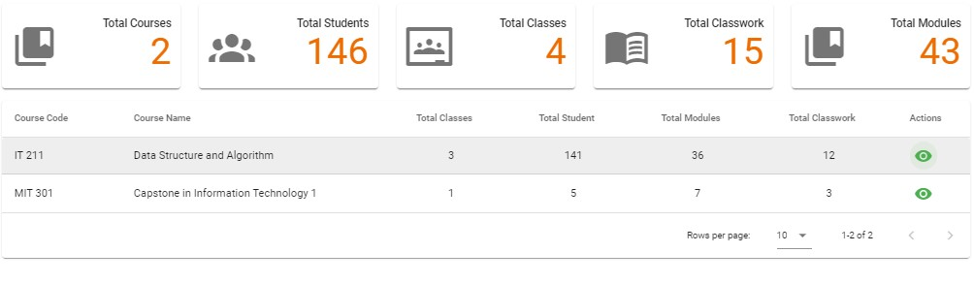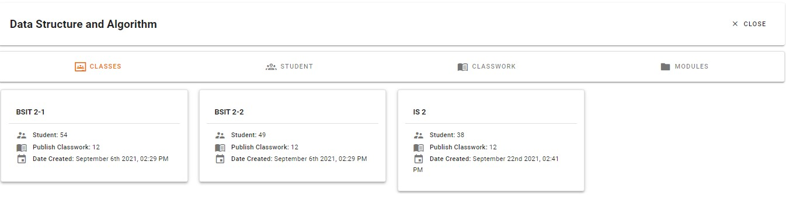

**Classes Tab**

Program chair can view details of the classes that a faculty member created including the total student in class, total published classwork, and the date and time when the faculty member create the class.

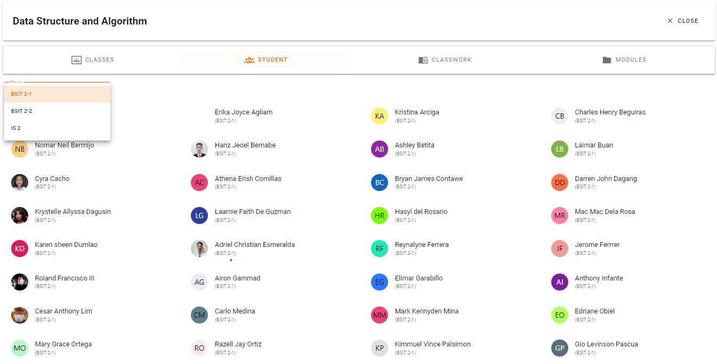

**Student**

**Tab**

The Program Chair can also view the list of students enrolled in that course and the program chair can view the class list for every section/class created in that specific course.

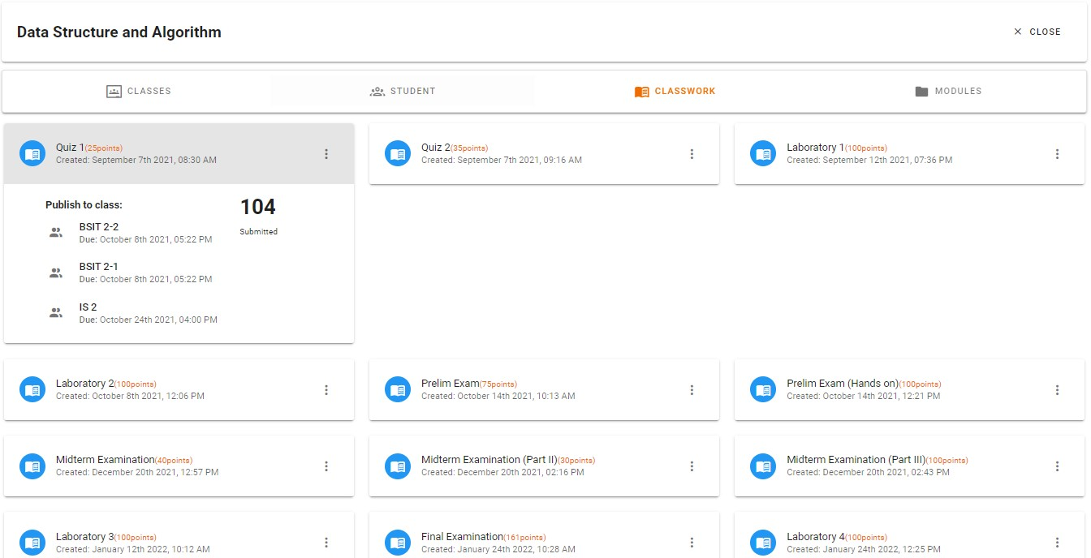

**Classwork**

**Tab**

The Program Chair can also view the classworks faculty members created, Program Chair can also view where and when the classwork been published and how many students have already submitted.

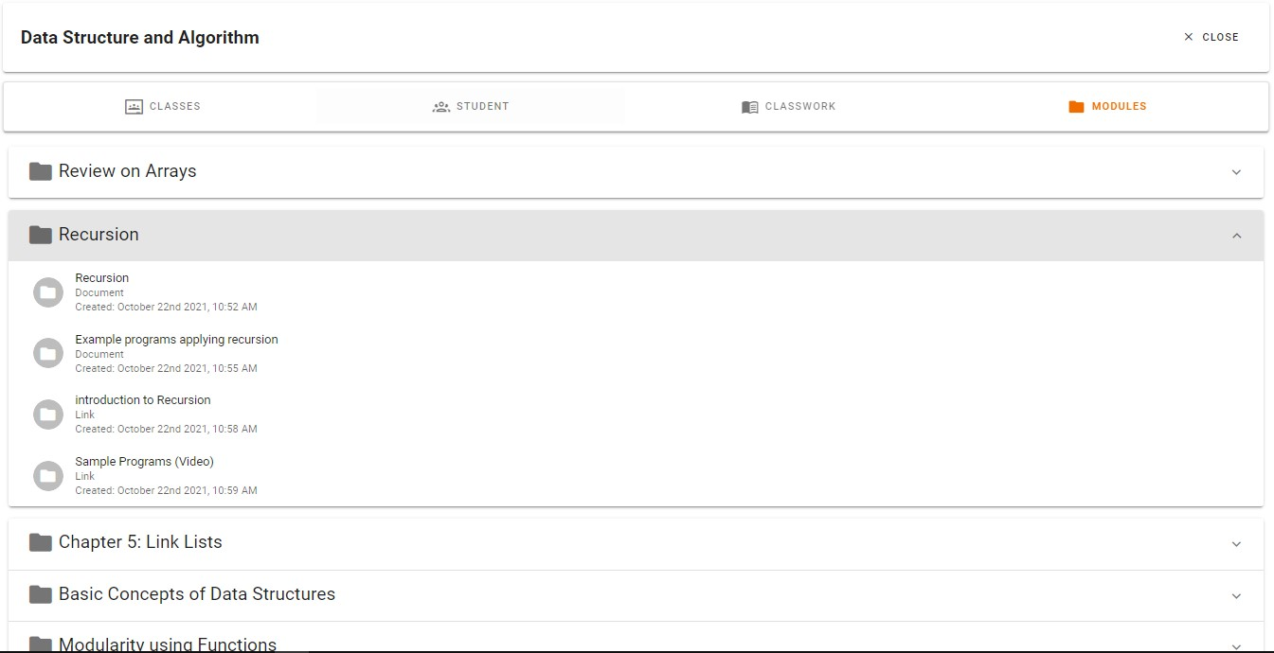

**Modules**

**Tab**

The Program Chair can also view all the modules that a faculty members created.

##### Campus Director

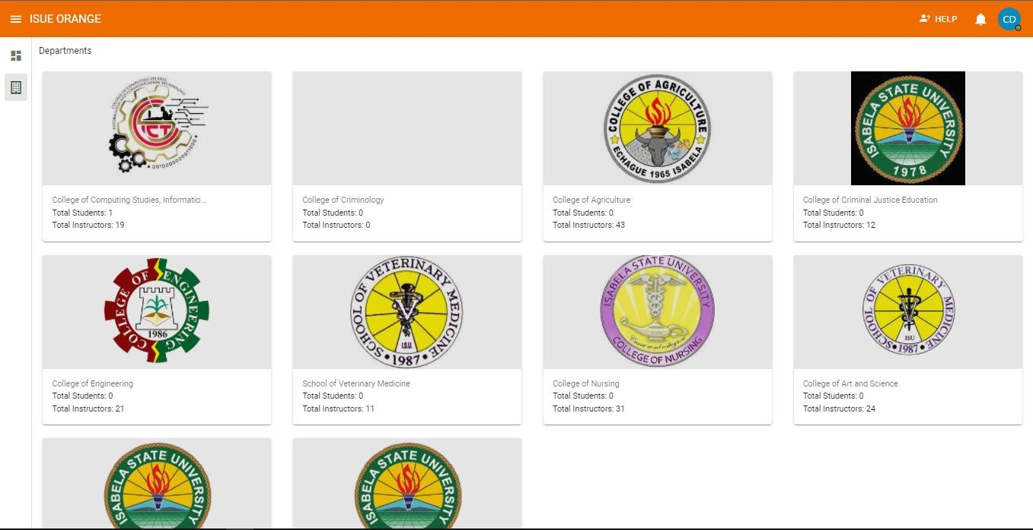

Campus Director can view and monitor the different colleges inside the campus which include the faculty members in every Colleges.

**How to View a College?**

To view and monitor a college, **click the college Logo** to view a certain college**.**

Campus Directors are able to see all the faculty members on every colleges including their total courses, classes, modules created Campus Directors can also search names of the faulty members.

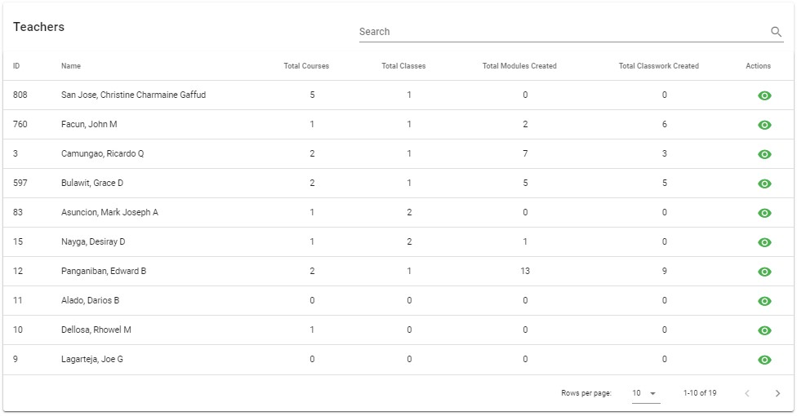

To view or visit a faculty member **click the eye icon on the right side** of a faculty member.

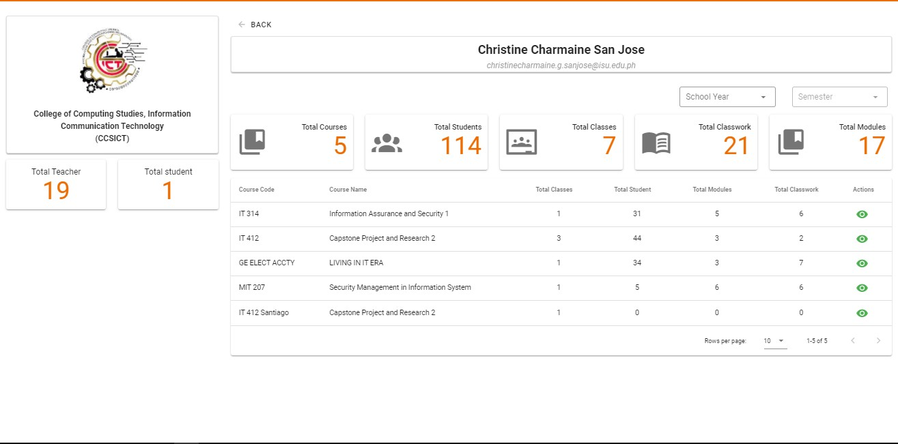

In this page the campus director can see all the details of the selected faculty member and this includes the total courses, students, classes, classwork’s, and modules. The Campus Director can also view the courses that a faculty member created and can be filter by school year and semester.

**How to view class**

**Step 1:** to view the course that Faculty members created the Campus Director need to click the green eye icon on the same line as to the course name.

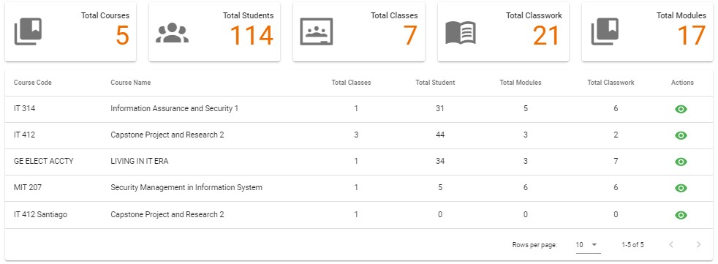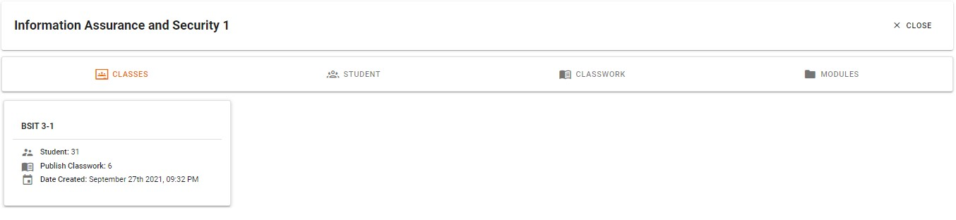

**Classes**

**Tab**

Campus Director can view details of the classes that Faculty members created from total student in class, total published classwork, and the date and time when the faculty member create the class.

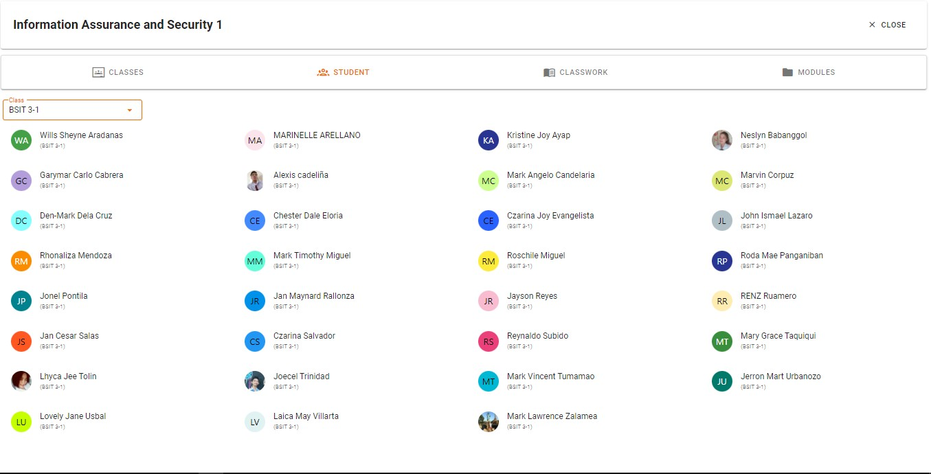

**Student**

**Tab**

The Campus Director can also view the list of students enrolled in that course and the Campus Director can view the class list for every section/class created in that specific course.

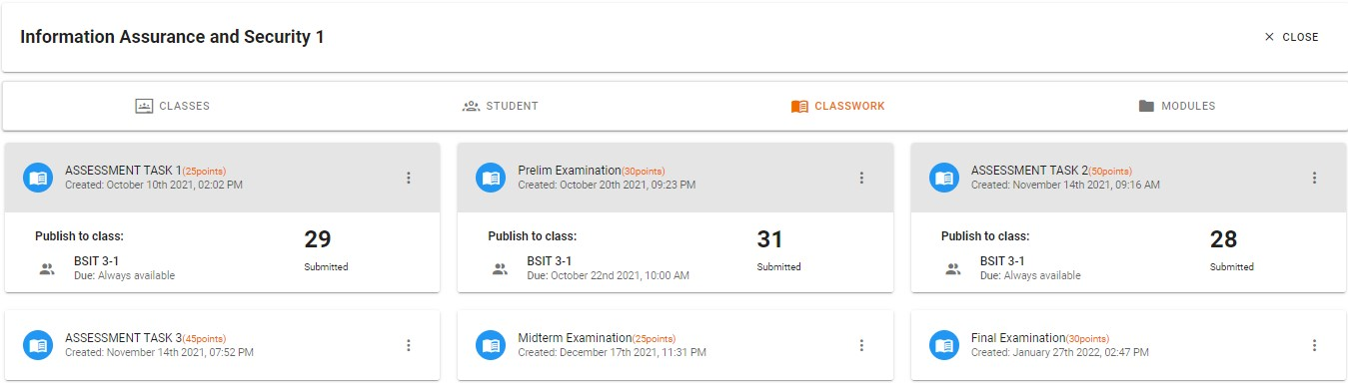

**Classwork**

**Tab**

The Campus Director can also view the classwork’s faculty members create, Campus Director can also view where and when the classwork been published and how many students have already submitted.

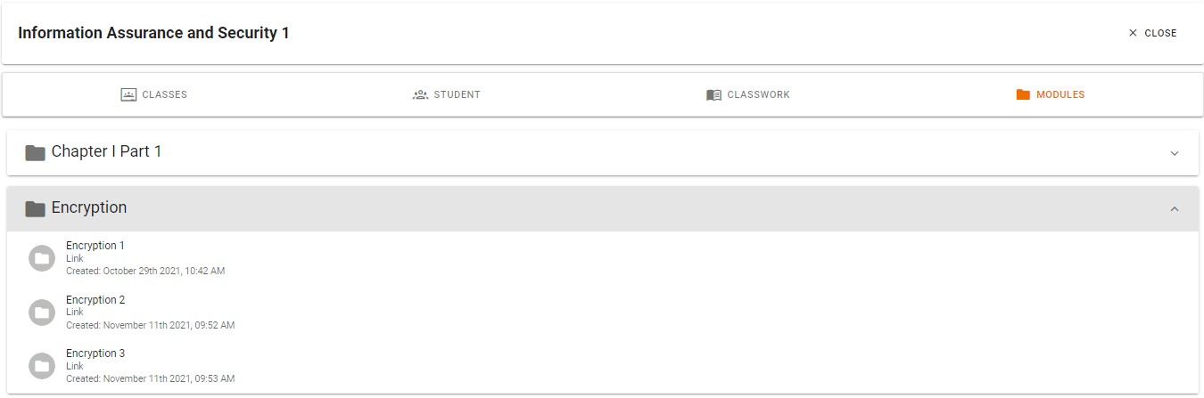

**Modules**

**Tab**

The Campus Director can also view the modules that when the faculty members created and published it.

##### Administrator

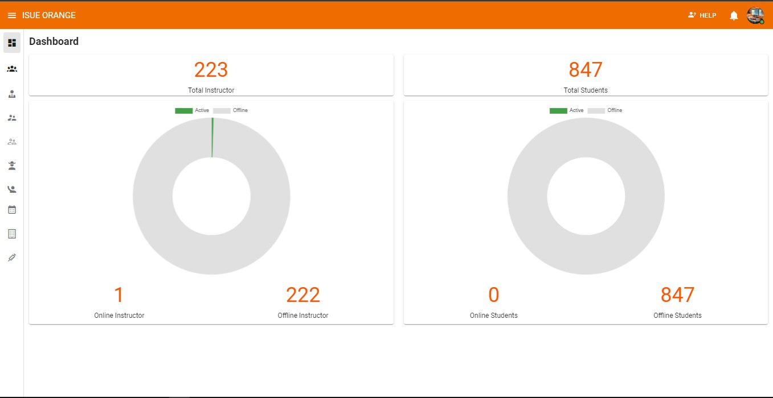

Dashboard Page: Display the Total Faculty members and Students that are signed in to ISUE – ORANGE, dashboard also display the Active and Offline User.

**How to Add Campus**

**Director:**

To

**Add**

Campus Director the Administrator need to

hover the left pane menu and click the

**Campus Director**

menu

to proceed.

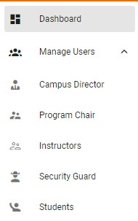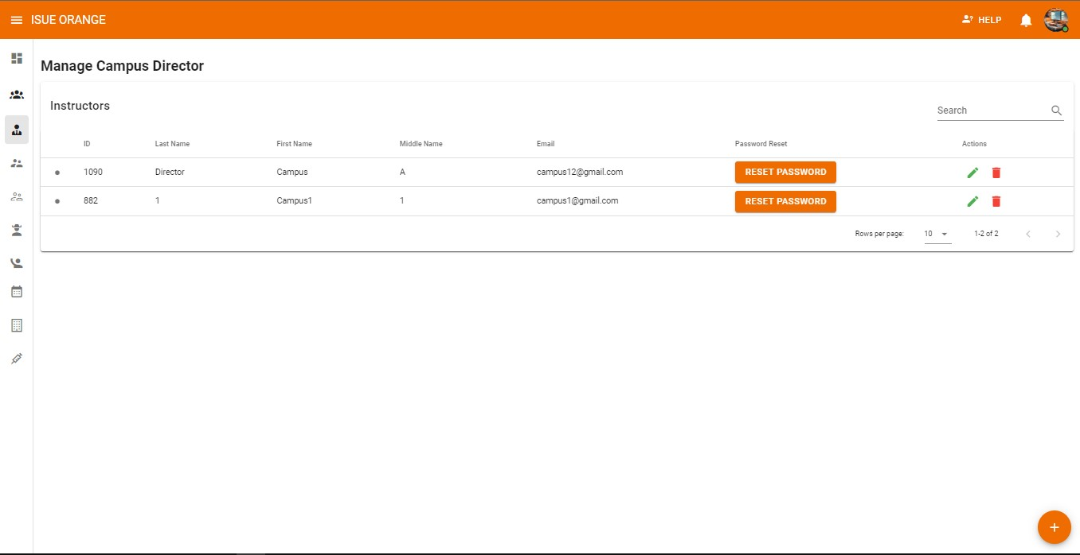

Add Campus Director



Reset Password



Search



Edit Setting



**Delete**

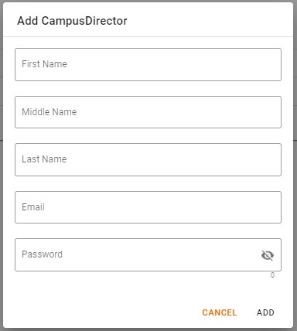

Add

1. Add Campus Director: the administrator will click the plus icon on the lower right corner of the manage Campus Director Page and a pop up menu will show.
2. Search: the administrator can search if there are existing users already or none.
3. Reset Password: the administrator can reset the password of the campus director if the user forgot their passwords
4. Edit Setting: the administrator can edit the created account details if the users want the administrator to change it.
5. Delete: the administrator can delete account if there are malicious or and redundant accounts.
6. Add: this menu will show if the administrator click the Plus Icon, the administrator will input the First, Middle, and the Last Name of the Campus Director same with the Email and Password. And after finishing the administrator can now add the Campus Director.

**How to Add Campus Director:**

To

**Add**

Program Chair the Administrator need to

hover the left pane menu and click the

**Program Chair**

menu to proceed.

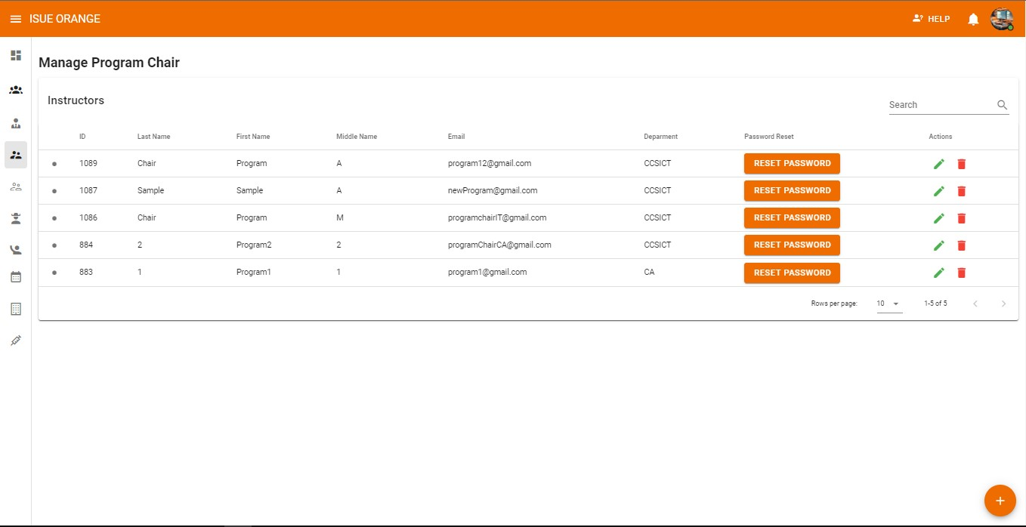

Search



Edit Setting



**Delete**



Reset Password



Add Program Chair

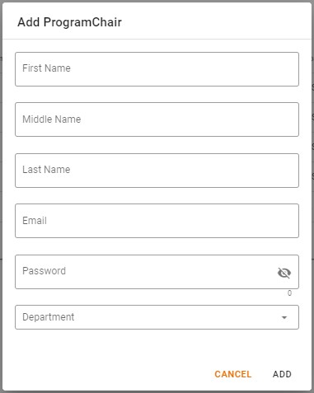

Add

1. Add Program Chair: the administrator will click the plus icon on the lower right corner of the manage Program Chair Page and a pop up menu will show.
2. Search: the administrator can search if there are existing users already or none.
3. Reset Password: the administrator can reset the password of the Program Chair if the user forgot their passwords
4. Edit Setting: the administrator can edit the created account details if the users want the administrator to change it.
5. Delete: the administrator can delete account if there are malicious or and redundant accounts.
6. Add: this menu will show if the administrator click the Plus Icon, the administrator will input the First, Middle, and the Last Name of the Program Chair same with the Email, Password, and what department does to monitor. And after finishing the administrator can now add the Program Chair.

**How to Add Faculty Member:**

To

**Add**

Instructor the Administrator need to hover

the left pane menu and click the

**Instructor**

menu to

proceed.

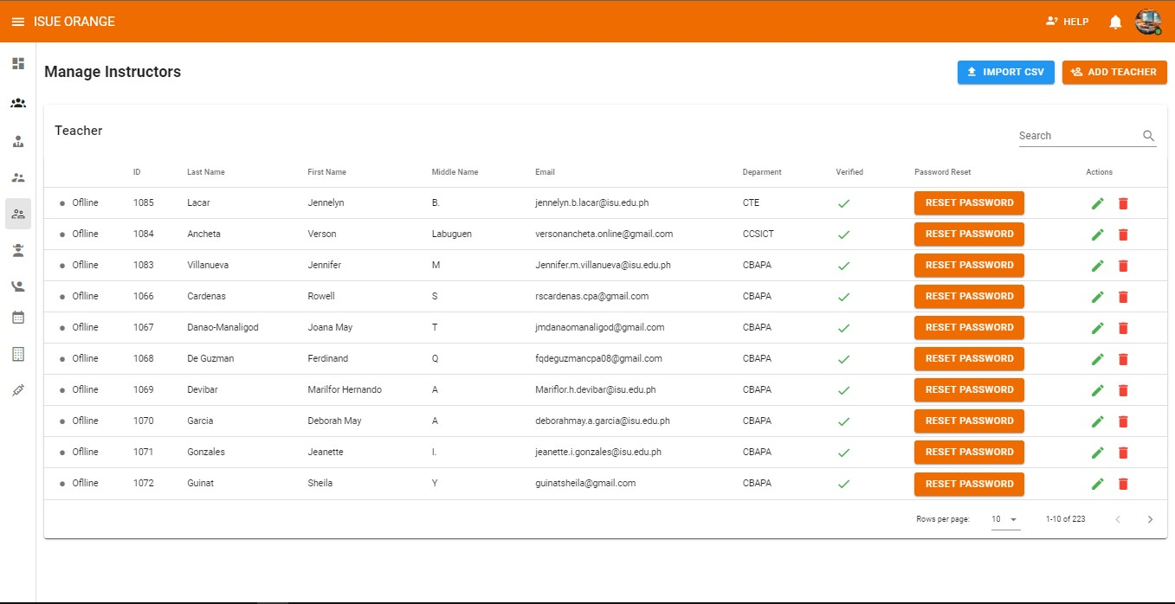

Search



Import CSV



Add Teacher



Reset Password



Edit



Delete



1. Add Faculty Member: the administrator will click the plus icon on the lower right corner of the manage Faculty Member Page and a pop up menu will show.
2. Search: the administrator can search if there are existing users already or none.
3. Reset Password: the administrator can reset the password of the Faculty member if the user forgot their passwords
4. Edit Setting: the administrator can edit the created account details if the users want the administrator to change it.
5. Delete: the administrator can delete account if there are malicious or and redundant accounts.
6. 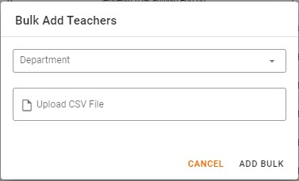Import CSV: the administrator will upload a csv and choose the department where

that csv belong

1. 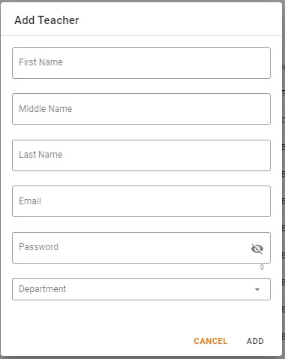Add Teacher: this menu will show if the administrator click the Add Teacher Button, the administrator will input the First, Middle, and the Last Name of the Faculty member same with the Email, Password, and what department. And after finishing the administrator can now add the Faculty Member.

**How to Add Students:**

To

**Add**

Students the Administrator need to hover

the left pane menu and click the

**Students**

menu to proceed.

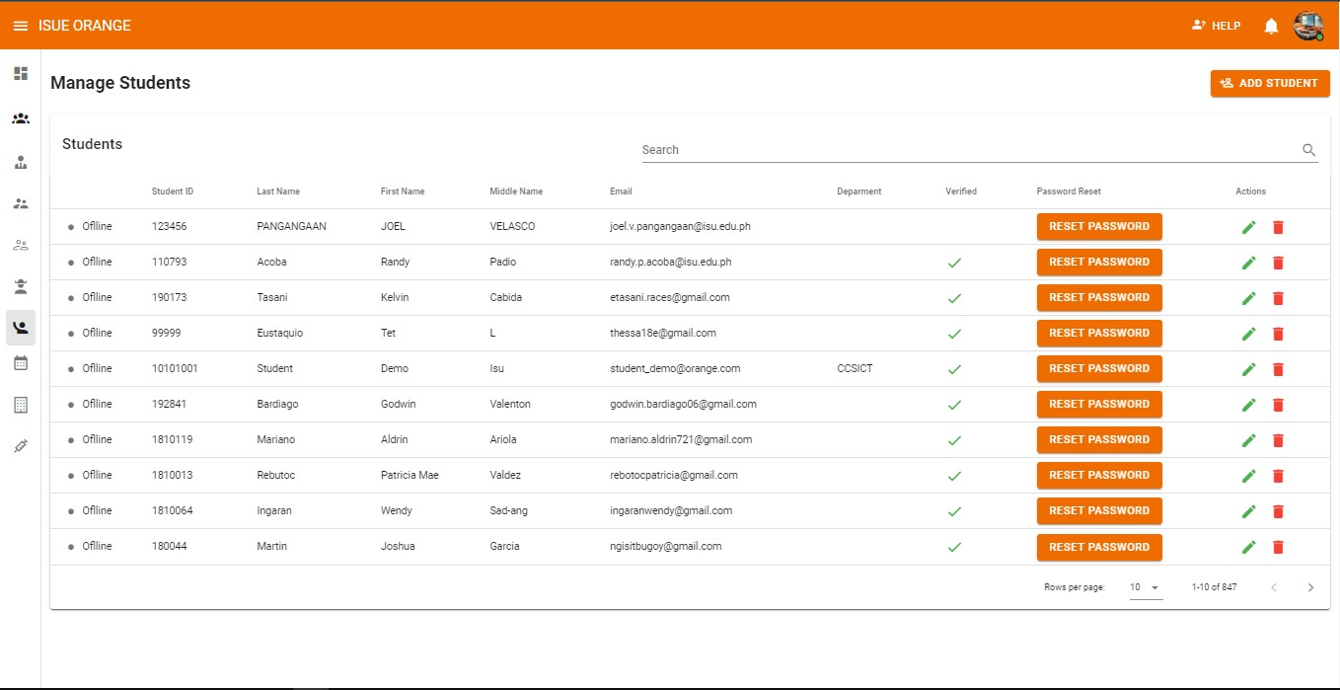

Add Student



Search



Reset Password



Edit



Delete

* 1. Add Student: the administrator will click the plus icon on the lower right corner of the manage Student Page and a pop up menu will show.
  2. Search: the administrator can search if there are existing users already or none.
  3. Reset Password: the administrator can reset the password of the Student, if the Student forgot their passwords
  4. Edit Setting: the administrator can edit the created account details if the users want the administrator to change it.
  5. Delete: the administrator can delete account if there are malicious or and redundant accounts.
  6. Add Student: this menu will show if the administrator click the Add Student Button, the administrator will input the First, Middle, and the Last Name of the Student same with the Email, Password, and what department. And after finishing the administrator can now add the Student.

**How to Add Students:**

To **Add** **School Year** and **Semester** the Administrator need to hover the left pane menu and click the **School Year/Semester** to proceed.

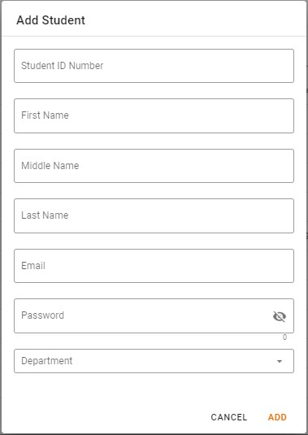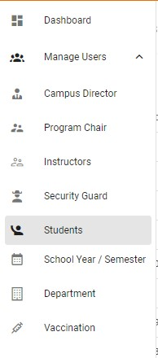

1.

School

Year: the administrator can add and set the

school year and click save it.

2.

School Year Edit Setting: the administrator can

edit the school year.

3.

School Year Delete Setting: the

administrator can delete the School

Year.

4.

Semester: the administrator

can add and

set the Semester and click save it.

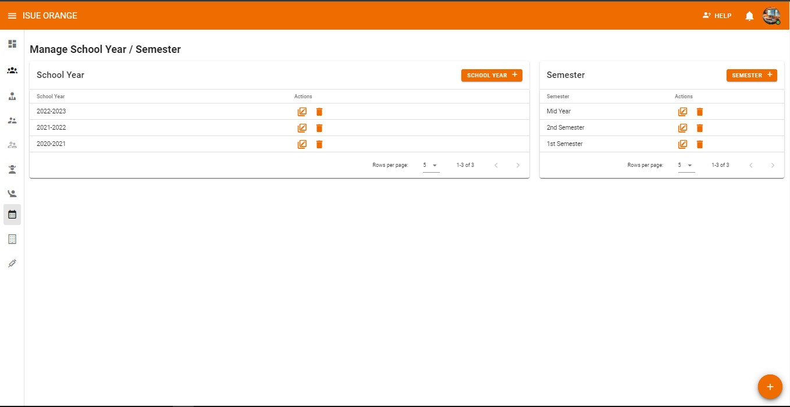

School Year



Edit



Delete



Semester



Edit



Delete

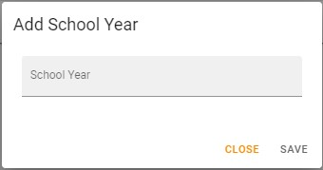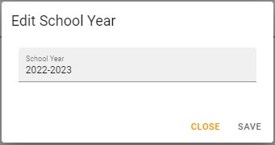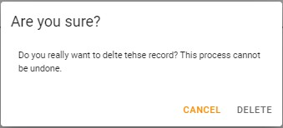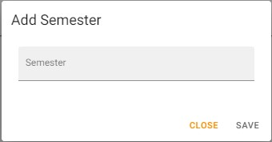

* 1. Semester Edit Setting: the Administrator can Edit the Semester if there are something wrong.

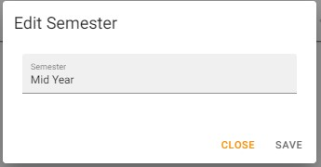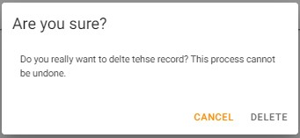

* 1. Semester Delete Setting: the Administrator can deleter the semester.

**Department**

**How to Add Department:**

To **Add** **Department** the Administrator need to hover the left pane menu and click the **Department** to proceed.

1.

Add Department: the Administrator can add departments

that are included in the

campus and to add department the

administrator need to click the department button and a

menu will pop up where they will input the name of the

department, short description and the Department Logo.

2.

Edit Department: the administrator can edit the

existing department if there are wrong spellings or

department was changing its name.

3.

Delete Department: the administrator can delete

the existing department or duplicate departments.

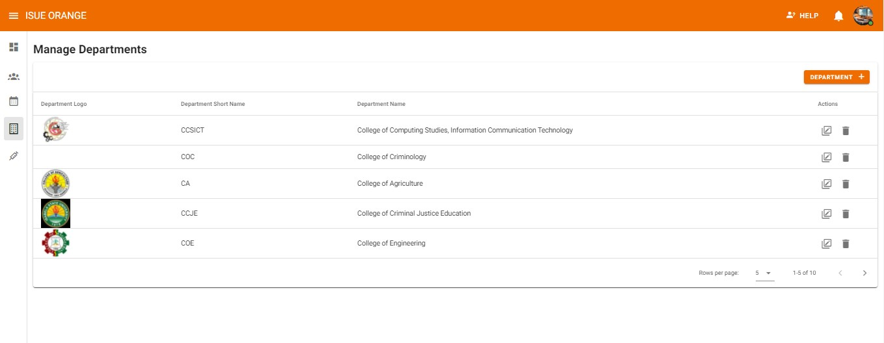

Add Departments



Edit



Delete

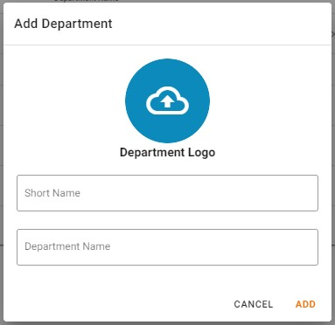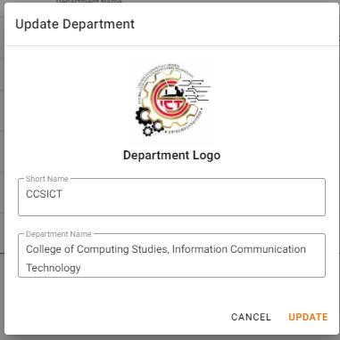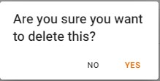

**APPENDIX C.**

# GALLERY

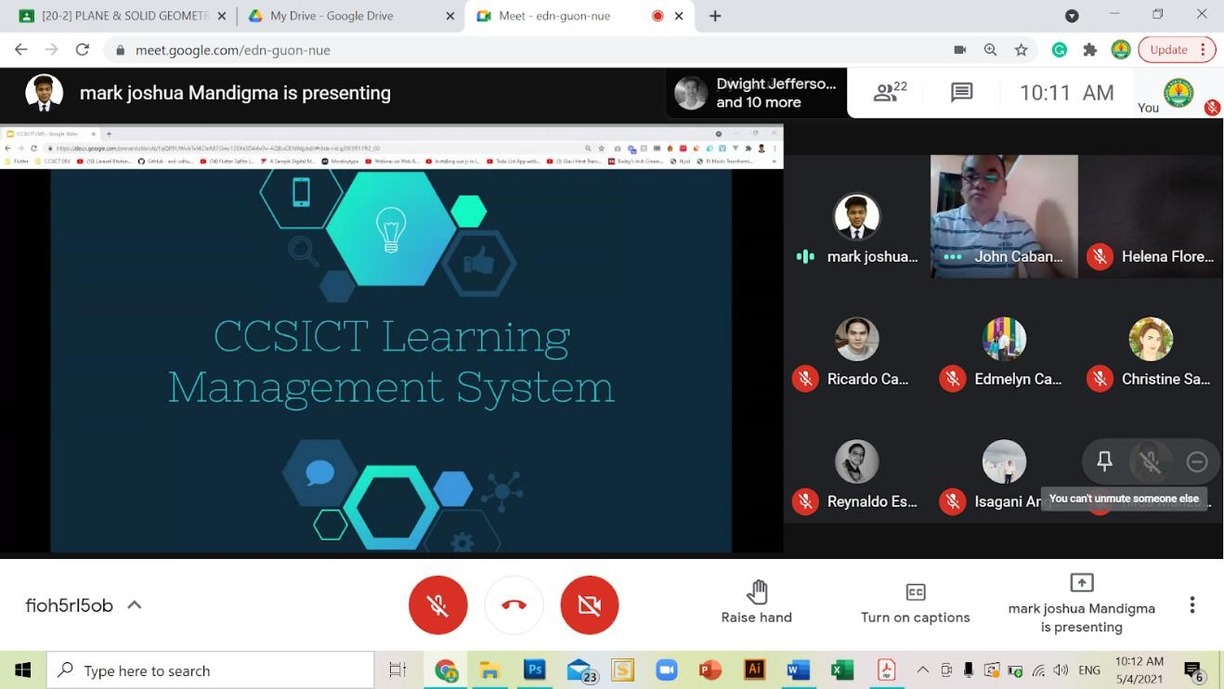

**Project proposal with the Executive Officer and Deans of ISU Echague on May 4,**

###### **2021 via Google Meet**

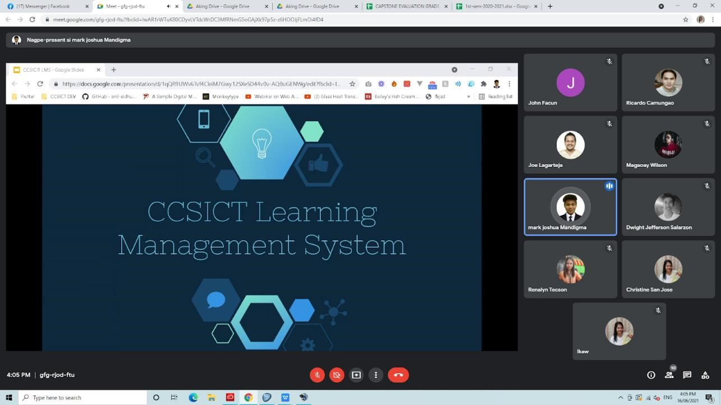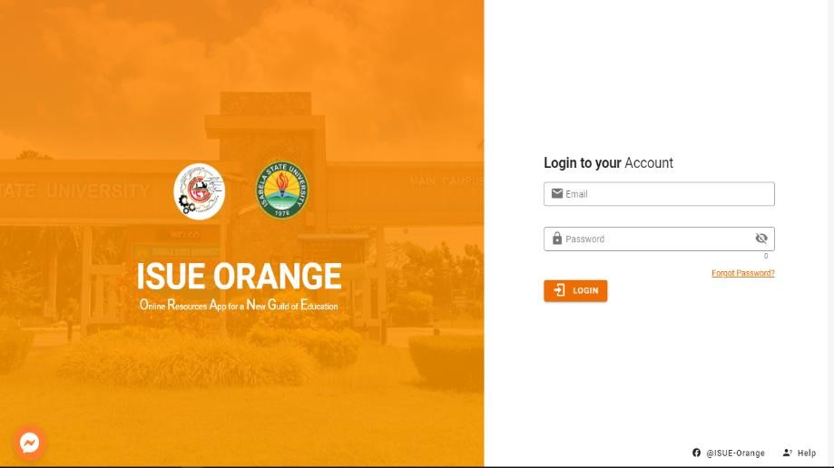

##### System Defense via Google Meet on June 16, 2021

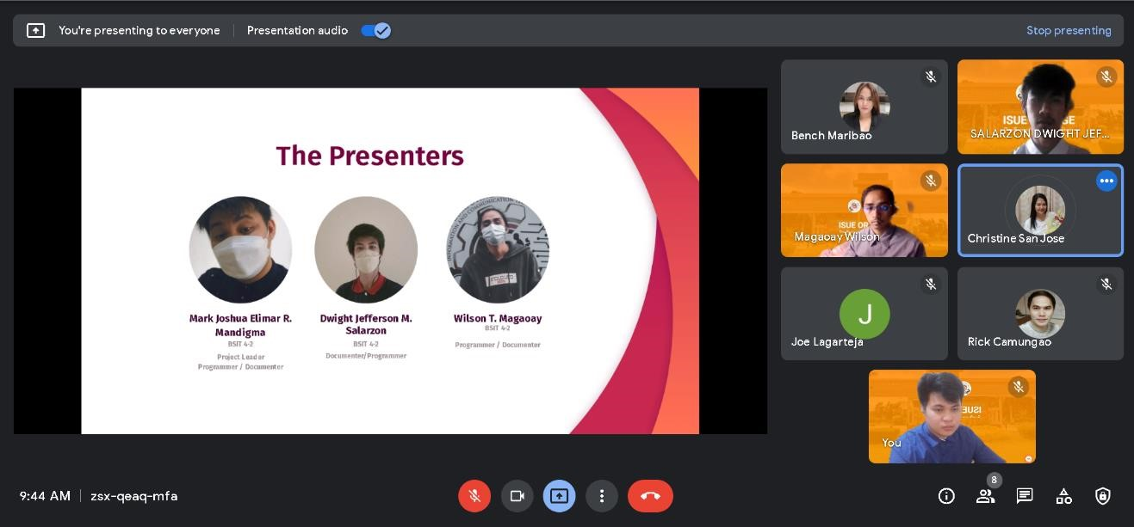

**Final Capstone Defense via Google Meet on February 4, 2022**



**Presentation and User’s Training of the ISUE-ORANGE**

##### (December 13-17, 2021)

**APPENDIX D.**

# CERTIFICATE OF IMPLEMENTATION

**APPENDIX E.**

# GRAMMARIAN’S CERTIFICATE

Republic of the Philippines

##### ISABELA STATE UNIVERSITY Echague, Isabela

**COLLEGE OF COMPUTING STUDIES INFORMATION**

**AND COMMUNICATION TECHNOLOGY**

Date___________

**G R A M M A R I A N’S C E R T I F I C A T E**

This is to certify that the undersigned has reviewed and went through all the pages of the proposed capstone project entitled “**ISUE ORANGE: Isabela State University Echague Online Resources App for a New Guild of Education**” as against the set of structural rules that govern the composition of sentences, phrases, and words in the English language.

Signed:

Victor M. Ringor Jr., MAT English, MPA

Grammarian

**APPENDIX F.**

# CURRICULUM VITAE

**PERSONAL INFORMATION**

**Last Name:** Mandigma

**First Name:** Mark Joshua Elimar

**Middle Name:** Roxas

**Birth Date:** January 16, 2000

**Address:** Cabugao, Echague, Isabela

**Contacts:** 09295454035

**Gender:** Male

**Status:** Single

**Email Address:** markjoshua.mandigma@gmail.com

**EDUCATIONAL BACKGROUND**

**Tertiary:**

Isabela State University – Main Campus

Course: Bachelor of Science in Information Technology

Year Graduate: 2022

**Secondary:**

La Patria College

08 Guzman St., Calao West, Santiago, Philippines

Year Graduated: 2018 **Elementary:**

Echague East Central School

Sanfabian, Echague, Isabela

Year Graduated: 2012

##### PERSONAL INFORMATION

**Last Name:** Magaoay

**First Name:** Wilson

**Middle Name:** Tubera

**Birth Date:** September 14, 1999

**Address:** Libertad, Echague, Isabela

**Contacts:** 09352355629

**Gender:** Male

**Status:** Single

**Email Address:** magaoaywilson14@gmail.com

**EDUCATIONAL BACKGROUND**

**Tertiary:**

Isabela State University – Main Campus

Course: Bachelor of Science in Information Technology

Year Graduate: 2022

**Secondary:**

La Patria College

08 Guzman St., Calao West, Santiago, Philippines

Year Graduated: 2018 **Elementary:**

Echague South Central Elementary School

Ipil, Echague, Isabela

Year Graduated: 2012

##### PERSONAL INFORMATION

**Last Name:** Salarzon

**First Name:** Dwight Jefferson

**Middle Name:** Magaway

**Birth Date:** January 22, 2000

**Address:** Ipi, Echague, Isabela

**Contacts:** 09218357043

**Gender:** Male

**Status:** Single

**Email Address:** dwightjeffersonsalarzon222@gmail.com

**EDUCATIONAL BACKGROUND**

**Tertiary:**

Isabela State University – Main Campus

Course: Bachelor of Science in Information Technology

Year Graduate: 2022

**Secondary:**

Don Mariano Marcos National High School

Ipil, Echague, Isabela Year Graduated: 2018 **Elementary:**

Echague South Central School

Ipil, Echague, Isabela

Year Graduated: 2012